_____________________ _____________________ _____________________ ______________________
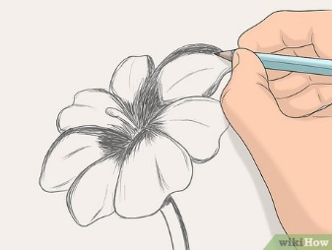
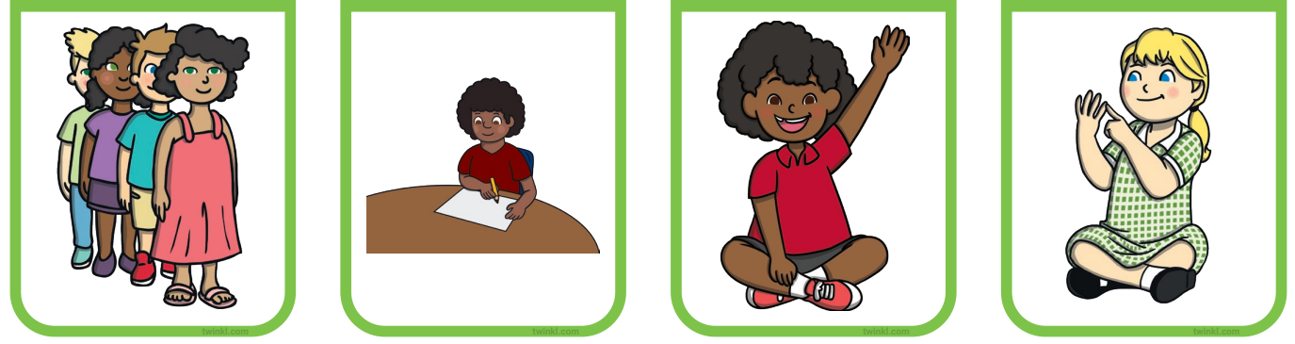

______________________ ______________________ ______________________ _____________________
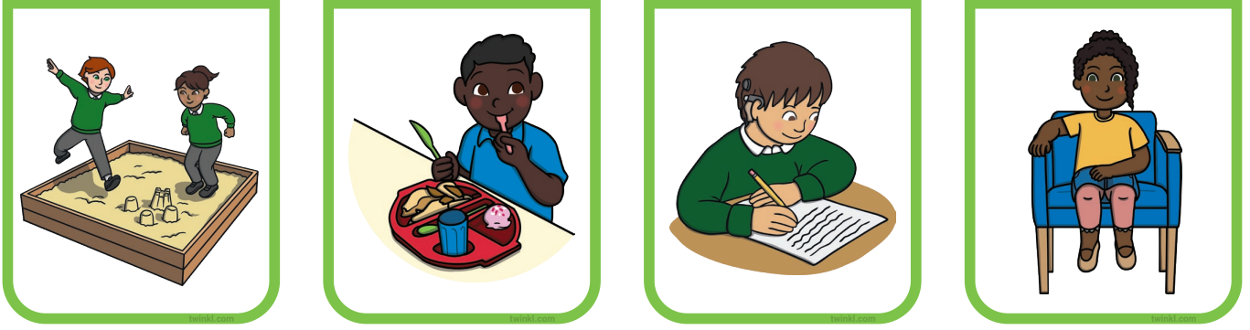

______________________ ______________________ ______________________ ____________________
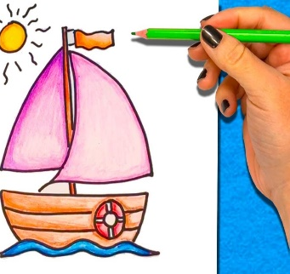
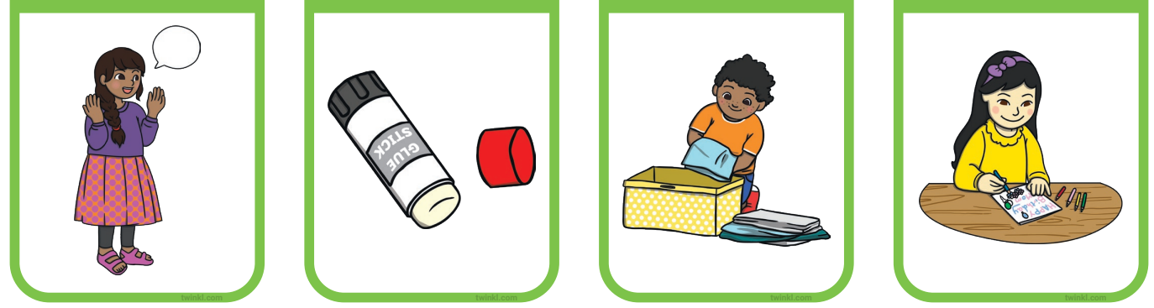

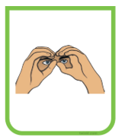
______________________ ______________________ ______________________ ______________________
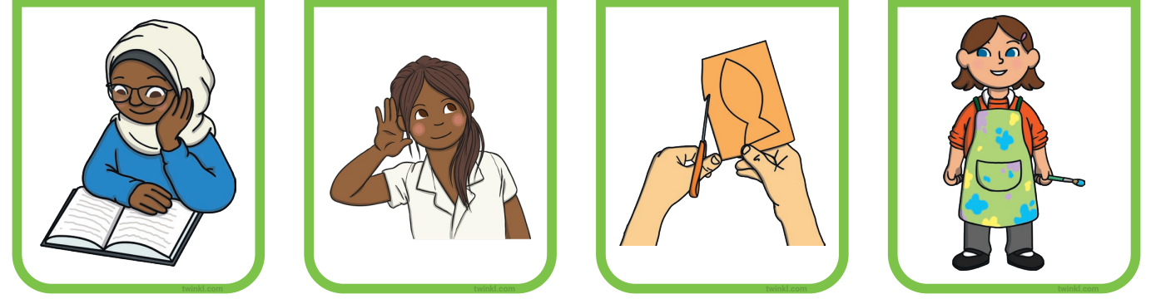
LINE UP DRAW HANDS UP COUNT
PLAY EAT WRITE SIT
TALK STICK TIDY COLOUR

READ LISTEN CUT LOOK

