ON HOLIDAY
- SUMMER HOLIDAY - WINTER HOLIDAY

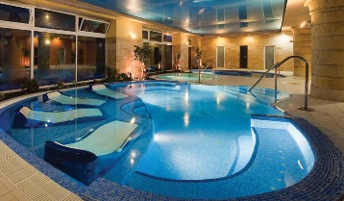
Where can you go?
You can go | 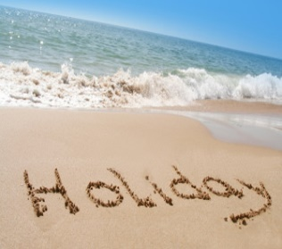  to the seaside.
 | to the country.
 | to the mountains.
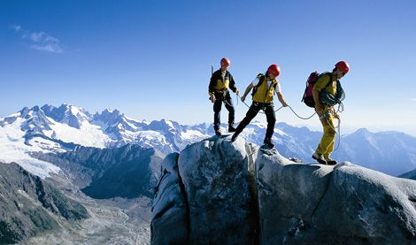
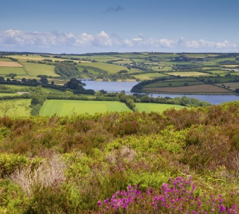
to the spa.

What can you do …?
AT THE SEASIDE | I can swim. / I can go swimming.
 | I can go snorkelling / windsurfing / kiteboarding.
IN THE COUNTRY | I can go for a walk. I can swim in the river.
 | I can go fishing. I can go hiking.
IN THE MOUNTAINS | I can ski. I can go snowboarding.
 | I can rock-climb. I can go hill-walking.

How do you travel?
We travel … | BY | car / taxi / underground / ferry / train / plane / bike
 | ON | foot / rollerblades


