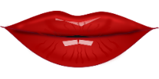 | MOUTH /MAUT/ | 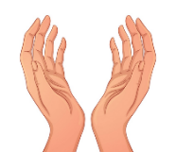 | 1 HAND /HEND/  2 HANDS /HENDS/
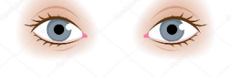 | 1 EYE /AJ/  2 EYES /AJS/ | 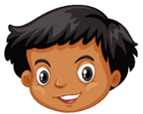 | HEAD /HED/
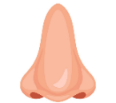 | NOSE /NOUS/ | 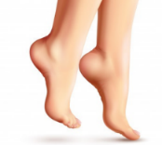 | FEET /FIT/
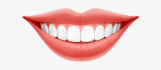 | TEETH /TIT/ | 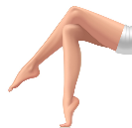 | 1 LEG /LEG/  2 LEGS /LEGS/
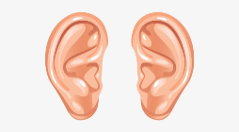 | EARS /IRS/ | 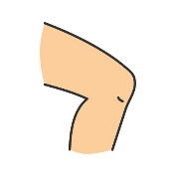 | KNEE /KNI/  2 KNEES (KNIS/
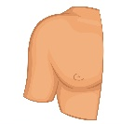 | SHOULDER /ŠOLDER/  SHOULDERS /ŠOULDERS | 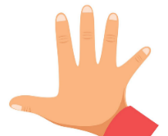 | 1 FINGER /FINGER/  2 FINGERS /FINGRS/
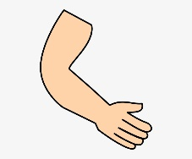 | ARM /ARM/  2 ARMS /ARMS/ | 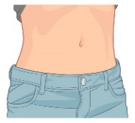 | TUMMY /TAMI/
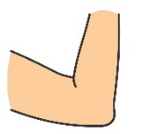 | ELBOW /ELBOU/  2 ELBOWS /ELBOUS/ | 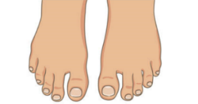 | 1 TOE /TOU/  2 TOES /TOUS/
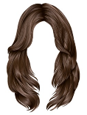 | HAIR /HER/ | 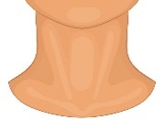 | NECK /NEK/
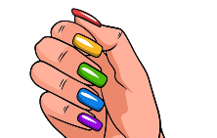 | NAIL /NEJL/  2 NAILS | 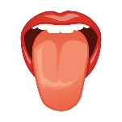 | TONGUE /TNG/

