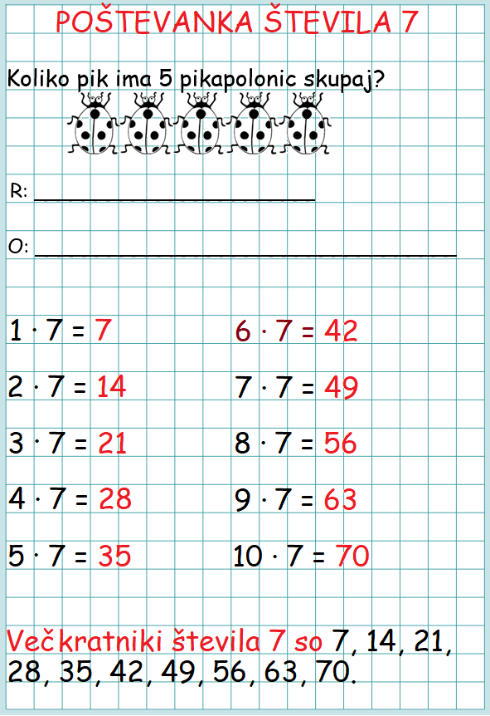
_______________________
_______________________
_______________________
_______________________
_______________________
_______________________
_______________________
_______________________
_______________________
_______________________


Koliko pik ima 5 pikapolonic skupaj?
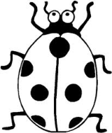
R: ______________________________________
O: ____________________________________________________________

