

Jezikovno in medkulturno ozaveščanje
PROJECT WORK
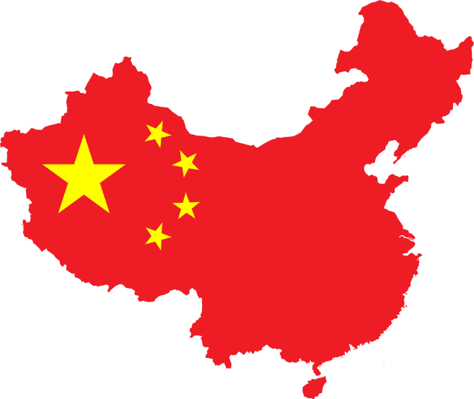
CHINA

Date: 30. 4. 2023
Students: Katja Turinek and Tjaša Mrvar

Ljubljana, 2023
- An introduction in which you justify the selection of the topic
When we first heard we had to make a presentation about one country none of us had a really favorite country we would love to present. So we decided to think a little bit and then we remembered that China has some very different and interesting traditions. We chose China as the topic of our presentation because we found its culture to be incredibly intriguing, with its unique writing symbols, cuisine, clothes, and traditions. Although we have never been there before, we wanted to shed light on various aspects of China through our presentation and showcase what makes it such a unique and significant country. We have always been fascinated by China's rich culture and history. It is home to some of the world's oldest and most influential civilizations, and its contributions to art, literature, philosophy, and science are immense. We also find the diversity of China's regions and people to be incredibly compelling, with each area of the country having its own distinct traditions, cuisines, and dialects. We hoped that with captivating and more detailed presentation others would find Chinese culture interesting too.
- A ppt on the topic
A ppt is provided in a separate document.
- A collection of activities

- Guess the word
For this activity, we would put mixed letters on the PowerPoint slide or on the blackboard. Students would need to guess/make the correct word for the traditional clothing in China. The letters are A, H, F, U, N HANFU. They could just think about it or even write it down on the paper. After 1 minute they would share their answers.
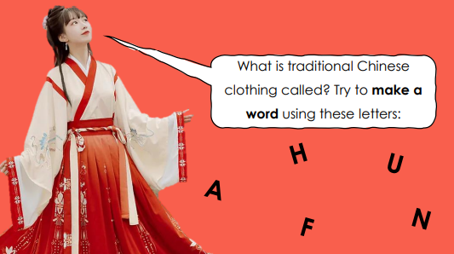
- Would you rather
In this activity, students would be choosing either between two dishes/foods or between one food/dish and a statement. We would put two pictures at a time on the slide without the name or ingredients. They could be choosing with standing up and sitting down or in our case with hand signs. So we put one hand sign on the right side and the other one on the left side. If they prefer the thing on the left side they make that hand sign if not they make the other one. For younger students we could include movement (right stand up, left sit down). When they make their choice, we show them the name of the food.
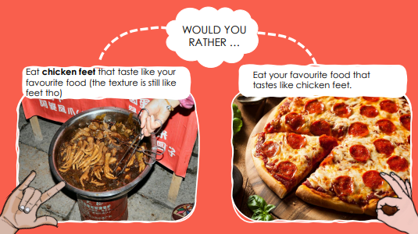
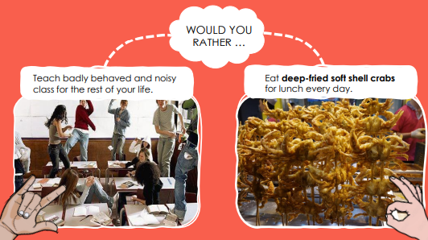
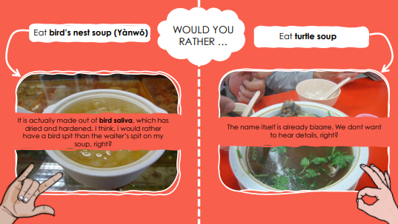
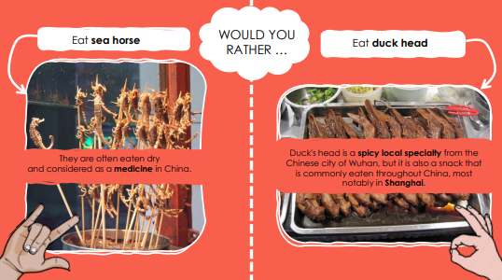
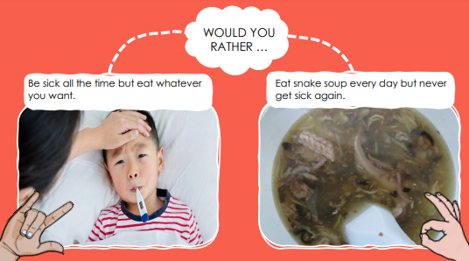
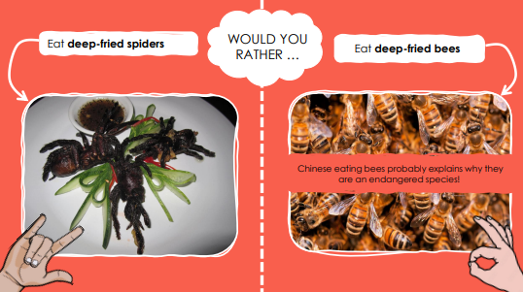
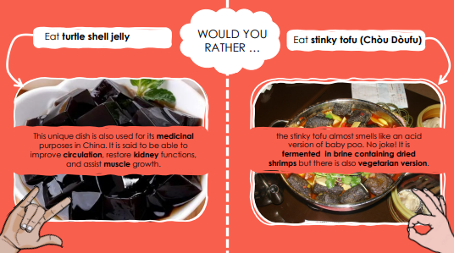
- 2 truths and 1 lie
This activity can be connected to the one before or it can be done separately. We did not want to do the same type of activity for too long so we decided to mix it and make it more interesting. Fort his one students are choosing between three statements. 2 of them are truths and one is a lie. They try to guess which one is a lie. They choose a lie with the number of fingers (they show one finger for the first statement, two fingers for the second and three for the third one). We also tell them why the statement is a lie.
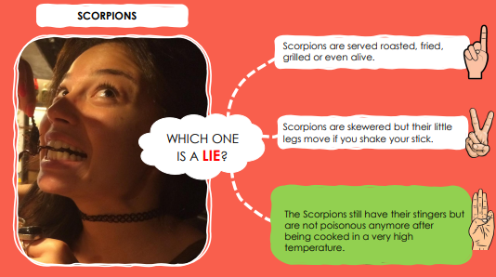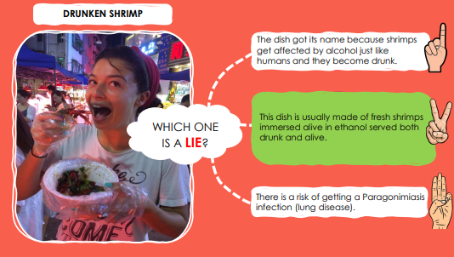
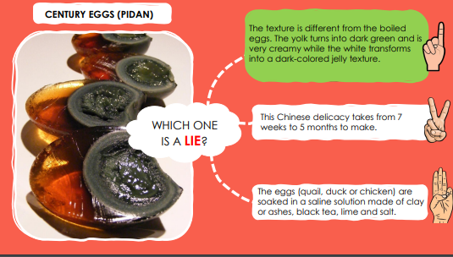
- Role play
For the role play we put students in groups of 5 or more. Each group gets a situation written on the piece of paper that they need to act out. Scenes are about table manners in China. Each scene has 2 mistakes. When one group is playing a scene, other students try to guess what are they doing wrong and why is it wrong (for example bending over the table, sitting down before the eldest person and so on).
GROUP 1:
ROLE PLAY situation:
Members: father, mother, granddad, son, daughter (there can be more/less sons or daughters).
Pretend to be members of a Chinese family eating a meal at home. All the food is on the table. First granddad is seated and he first makes the toast and when he says “let's eat”, all members can start eating. Members who eat from their bowl, hold it with their thumb on the mouth of the bowl, first finger, middle finger the third finger supporting the bottom of the bowl and palm empty. Father is not holding his bowl in his hand. He bends over the table and eats facing his bowl. Mother wants more food, so she takes food first from the plates in front of her. Son/daughter starts to use their phone. He/she starts to text and scroll through social media.

GROUP 2:
ROLE PLAY situation:
Members: father, mother, granddad, son, daughter (there can be more/less sons or daughters).
Pretend to be members of a Chinese family eating a meal at home. All the food is on the table. First granddad is seated and just as he starts to make the toast one of the kids just puts the food on his plate and starts eating. Members who eat from their bowl, hold it with their thumb on the mouth of the bowl, first finger, middle finger the third finger supporting the bottom of the bowl and palm empty. Dad wants more food and he sees some food he would like on the other side of the table. He bends over all the food and grabs some food far away from where he is seated.

GROUP 3:
ROLE PLAY situation:
Members: father, mother, granddad, son, daughter (there can be more/less sons or daughters).
Pretend to be members of a Chinese family eating a meal at home. All the food is on the table. First granddad is seated and he first makes the toast and when he says “let's eat”, all members can start eating. Members who eat from their bowl, hold it with their thumb on the mouth of the bowl, first finger, middle finger the third finger supporting the bottom of the bowl and palm empty. Daughter has a hard time eating the meat so she stands up, goes to the kitchen and brings a knife back to the table. She uses the knife to cut the meat. Mother wants more food, so she takes food first from the plates in front of her. Granddad adds food to his grandson's bowl, and he has an angry look on his face and says “Why did you do that!?” with an angry voice.

GROUP 4:
ROLE PLAY situation:
Members: father, mother, granddad, son, daughter (there can be more/less sons or daughters).
Pretend to be members of a Chinese family eating a meal at home. All the food is on the table. First granddad is seated and he first makes the toast and when he says “let's eat”, all members can start eating. The daughter takes her chopsticks and stabs the food with them and brings the food into her mouth. Members who eat from their bowl, hold it with their thumb on the mouth of the bowl, first finger, middle finger the third finger supporting the bottom of the bowl and palm empty. Son wants more food, so he takes food first from the plates in front of him. Father keeps his eyes glued to the plate and he uses his chopsticks to dig through the food as he was "digging for treasure".

GROUP 5:
ROLE PLAY situation:
Members: father, mother, granddad, son, daughter (there can be more/less sons or daughters).
Pretend to be members of a Chinese family eating a meal at home. All the food is on the table. Mother says that the food is ready so they can come to the table. As she does so, she seats first and eats a little bit while waiting for others to come to the table. Granddad makes the toast and then says “let's eat”. Members who eat from their bowl, hold it with their thumb on the mouth of the bowl, first finger, middle finger the third finger supporting the bottom of the bowl and palm empty. Son wants more food, so he takes food first from the plates in front of him. Granddad excuses himself, he has to go to the toilet. He sticks chopsticks vertically into rice.

GROUP 6:
ROLE PLAY situation:
Members: father, mother, granddad, son, daughter (there can be more/less sons or daughters).
Pretend to be members of a Chinese family eating a meal at home. All the food is on the table. First granddad is seated and he first makes the toast and when he says “let's eat”, all members can start eating. Members who eat from their bowl, hold it with their thumb on the mouth of the bowl, first finger, middle finger the third finger supporting the bottom of the bowl and palm empty. Daughter starts to play with her chopsticks, she spins them around and waves her chopsticks around in the air. Father wants more food, so he takes food first from the plates in front of him. The son is a little bit bored so he pulls his phone out of his pocket and when he finds a funny video, he shares it with his sister. They watch the video and laugh loudly while the others are eating.

- What do you see?

We put a picture of an elevator buttons on the PPT slide. Students guess what it is and also try to find out why is the picture odd or unusual. When they find out that number four is missing, we ask them why they think it is missing. Eventually we tell them that number four is the unluckiest number in China, so they sometimes do not even use it in buildings. Then we show them lucky and unlucky numbers.
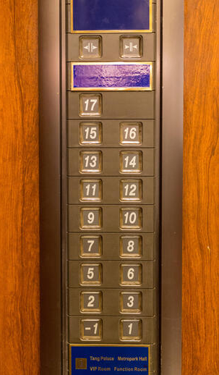
- Quiz
At the end of the presentation, students can do this online quiz to check what they remembered about China. They can play the quiz on their phones while the questions and correct answers are provided on mentimeter.
Part 1: https://www.mentimeter.com/app/presentation/alwboiowo3mq2zwzfygqmsyh897sripa
Part 2: https://www.mentimeter.com/app/presentation/alztptycvbughii3p9y9szpkj9pe7k8w

- Two activities for children

- ACTIVITY 1: Role play
Name of the activity: Role play
Aim of the activity: Students know the table manners and recognize the wrong eating behaviour when they see it
Age of learners: 10 years (5th grade)
Approximate length of the activity: 15 minutes
Description of the activity: Students work in groups of 5 and play/act out the situation about table manners while others try to guess what is wrong/which table manner was not correct.
Language level of learners: A1
Skills practiced (listening/speaking/reading/writing): listening, reading, speaking
Vocabulary practiced: mother, father, son, daughter, eating, food, members, family, bowl, plate
Materials needed: scene/situation written on a piece of paper (6 different situations 6 pieces of paper), items like a bowl, a glass, a plate …
Cross – curricular links: družba
FERPA/CARAP descriptors:
- knows some of the principles of how languages work;
- possesses knowledge about what cultures are and how they work;
- knows that a culture is a grouping of practices, representations, values of all kinds shared (at least partially) by its members;
- knows some characteristics of one’s cultural environment;
- being sensitive to differences and to similarities between different languages/
cultures;
- knows that there are similarities and differences between verbal /nonverbal communication systems;
- respect and openness to diversity of cultures;
- a wish to discover other cultures and languages.
How the activity develops intercultural awareness: they learn about different traditions, cultures, eating and table manners; they can compare Slovenia and China in terms of eating manners.
Classroom organization (group work, pair work, whole-class …): group work.
Possible pre- and post- activities:
Pre-activities: group work where each group gets the literature about eating manners and behaviour around the table. Groups read about different things that you cannot do when eating a meal in china. Each group chooses one wrong thing and makes a mind map or just write a short paragraph about it. Then they act it out or just present it.
Post-activities: students can compare table manners in their culture and table manners in China and add that to their mind maps or texts. Then they present that to others.
Variations (if there are any): /
Additional notes (if applicable):/
- ACTIVITY 2: Would you rather
Name of the activity: Would you rather
Aim of the activity: Students get to know unusual food and dishes in China and choose which one they would rather try.
Age of learners: 8 years (3rd grade)
Approximate length of the activity: 10 minutes
Description of the activity: Students independently. When they see two foods on the PPT slide they have to choose one that they would rather try. If they prefer the food on their left, they stand up, if they prefer the food on their right, they sit down. We also talk about what they eat in China and check the name and ingredients of the food.
Language level of learners: A1
Skills practiced (listening/speaking/reading/writing): listening, speaking
Vocabulary practiced: food, dish, bee, snake, spider, turtle, tofu, egg, scorpion, sea horse, chicken feet … (different names of food)
Materials needed: pictures of the dishes. We can have them on the PPT slide or printed out.
Cross – curricular links: spoznavanje okolja
FERPA/CARAP descriptors:
- knows that one can learn better if one has a positive attitude towards linguistic differences;
- possesses knowledge about what cultures are and how they work;
- knows that a culture is a grouping of practices, representations, values of all kinds shared (at least partially) by its members;
- knows that the members of each culture define (partially) specific rules / norms / values about social practices / behaviours;
- being sensitive to differences and to similarities between different languages/
cultures;
- knows that there are similarities and differences between verbal /nonverbal communication systems;
- respect and openness to diversity of cultures;
- knows that the diversity of cultures does not imply superiority / inferiority of any one in relation to the others.
How the activity develops intercultural awareness: they learn about different traditions, cultures, unusual foods and dishes and compare them to foods in their culture.
Classroom organization (group work, pair work, whole-class …): whole-class.
Possible pre- and post- activities:
Pre activities: students work in groups and each group chooses one food from China and compares in to their favourite food. They can also compare ingredients, describe the how the food looks like, and also make a new food out of these ingredients.
Post activities: students work in pairs and each pair gets pictures of foods and their names. They can play memory game in which they connect pictures and names and that way learn and remember unusual foods.
Variations (if there are any):
Additional notes (if applicable):/
- One lesson plan for teaching this topic to children
DNEVNA PRIPRAVA NA VZGOJNO-IZOBRAŽEVALNO DELO
Šola: / | Šolsko leto: 2022/23
Učiteljici: Katja Turinek in Tjaša Mrvar | Razred/oddelek: 5.r
Mentorica: / | Zaporedna številka ure: /
Predmet: TJA | Datum: /
Tematski sklop: Cultures around the world | Tip učne ure: ura obravnave nove snovi
Tema: China
Učne metode: gibalna igra, razlaga, pogovor, opazovanje.
Učne oblike: frontalna, individualna, skupinska
Učni pripomočki in učna sredstva: PowerPoint Predstavitev, računalnik z zvočniki, lističi s situacijami za igro vlog
Učni cilji:
Učenci:
- se ozaveščajo o nekaterih temeljnih medkulturnih podobnostih in razlikah;
- uporabljajo osnovne sporazumevalne funkcije (npr. vprašanja, pozdravi);
- razvijajo svojo medkulturno občutljivost in ozaveščenost;
- spoznajo medkulturne podobnosti in razlike na primerih izvirnih besedil (npr. pesmi) in nekatere značilnosti tradicionalne in sodobne kulture dežel ciljnega jezika, evropskih in drugih kultur;
- uporabljajo pogosto rabljeno, omejeno besedišče s tematskih področij, primernih in zanimivih zanje.
Besedišče:
- China, Chinese, culture, food, traditions, bowl, to make a toast, guest of honour
Medpredmetne povezave: SPO

POTEK UČNE URE
UVODNA MOTIVACIJA
Napoveva temo današnje učne ure. Na tablo zapiševa vsaka eno kitajsko pismenko (priloga 1). Skupaj tvorita ime države, ki jo bova danes predstavili učencem. “Today we are going to talk about another very interesting country, but we will not tell you the name of the country just yet. You will have to guess it. We are going to draw something on the blackboard and you try to guess the country.” Ko učenci ugotovijo državo, nadaljujeva z glavnim delom (če potrebujejo pomoč pri ugibanju, jim dava nekaj namigov).
GLAVNI DEL
Najprej z učenci pogledamo kratek videoposnetek o Kitajski. Nato spoznamo nekaj splošnih informacij s pomočjo PowerPoint predstavitve (priloga 2). “First, let’s look at some general information about China.” Predstaviva lego Kitajske, velikost v primerjavi s Slovenijo, število prebivalcev, število jezikov, ki jih govorijo na Kitajskem, nekaj o Kitajskem zidu in največje mesto ter glavno mesto.
Sledi predstavitev hrane na kitajskem in pravilno vedenje pri mizi med obroki. Začneva z nekaj besedami o hrani, o kitajski kuhinji in o zgodovini kitajske hrane. Predstaviva jim tudi sestavine, ki jih najdemo v običajnem kitajskem obroku. Poleg razlaga uporabljava PPT predstavitev (priloga 2).
Učencem poveva navodila za aktivnost, ki sledi. “We will look at some Chinese food. We will play a game would you rather. You will see two pictures and you have to decide, which food would you rather taste the one on the left or the one on the right. You stand up if you would rather try the food on the left and you sit down if you would rather try the food on the right. Are you ready?” Pokaževa nekaj primerov in poleg podava krajši opis jedi (priloga 2).
Sledi predstavitev ustreznega vedenja pri mizi na kitajskem. “Now, you will get to know some dining etiquette in China.”
S pomočjo PPT predstavitve predstaviva naslednje:
- seating:
The seating arrangement is probably the most important part of Chinese dining etiquette. If the guest of honor or most senior member is not seated, other people are not allowed to be seated. If he hasn’t eaten, others should not begin to eat. When making toasts, the first toast is made from the seat of honor.
- eating:
When eating a meal in China, people are expected to behave according to Chinese customs, pay attention to table manners and practice good dining habits. In order to avoid offense, people around the table should pay attention to the following points:
Let older people eat first, or if you hear an elder say "let's eat", you can start to eat.
You should pick up your bowl with your thumb on the mouth of the bowl, first finger, middle finger the third finger supporting the bottom of the bowl and palm empty. If you bend over the table, and eat facing your bowl, it will be regarded as bad table manners.
When helping yourself to the dishes, you should take food first from the plates in front of you rather than those in the middle of the table or in front of others.
It's bad manners to use your chopsticks to dig through the food and "dig for treasure" and keep your eyes glued to the plates.
Concentrate on the meal and your companions. Watching television, using your phone, or carrying on some other activity while having a meal is considered a bad habit.
If elders fill your bowl or add food to your bowl, you should express your thanks.
CHOPSTICKS
Do not stick chopsticks vertically into your food when not using them, especially not into rice, as this will make Chinese people think of funerals. At funerals joss sticks are stuck into a pot of rice that is put onto the ancestor altar.
Do not wave your chopsticks around in the air too much or play with them.
Do not stab food with your chopsticks.
Knives are traditionally seen as violent in China, and breakers of the harmony, therefore knives are not provided at the table. Some restaurants in China have forks available and all will have spoons. If you are not used to chopsticks, you can ask the restaurant staff to provide you with a fork or spoon.
Ko učencem predstaviva ustrezno vedenje pri mizi, sledi igra vlog (priloga 3). “For the next activity we will divide you into groups of 5. Each group will get one situation. Read the text, divide the roles and try to act out the situation. Find the mistakes that appeared in your situation. When you are done, you will act out the situation to the other groups and they will have to guess which mistakes you did.”
Po koncu igre vlog učenci v enakih skupinah primerjajo vedenje pri mizi na Kitajskem in v Sloveniji. Poiščejo podobnosti in razlike. “You can stay in the same groups. Try to compare table manners in your culture and table manners in China and write a mindmap or a text.”
ZAKLJUČNI DEL
Učencem postavim nekaj vprašanj. “Which activity did you like the most? Did you learn anything new today? Did anything surprise you? Would you visit China?”

PRILOGE:
Priloga 1:
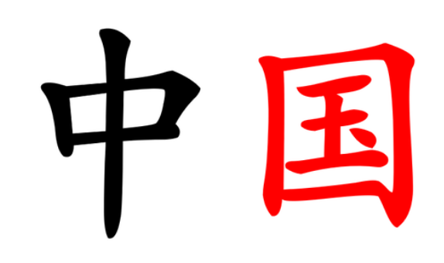
Priloga 2:
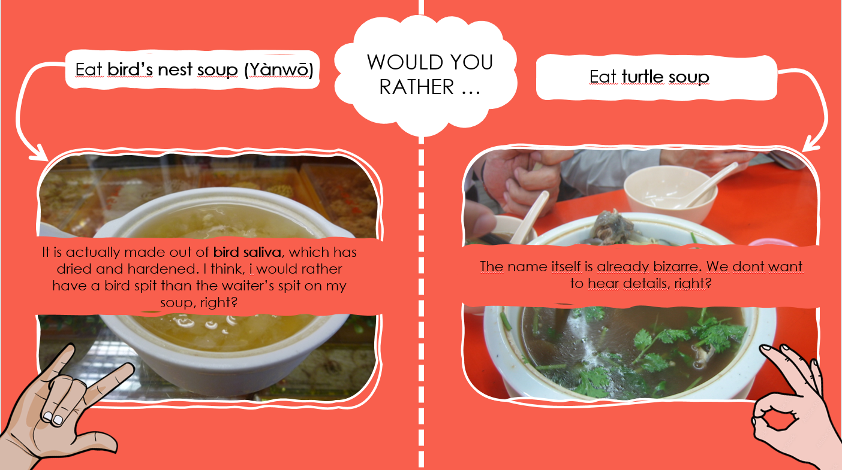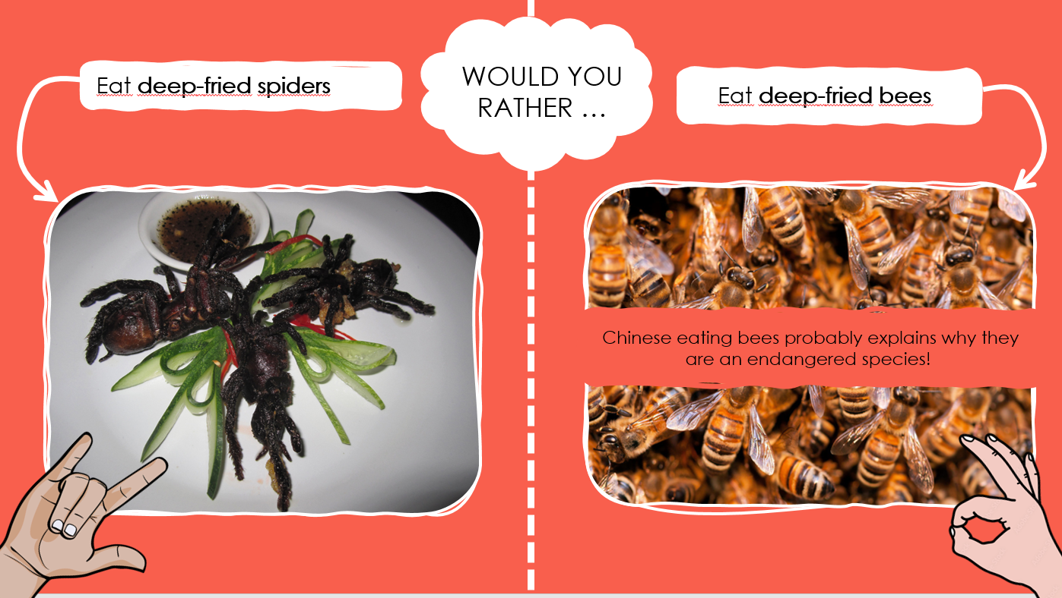
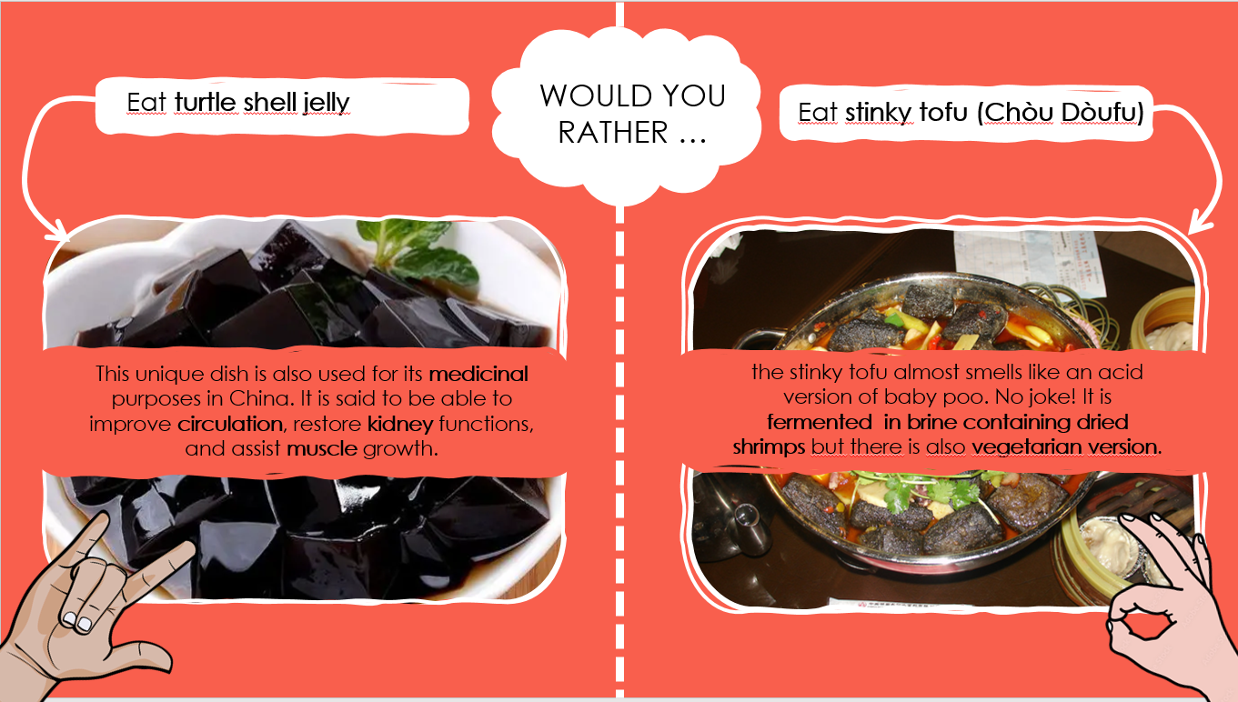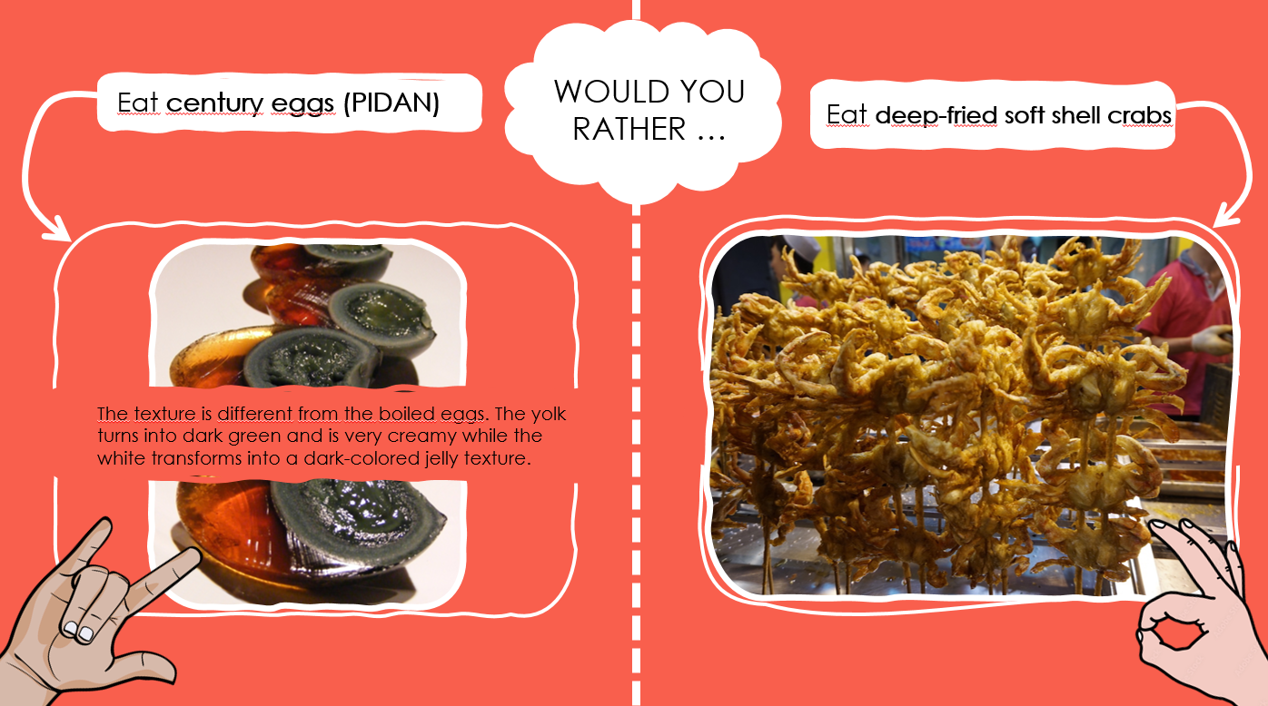
Priloga 3:
GROUP 1:
ROLE PLAY situation:
Members: father, mother, granddad, son, daughter (there can be more/less sons or daughters).
Pretend to be members of a Chinese family eating a meal at home. All the food is on the table. First granddad is seated and he first makes the toast and when he says “let's eat”, all members can start eating. Members who eat from their bowl, hold it with their thumb on the mouth of the bowl, first finger, middle finger the third finger supporting the bottom of the bowl and palm empty. Father is not holding his bowl in his hand. He bends over the table and eats facing his bowl. Mother wants more food, so she takes food first from the plates in front of her. Son/daughter starts to use their phone. He/she starts to text and scroll through social media.

GROUP 2:
ROLE PLAY situation:
Members: father, mother, granddad, son, daughter (there can be more/less sons or daughters).
Pretend to be members of a Chinese family eating a meal at home. All the food is on the table. First granddad is seated and just as he starts to make the toast one of the kids just puts the food on his plate and starts eating. Members who eat from their bowl, hold it with their thumb on the mouth of the bowl, first finger, middle finger the third finger supporting the bottom of the bowl and palm empty. Dad wants more food and he sees some food he would like on the other side of the table. He bends over all the food and grabs some food far away from where he is seated.

GROUP 3:
ROLE PLAY situation:
Members: father, mother, granddad, son, daughter (there can be more/less sons or daughters).
Pretend to be members of a Chinese family eating a meal at home. All the food is on the table. First granddad is seated and he first makes the toast and when he says “let's eat”, all members can start eating. Members who eat from their bowl, hold it with their thumb on the mouth of the bowl, first finger, middle finger the third finger supporting the bottom of the bowl and palm empty. Daughter has a hard time eating the meat so she stands up, goes to the kitchen and brings a knife back to the table. She uses the knife to cut the meat. Mother wants more food, so she takes food first from the plates in front of her. Granddad adds food to his grandson's bowl, and he has an angry look on his face and says “Why did you do that!?” with an angry voice.

GROUP 4:
ROLE PLAY situation:
Members: father, mother, granddad, son, daughter (there can be more/less sons or daughters).
Pretend to be members of a Chinese family eating a meal at home. All the food is on the table. First granddad is seated and he first makes the toast and when he says “let's eat”, all members can start eating. The daughter takes her chopsticks and stabs the food with them and brings the food into her mouth. Members who eat from their bowl, hold it with their thumb on the mouth of the bowl, first finger, middle finger the third finger supporting the bottom of the bowl and palm empty. Son wants more food, so he takes food first from the plates in front of him. Father keeps his eyes glued to the plate and he uses his chopsticks to dig through the food as he was "digging for treasure".

GROUP 5:
ROLE PLAY situation:
Members: father, mother, granddad, son, daughter (there can be more/less sons or daughters).
Pretend to be members of a Chinese family eating a meal at home. All the food is on the table. Mother says that the food is ready so they can come to the table. As she does so, she seats first and eats a little bit while waiting for others to come to the table. Granddad makes the toast and then says “let's eat”. Members who eat from their bowl, hold it with their thumb on the mouth of the bowl, first finger, middle finger the third finger supporting the bottom of the bowl and palm empty. Son wants more food, so he takes food first from the plates in front of him. Granddad excuses himself, he has to go to the toilet. He sticks chopsticks vertically into rice.

GROUP 6:
ROLE PLAY situation:
Members: father, mother, granddad, son, daughter (there can be more/less sons or daughters).
Pretend to be members of a Chinese family eating a meal at home. All the food is on the table. First granddad is seated and he first makes the toast and when he says “let's eat”, all members can start eating. Members who eat from their bowl, hold it with their thumb on the mouth of the bowl, first finger, middle finger the third finger supporting the bottom of the bowl and palm empty. Daughter starts to play with her chopsticks, she spins them around and waves her chopsticks around in the air.Father wants more food, so he takes food first from the plates in front of him. The son is a little bit bored so he pulls his phone out of his pocket and when he finds a funny video, he shares it with his sister. They watch the video and laugh loudly while the others are eating.

