

Univerza v Ljubljani
Pedagoška fakulteta
Magistrski študij Poučevanje
Likovna pedagogika
1. letnik

Japan

Project work file
Authors: Jerca Rogelj, Lovro Pinter

Ljubljana, May 2023

Vsebina
Introduction 3
A collection of activities 3
Activity description Folding a Crane 4
Activity description: Recognize the sport. 7
Activity description: The legend about Masamune and Muramasa. 9
Presentation 11
Lesson Plan: Revision of irregular verbs through the introduction of Japanese culture 22

Introduction

Greetings, Jerca and Lovro here.

We hope you find this work file based on Japan and its culture interesting. The presentation was mostly revolving around our hobbies in connection with Japan, Jerca’s being Ken-dou, Lovro’s being Manga and everything concerning it. While hobbies were our main point of connection, more general things were indeed added to make the topic more easily approachable to an average reader/listener. While designing this presentation we divided our roles based on experience, Lovro taking care of general cultural information, since he visited Japan before, for a longer period, while Jerca taking care of more practical things like designing most of the activities. Since the topic of Japan is so wide, we did have some trouble watering it down, especially our hobbies, since each is a rabbit hole, with its many rules and intricacies, one can wander into and not come out of it for years. All in all though we think the presentation was well received and again, we hope you gain something useful out of this topic as well.

A collection of activities

- Kahoot quiz: What do you already know about Japan?
https://create.kahoot.it/share/what-do-you-know-about-japan/e555b63d-251a-4449-97b6-118f5476b6a2
- Kendo presentation videos:

https://www.youtube.com/watch?v=Cb13DKpDd_k
https://www.youtube.com/watch?v=KpjWDUp-5yc

- Recognize the sport.

Then the students must match each sport with the picture that shows it.

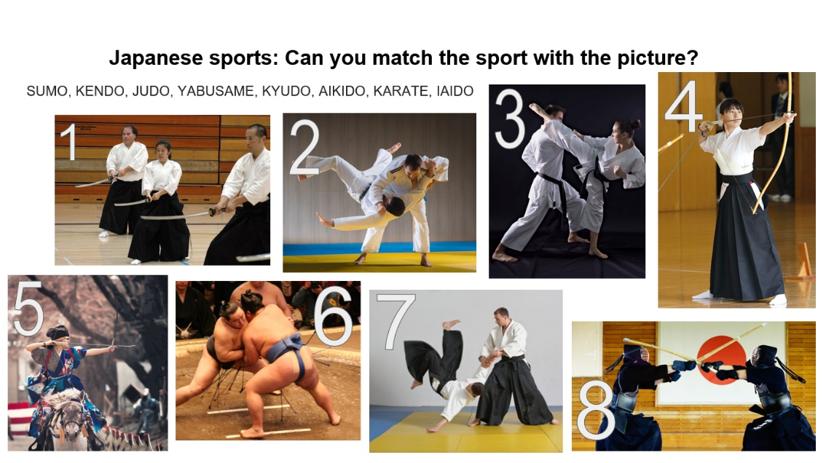

- The Legend of Masamune and Muramasa.
A legend tells of a test where Muramasa challenged his master, Masamune, to see who could make a finer sword. They both worked tirelessly, and when both swords were finished, they decided to test the results. The contest was for each to suspend the blades in a river with the cutting edge facing against the current. Muramasa's sword, the Juuchi Yosamu (十千夜寒, "10,000 Cold Nights") cut everything that passed its way; fish, leaves floating down the river, the very air which blew on it.
Highly impressed with his pupil's work, Masamune lowered his sword, the Yawarakai-Te (柔らかい手, "Tender Hands"), into the current and waited patiently. The blade cut no leaf that passed. The fish swam all around it. The air whistled passed it. Muramasa laughed and mocked Masamune for creating a sword that could cut nothing. Despite Muramasa's mocking, Masamune grabbed the hilt and gently pulled the blade out of the water, wiped it off, and sheathed it.
While Murasama was still laughing and mocking Masamune for his lack of swordsmithing skill and for creating such a poor katana, a monk walked over. The monk explained that he had watched the whole contest carefully. He bowed and humbly explained what he had seen. The first of the swords was by all accounts a fine sword, however, it is a blood-thirsty, evil blade, as it does not discriminate as to who or what it will cut. It may just as well be cutting down butterflies as severing heads. The second was by far the finer of the two, as it does not needlessly cut that which is innocent and undeserving.
- The legend of the crane origami.

Sadako and the Thousand Paper Cranes is a children's historical novel written by Canadian-American author Eleanor Coerr and published in 1977. It is based on the story of Sadako Sasaki.

After being diagnosed with leukemia from radiation caused by the atomic bombing of Hiroshima, Sadako's friend told her to fold origami paper cranes (orizuru) in hope of making a thousand of them. She was inspired to do so by the Japanese legend that one who created a thousand origami cranes would be granted a wish. Her wish was simply to live through her disease so she could fulfill her dream of being on the running team. In this retelling of her story, she managed to fold only 644 cranes before she became too weak to fold any more, and died in her sleep on the morning of October 25, 1955, knowing her family will always be there. Her friends and family helped finish her dream by folding the rest of the cranes, which were buried with Sadako.

- Create your own cane origami.
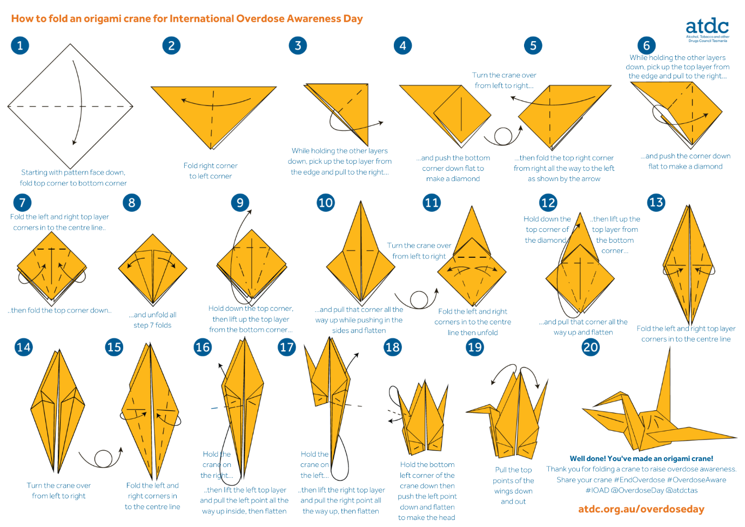

Activity description Folding a Crane

Name of the activity: Folding a crane origami
Aim of the activity:
- To practice basic vocabulary in format orientation
- to learn about Japanese culture
- to develop aesthetic appreciation
- develop patience, fine motor skills.
Age of learners: 8-10
Approximate length of the activity: 15 to 20 minutes, much faster for higher classes
Description of the activity: The activity can be performed as a group activity (everyone folding their own crane following the steps in the same pace), especially appropriate for lower classes from 2 to 5 grade, the teacher can read the instructions and guide the students to fold the crane properly. For older students this can be an individual exercise, each students receives his or hers own set of instructions to read. Mixed variations are also possible: each students reads one step and explains it to others.
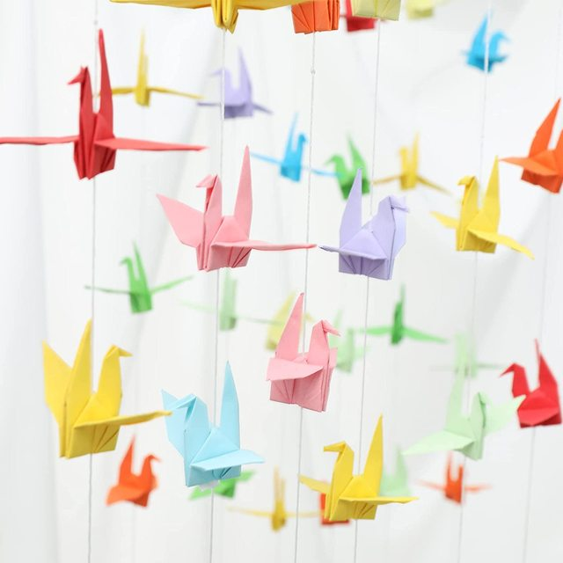
Language level of learners: A1
Skills practised (listening/speaking/reading/writing): Listening/reading.
Vocabulary practised: Format orientation keywords (Left/right/side …)
Materials needed: Origami paper.
Cross – curricular links:
FREPA/CARAP descriptors: (see pages 24 to 59 of the FREPA document https://www.ecml.at/Portals/1/documents/ECML-resources/CARAP-EN.pdf?ver=2018-03-20-120658-443
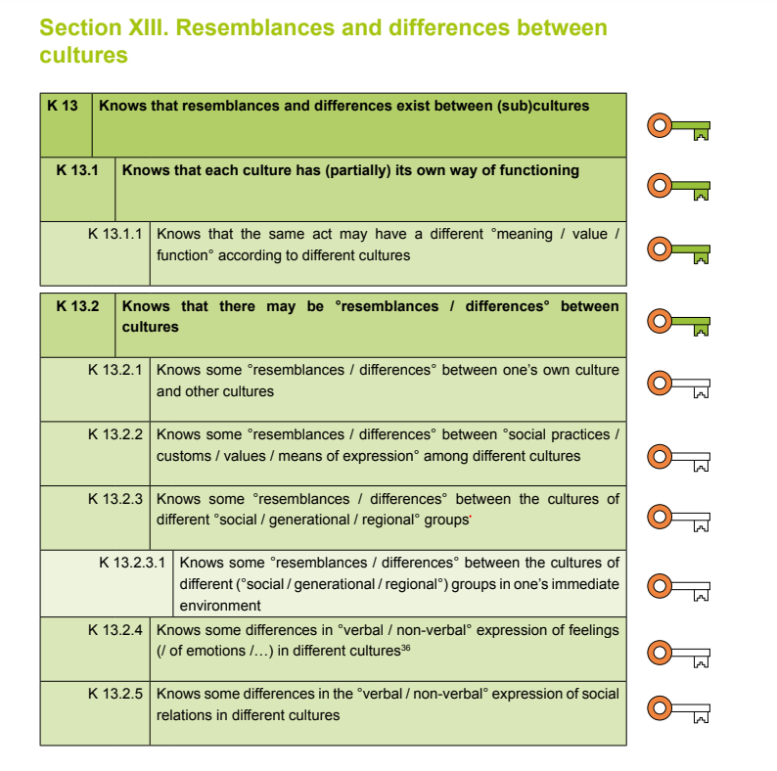
How the activity develops intercultural awareness: Through the activity the students experience the patience and focus Japanese people put in everything they know and therefore develop respect for small, simple thins and hard work.
Classroom organisation (group work, pair work, whole class …): individual or group
Possible pre- and post- activities: This activity should be a part of a larger cultural presentation, where we discuss the Japanese culture, the virtues they respect in their daily life (patience, respect, precision), their traditions, beliefs. + we present the story of 1000 cranes and what that signifies in Japanese.
Variations (if there are any): - above-
Seeking sea
Additional notes (if applicable):

Activity description: Recognize the sport.

Name of the activity: Recognize the sport.
Aim of the activity: The students get to know Japanese culture through sports and train their listening skills.
Age of learners: 4-6 grade
Approximate length of the activity: 10 minutes
Description of the activity: The teacher describes each Japanese sport separately and explains its distinctions. In the process we explain unknown words if there are any. Then the students must match each sport with the picture that shows it. In the end we can debate which sport they find most interesting and would possibly train.
Language level of learners: A1- A2
Skills practiced (listening/speaking/reading/writing): listening
Vocabulary practiced: martial arts, hand to hand combat, weapon, armor, punch, kick, throw, sword, push…
Materials needed: pictures/ writing templates (in additional notes)
Cross – curricular links: Sport/ PE
FREPA/CARAP descriptors: (see pages 24 to 59 of the FREPA document https://www.ecml.at/Portals/1/documents/ECML-resources/CARAP-EN.pdf?ver=2018-03-20-120658-443
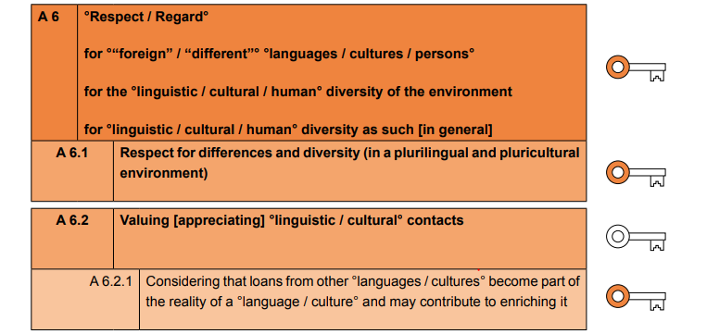
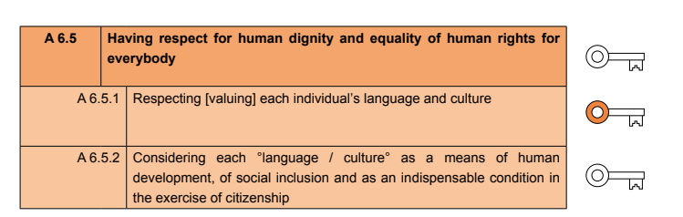
How the activity develops intercultural awareness: The students get to know foreign sports and gain awareness that many of those are known internationally and practiced in Europe. That the Japanese culture is already integrated all over the world.
Classroom organization (group work, pair work, whole class …): individual
Possible pre- and post- activities: Additional conversation about student’s interests (described above). Possible presentation of individual sports by practitioners.
Variations (if there are any): /
Additional notes (if applicable):
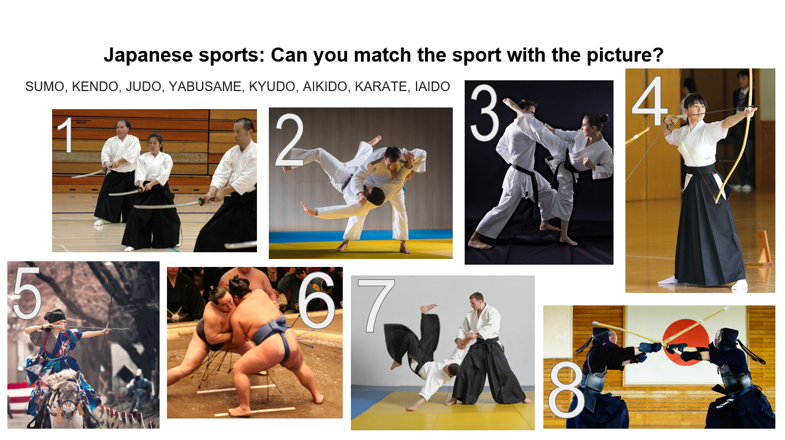

Picture number
- SUMO

- KENDO

- JUDO

- YABUSAME

- KYUDO

- AIKIDO

- KARATE

- IAIDO

Activity description: The legend about Masamune and Muramasa.

Name of the activity: The legend about Masamune and Muramasa.
Aim of the activity: The students get to know some values of Japanese culture through a traditional Japanese story. The students think about what is right and wrong when retaining the message of the story. +Develop creativity and their internal moral compass while creating their own “local” legend.
Age of learners: 6 - 9 grade.
Approximate length of the activity: 10 minutes + 30 minutes (creative part in groups)
Description of the activity: We present the Legend of Masamune and Muramasa, discus the values of the story, and encourage the students t o create their own “local” legend that would reflect the same value. The students in the process of writing the story create their own poster that depicts the continuation of the story in writing and pictures,
Language level of learners: A2 – B1
Skills practised (listening/speaking/reading/writing): listening, writing.
Vocabulary practised: Tense practice, Narrating a story – storytelling expressions.
Materials needed: (props for the play), poster paper, writing and drawing equipment.
Cross – curricular links: possibly Drama with few alterations
FREPA/CARAP descriptors: (see pages 24 to 59 of the FREPA document https://www.ecml.at/Portals/1/documents/ECML-resources/CARAP-EN.pdf?ver=2018-03-20-120658-443
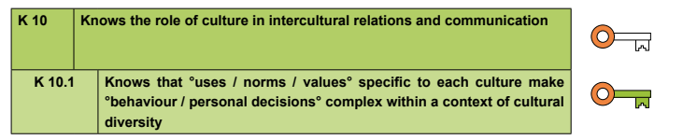
How the activity develops intercultural awareness: It encourages the student so think about the values their culture has and where are they represented (in behaviour, honorific titles…). The students acknowledge their cultural heritage and their role in it.
Classroom organisation (group work, pair work, whole class …): Group work
Possible pre- and post- activities: Debate about different cultural values.
Variations (if there are any): For younger students that are not jet so skilled in listening, we should while telling the story use a lot of body language and/ or props. It is possible also to present it as a play.
Additional notes (if applicable):

The Legend of Masamune and Muramasa.
A legend tells of a test where Muramasa challenged his master, Masamune, to see who could make a finer sword. They both worked tirelessly, and when both swords were finished, they decided to test the results. The contest was for each to suspend the blades in a river with the cutting edge facing against the current. Muramasa's sword, the Juuchi Yosamu (十千夜寒, "10,000 Cold Nights") cut everything that passed its way; fish, leaves floating down the river, the very air which blew on it.
Highly impressed with his pupil's work, Masamune lowered his sword, the Yawarakai-Te (柔らかい手, "Tender Hands"), into the current and waited patiently. The blade cut no leaf that passed. The fish swam all around it. The air whistled passed it. Muramasa laughed and mocked Masamune for creating a sword that could cut nothing. Despite Muramasa's mocking, Masamune grabbed the hilt and gently pulled the blade out of the water, wiped it off, and sheathed it.
While Murasama was still laughing and mocking Masamune for his lack of swordsmithing skill and for creating such a poor katana, a monk walked over. The monk explained that he had watched the whole contest carefully. He bowed and humbly explained what he had seen. The first of the swords was by all accounts a fine sword, however, it is a blood-thirsty, evil blade, as it does not discriminate as to who or what it will cut. It may just as well be cutting down butterflies as severing heads. The second was by far the finer of the two, as it does not needlessly cut that which is innocent and undeserving.

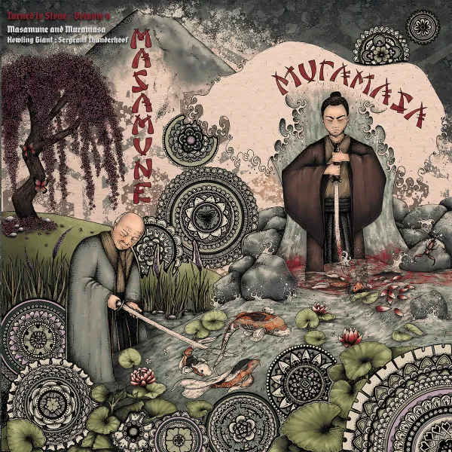

Presentation

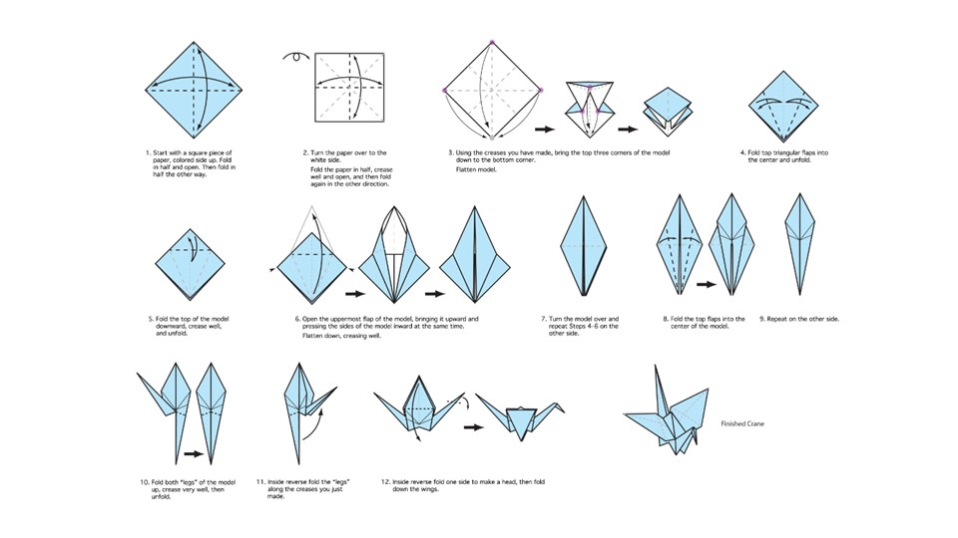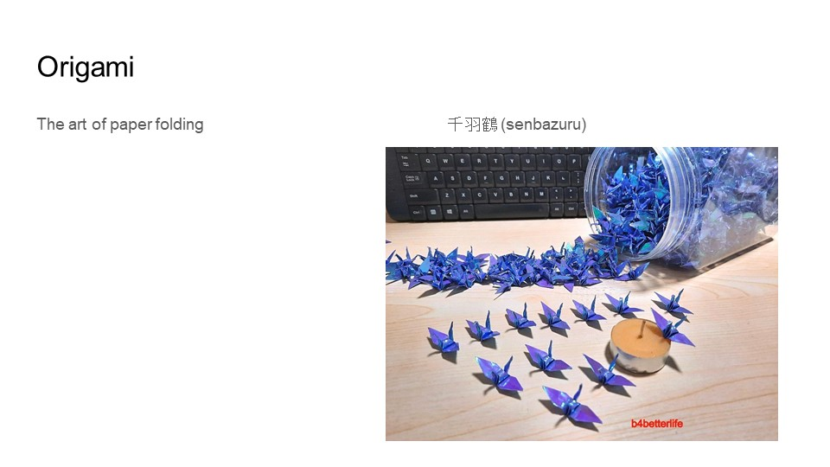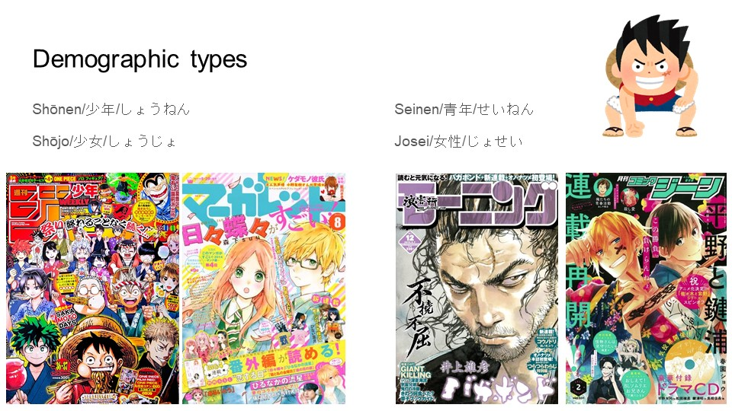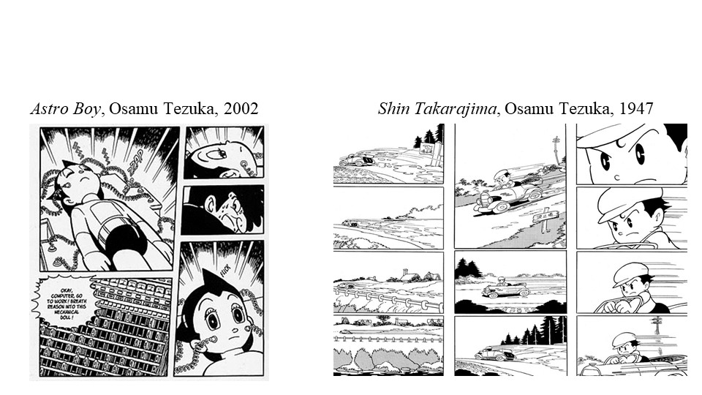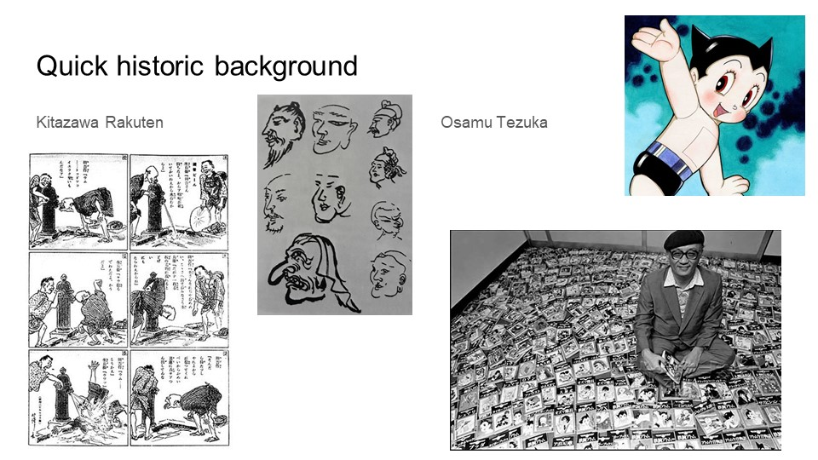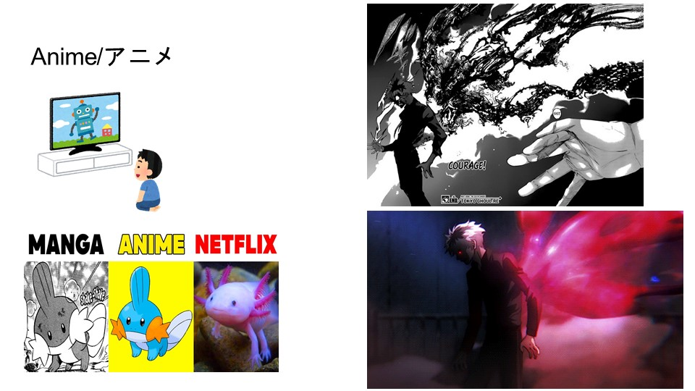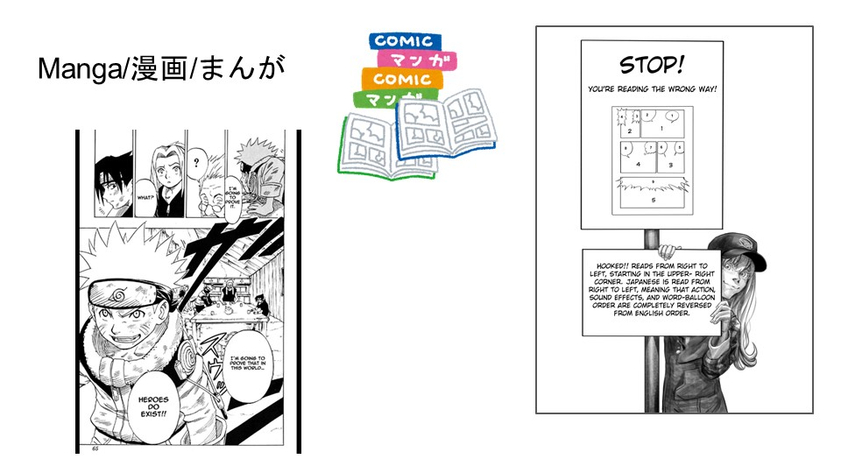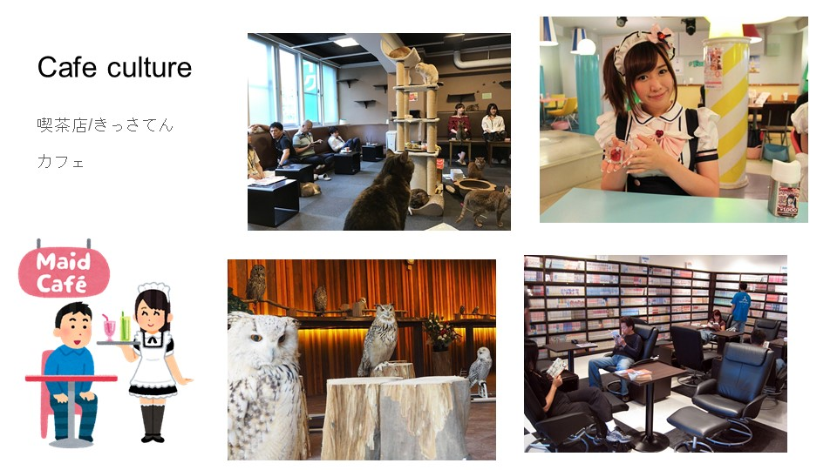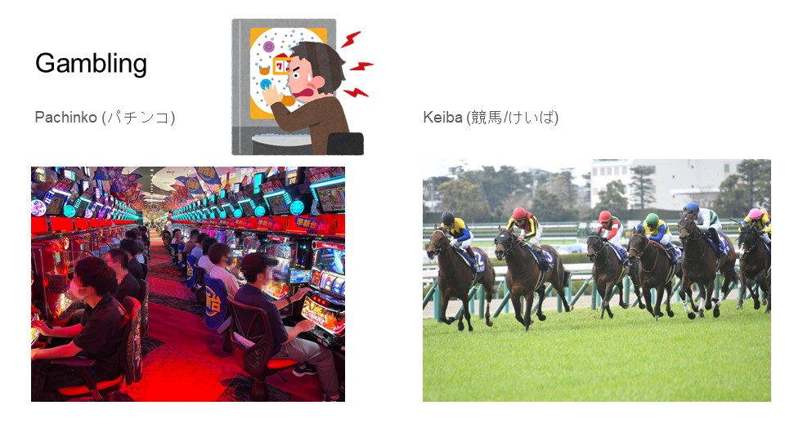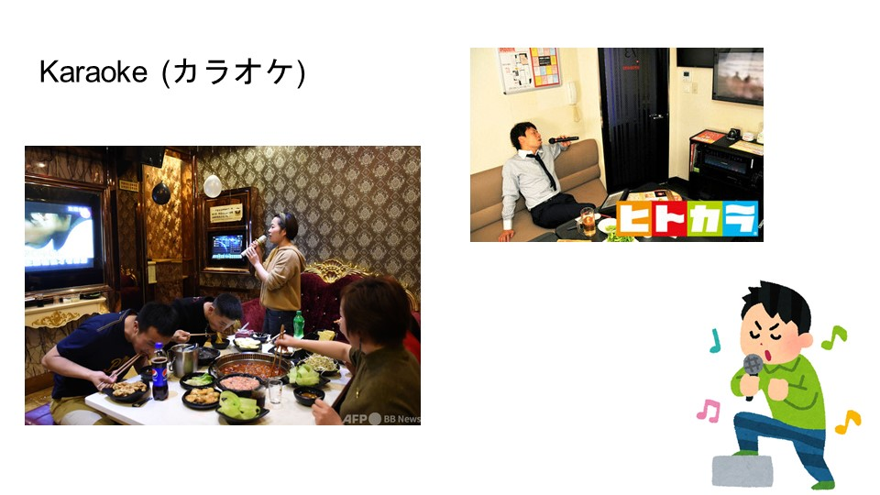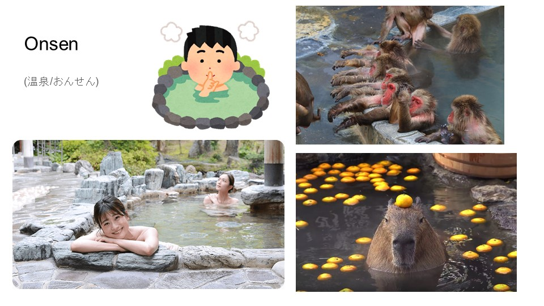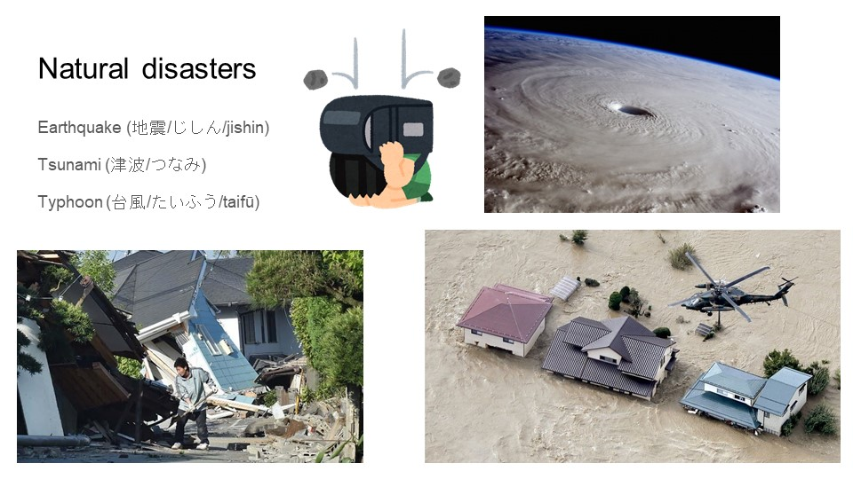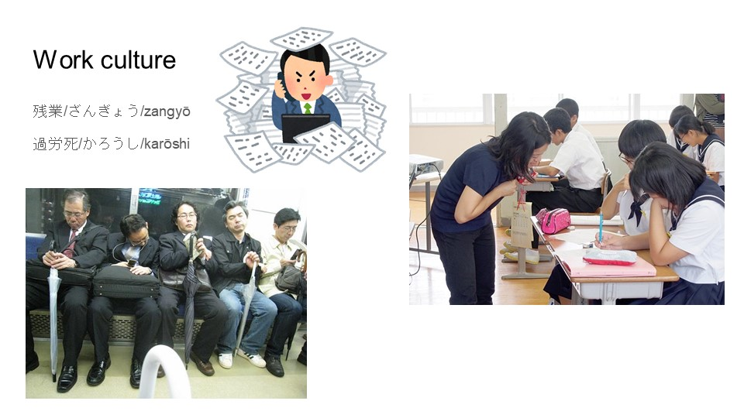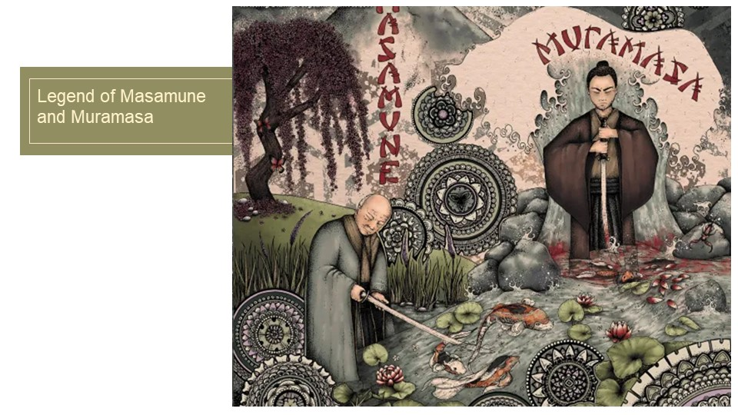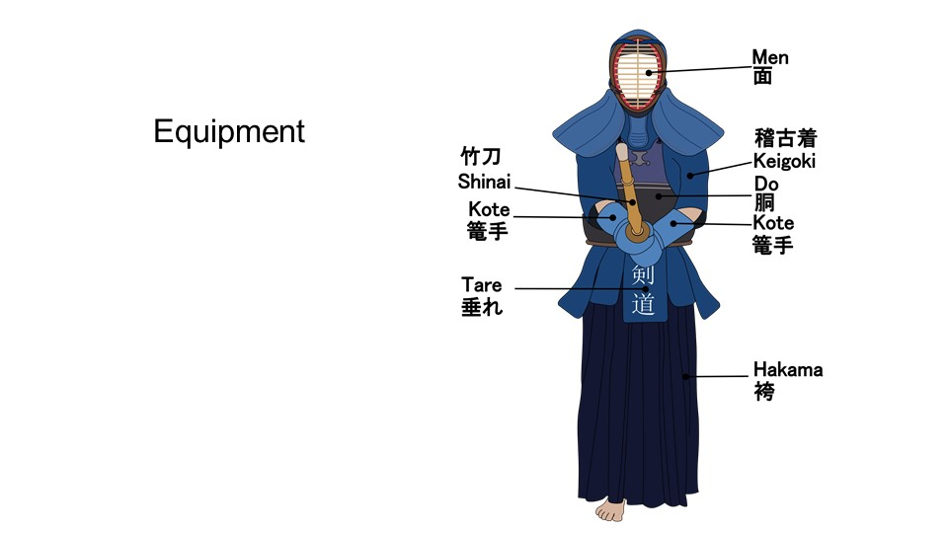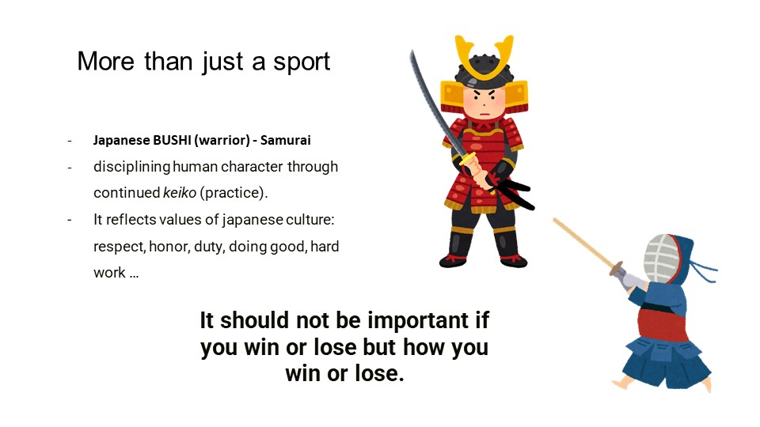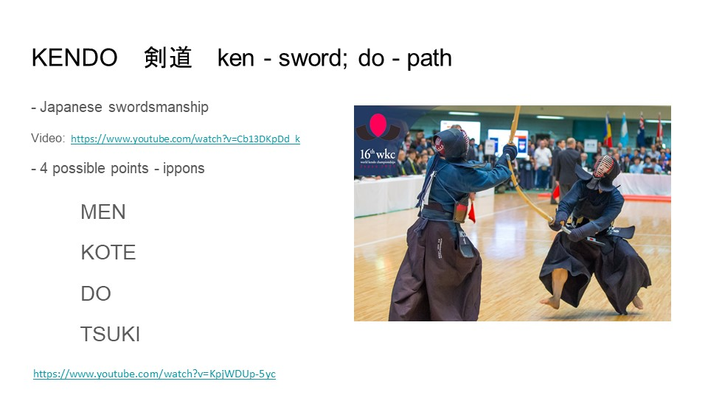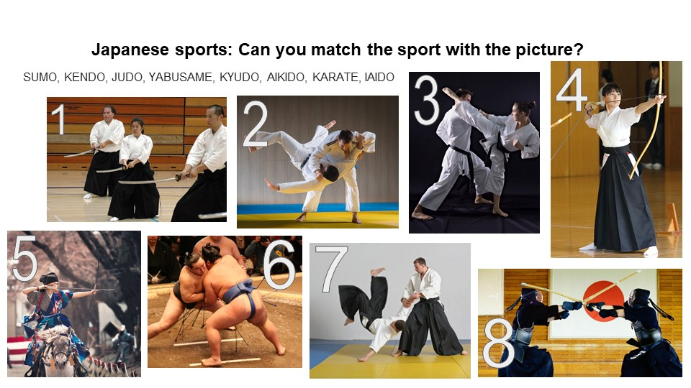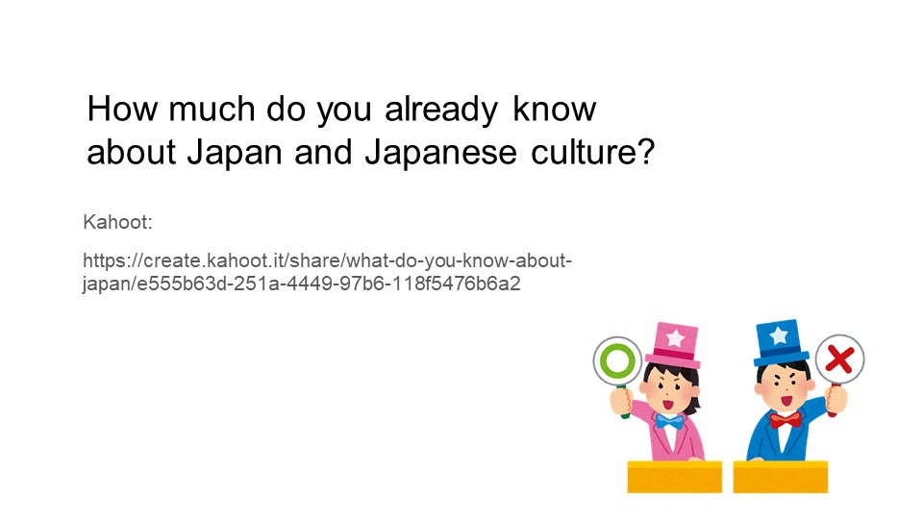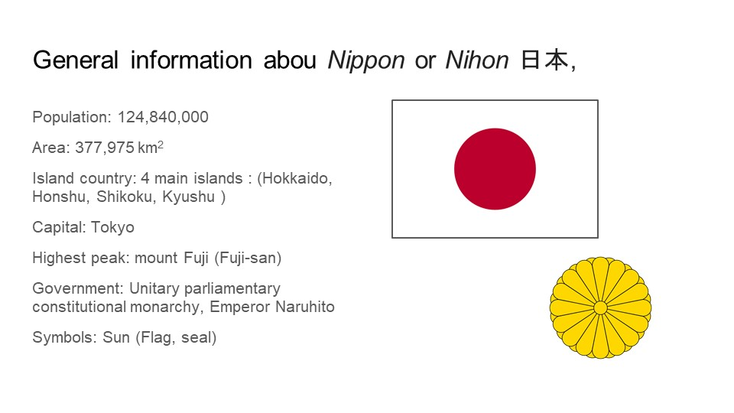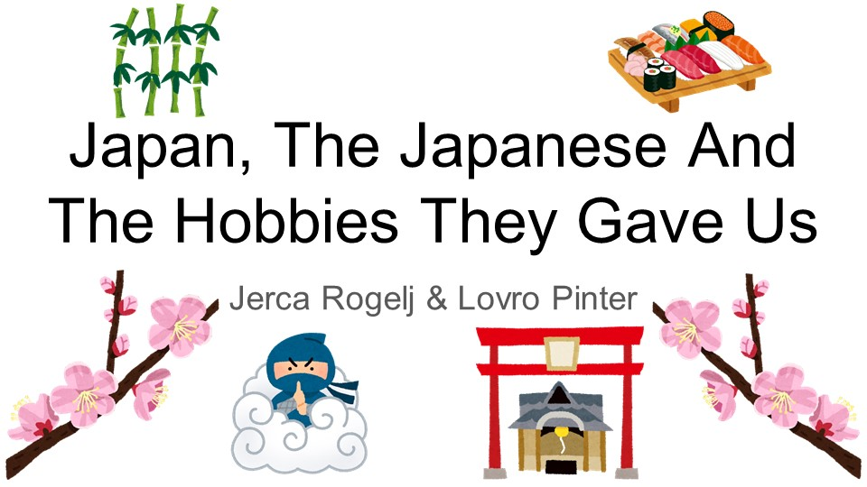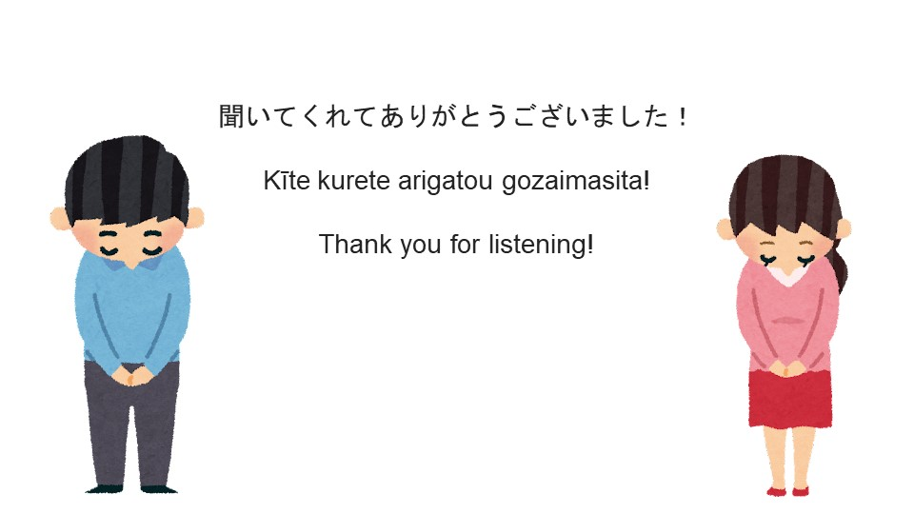

Lesson Plan: Revision of irregular verbs through the introduction of Japanese culture

DOCUMENT TRACKING:
Lesson Plan Ref: | / Revision of irregular verbs through the introduction of Japanese culture
Author: | Jerca Rogelj, Lovro Pinter
Date created: | 27. 4. 2023
Date last amended: | /
Amended by: | /
Reason for amendment: | /

PROFILE:
Audience: | 7. grade
Level: | A2
Duration: | 2 school hours
Skills: | Listening Speaking Reading Writing
Description: | Revision of irregular verbs through the introduction of Japanese culture
Target Language: | Vocabulary connected to Japanese sports, daily activities, geography, storytelling, free time activities, workplace.
Grammar: | Revision of irregular verbs:  Specifically: Be, Begin, Build, Choose, Drink, Forbid, Go, Have, Pay, Read, Sing, Sleep, Spend, Swim, Wrote, Beat, Blow, Draw, Fall, Fight, Fit, Lose, Quit, Ride, Run, Shoot, Stand, Strike, Sweep, Swing, Teach, Win, Withdraw  Practicing writing in past simple tense + present simple.

PROCEDURE:
Revision of irregular verbs through the introduction of Japanese culture

Part one: About Japan

We present the class with a challenge. We will tell them several interesting facts about Japan formed in sentences, they must listen attentively and remember as many as they can, without writing them down.

Examples:

- Despite Onsen being a bathing house, it isn’t allowed to swim within the pools.

- Manga is drawn in black and white, due to cost efficiency, since printing in color would make it more expensive.

- The houses in Japan are built in a way that makes their building blocks “move”, so that they wouldn’t collapse during an earthquake.

Conversation: We talk with students about the statements they remember, and what they found surprising etc.

Group activity: circle the irregular verbs in red and the regular in white.

We ask them if they can remember the verbs used in the sentences. We write town all verbs used even the ones the students couldn’t remember.
We give them two different colored chalks and employ them circle out the irregular verbs in one color and the regular with other. Each student circles one verb. When everyone had their turn, we ask the whole class if they want to make any changes.

Irregular verbs in this exercise: Be, Begin, Build, Choose, Drink, Forbid, Go, Have, Pay, Read, Sing, Sleep, Spend, Swim, Wrote

Individual activity: Fill in the panda.

Write both missing verbs for past simple and past perfect for the irregular verbs we discovered in our sentences about Japan.

To make it more fun, the students must write them inside the panda shapes that they receive.

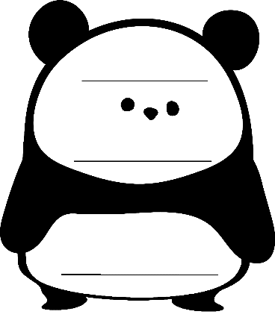

Part two: Sports

We look at some pictures of Japanese traditional sports, where the students listen to the description of each sport, and afterwards they must connect the correct picture with the name of the right sport. (See the described activity Recognize the sport).

Individual activity: Match the correct name.

Picture number
- SUMO

- KENDO

- JUDO

- YABUSAME

- KYUDO

- AIKIDO

- KARATE

- IAIDO

Group activity: Bingo of verbs

After the sports presentation, we would group students in pairs and hand them out bingo sheets with irregular verbs written on them, from which they should then pick out 6 of those that they think were used during the presentation. They should cut circle them out with a colored pencil, to avoid cheating. We would then call out these verbs in their conjugated forms, of which the students should then find their normal forms on the sheet and color them (if they circled them). The students that colors them all get a bingo. The teacher reads all the used verbs in their conjectured form and non-other. The verbs that were used in the description of sports – the winning bingo sheets: Beat, Blow, Draw, Fall, Fight, Fit, Lose, Quit, Ride, Run, Shoot, Stand, Strike, Sweep, Swing, Teach, Win, Withdraw

Group activity: Matching trios

We prepare trios of used irregular verbs for students. In groups they must find the matching trios.

Homework:

The final task would be creating their own legend, based on the information they gained throughout the lesson. In the legend one must use at least 3 irregular verbs. A table of verbs would be present as a helping aid. The legends should be short, from 3 to 5 sentences.

