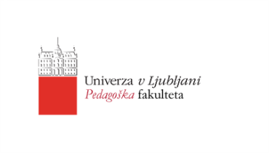
University of Ljubljana
Faculty of Education

PROJECT WORK FILE
(Language and intercultural awareness)

Manca Oblak and Barbara Železnik,
1st year of master’s studies
Academic year 2022/23

Ljubljana, March 2023
TABLE OF CONTENTS
1. Introduction 3
2. Presentation 3
3. Activities 8
THE FIRST ACTIVITY: True or false 8
THE SECOND ACTIVITY: The smallest countries in the world 9
THE THIRD ACTIVITY: The odd one out 9
THE FOURTH ACTIVITY: Maltese cuisine 10
THE FIFTH ACTIVITY: Let's learn some Maltese words 10
4. Activities for children 11
THE FIRST ACTIVITY 11
THE SECOND ACTIVITY 13
5. Lesson plan 16
PRILOGE 22

INTRODUCTION
Malta is an archipelago in the Mediterranean Sea. It is a European country located between Italy on the north and Libya on the south. Because of its position it was ruled by many different countries in the past. That resulted in coexistence of different cultures, languages and values in Malta. They internalized how to accept, respect and look at the intercultural differences in a positive way. Maltese people have two official languages, Maltese and English. Many of them are also fluent in Italian language.
Understanding Malta as an intercultural and multilingual country contributed to choosing it as a topic of our presentation. The cultural diversity was also evident when we travelled there in 2019. We were not amazed only by the sights but also by the hospitality and
open-mindness of the locals.

PRESENTATION
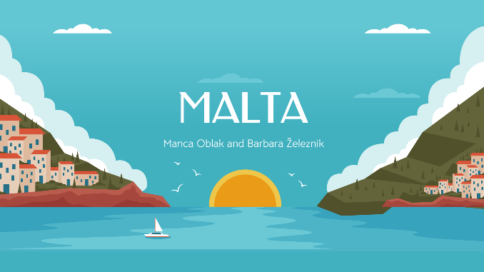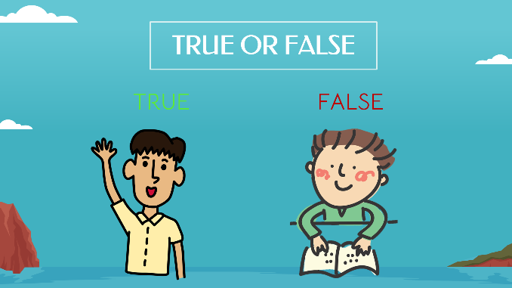
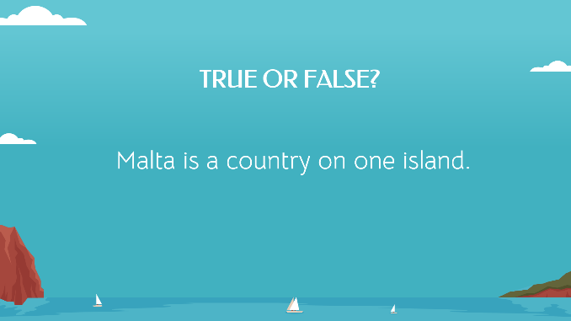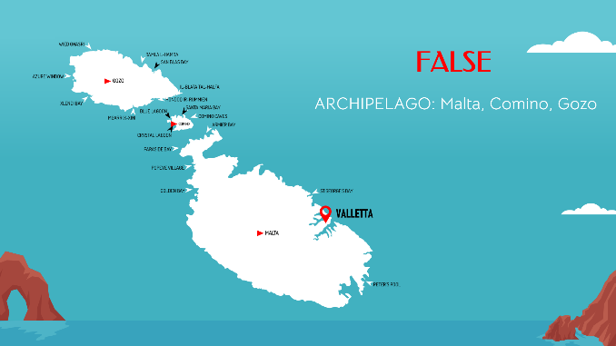
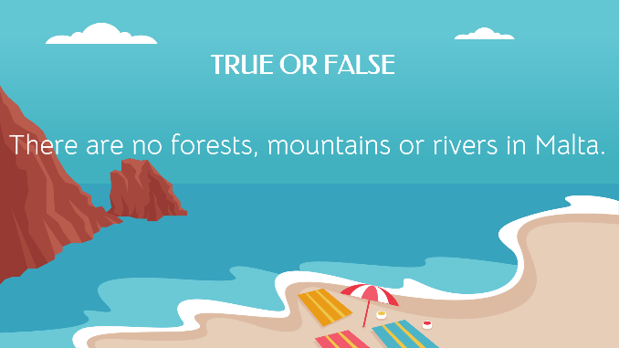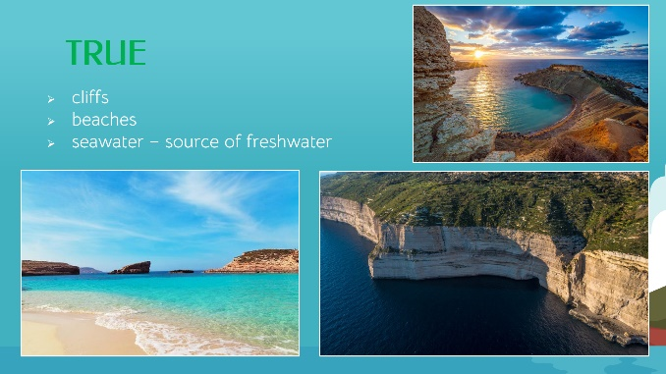
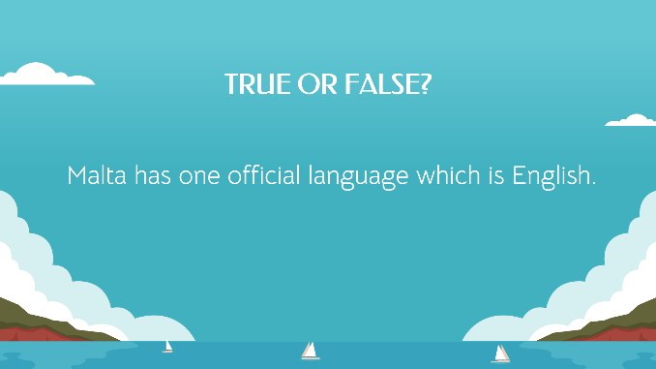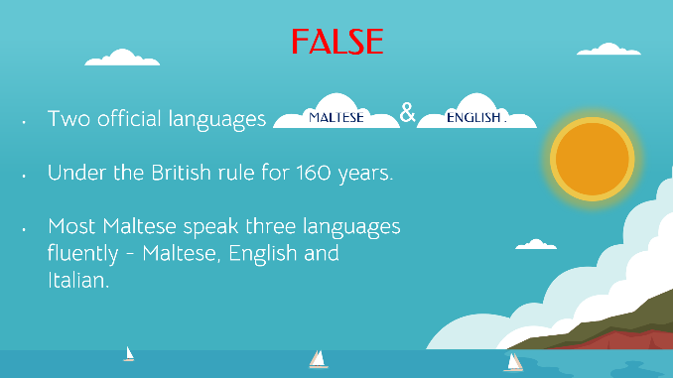
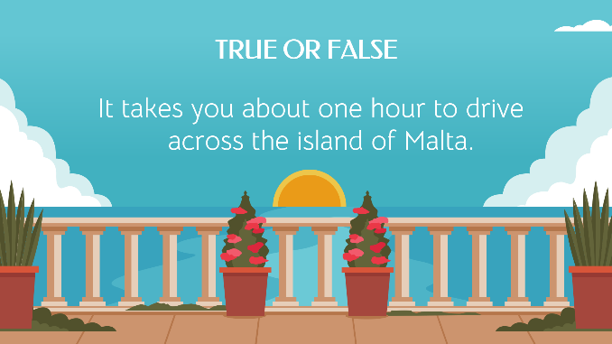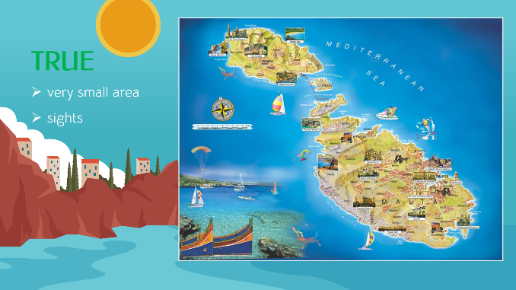
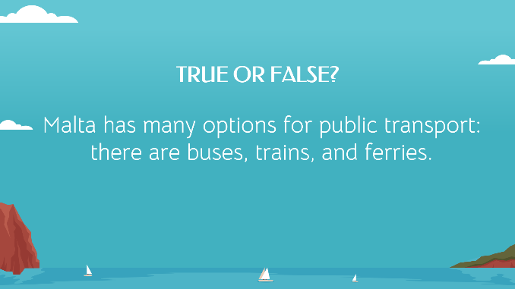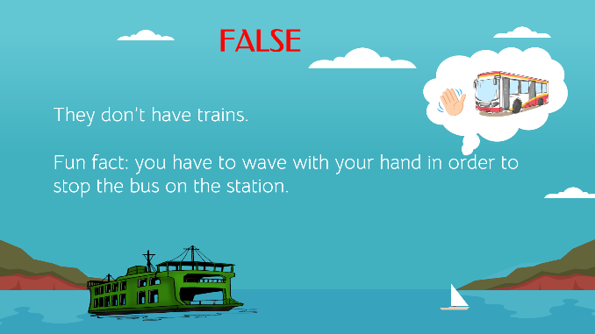
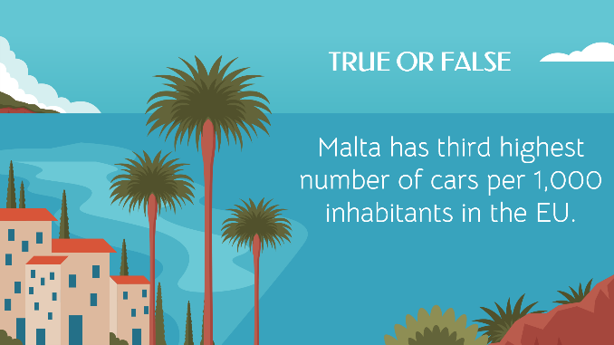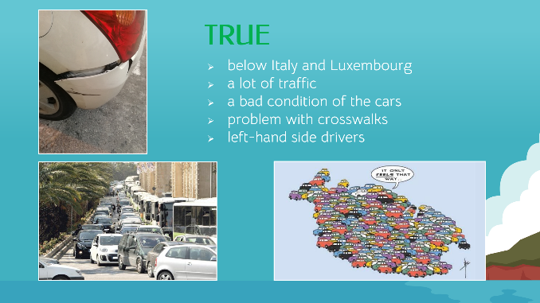
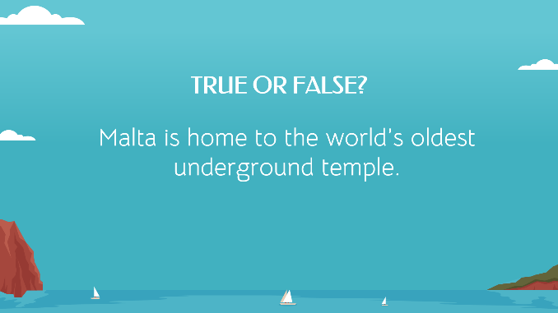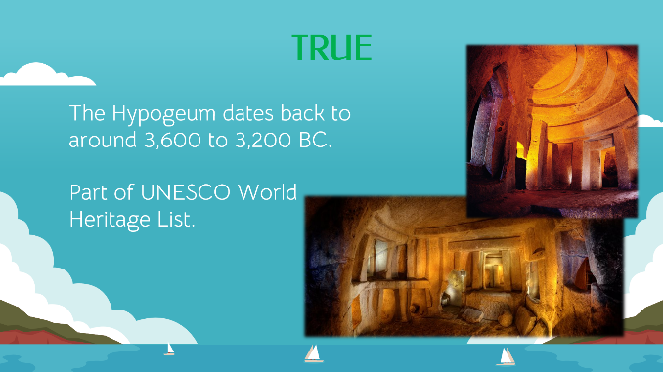
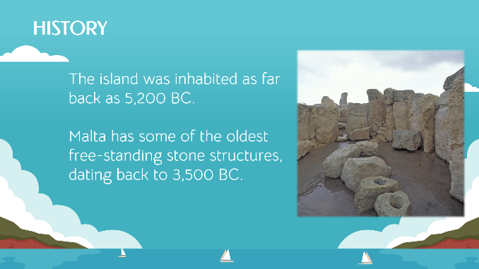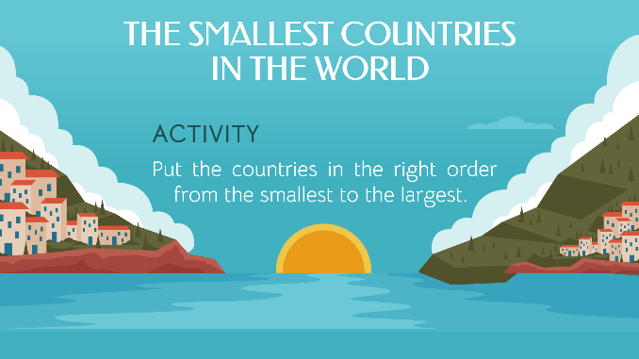
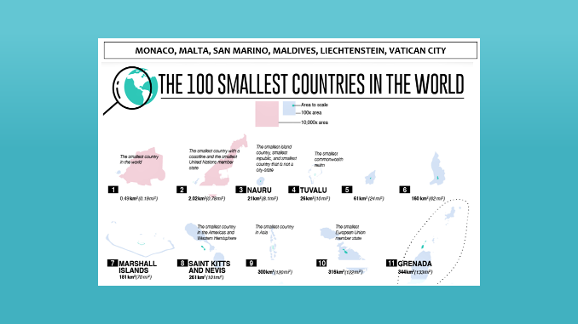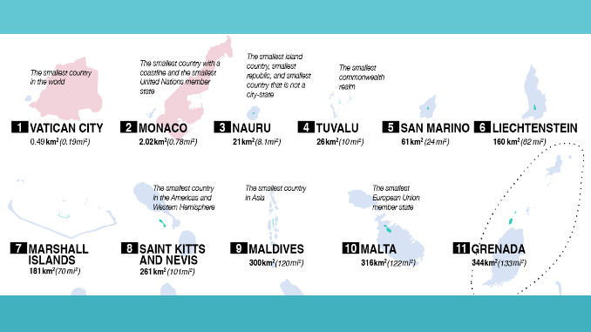
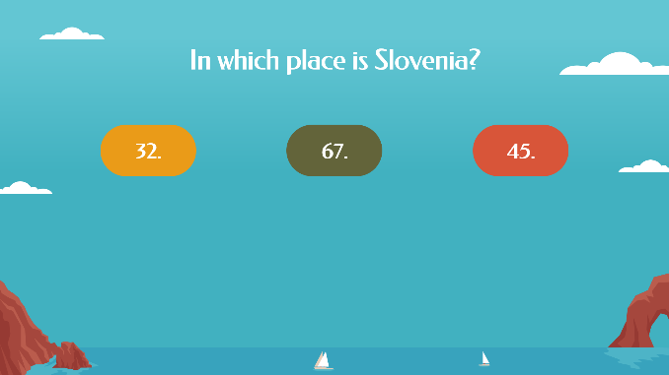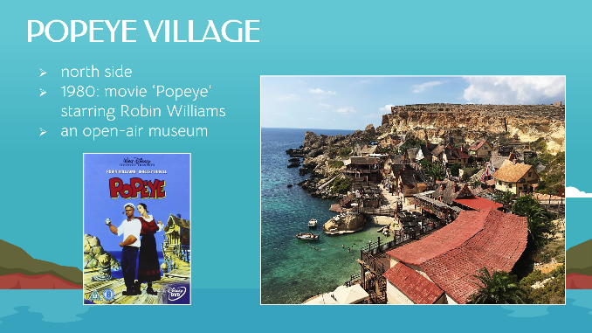
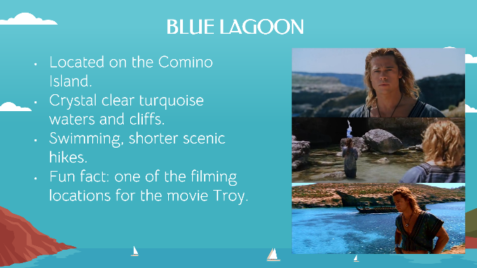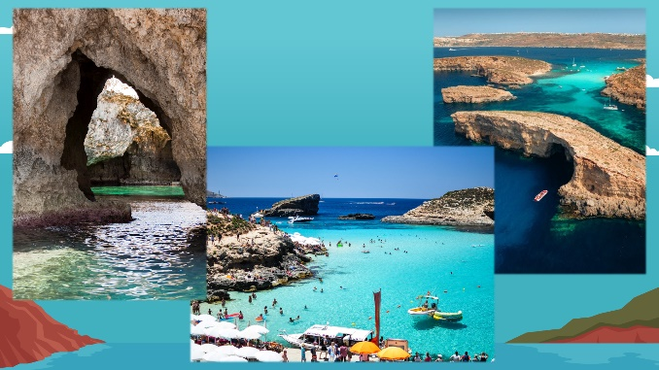
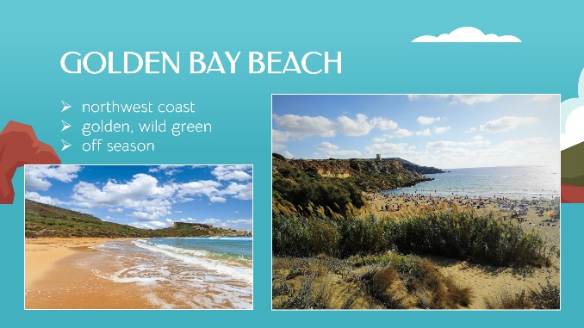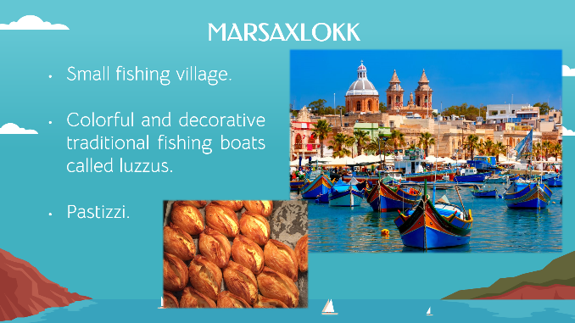
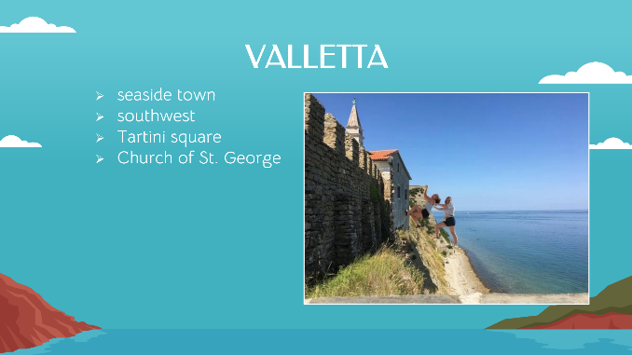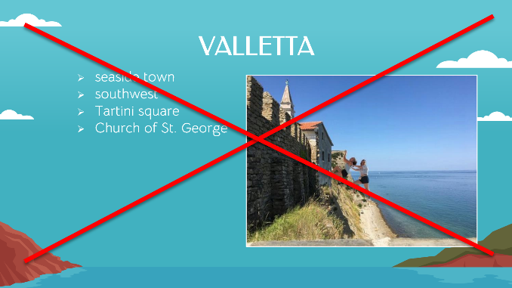
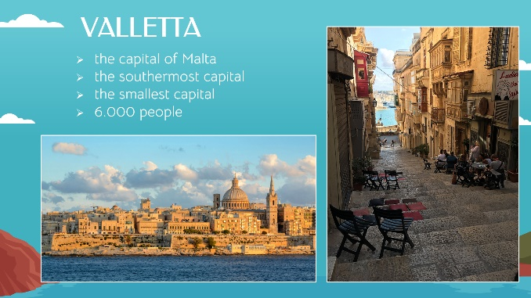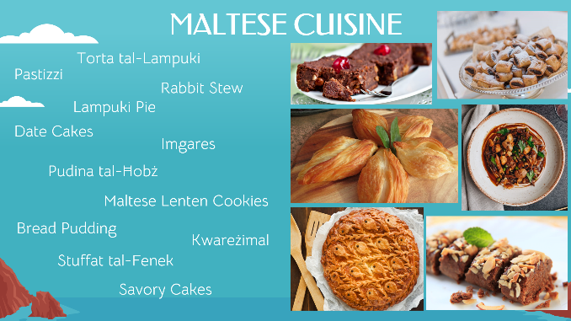
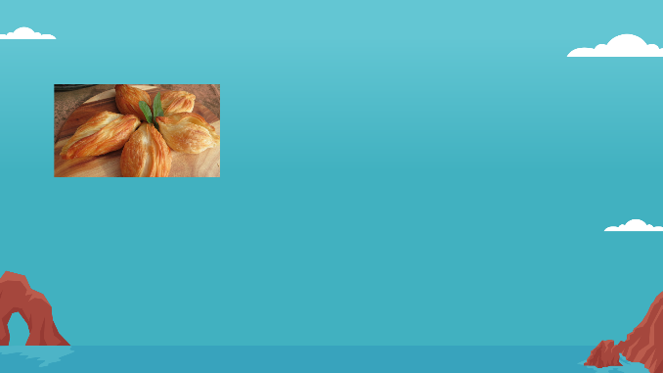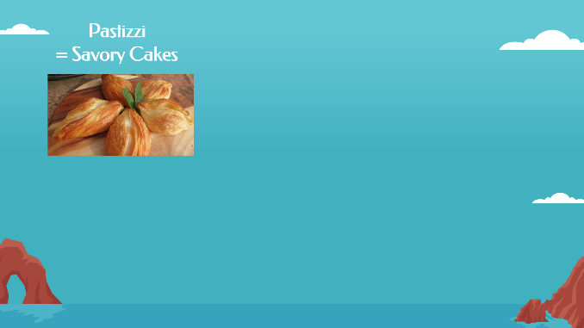
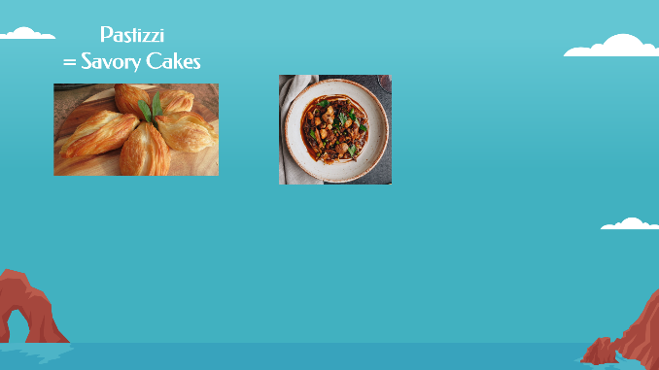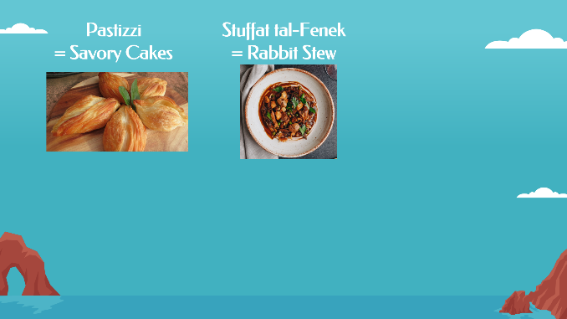
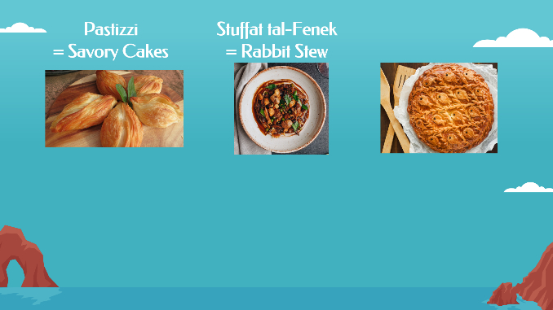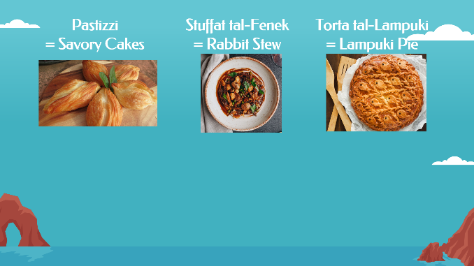
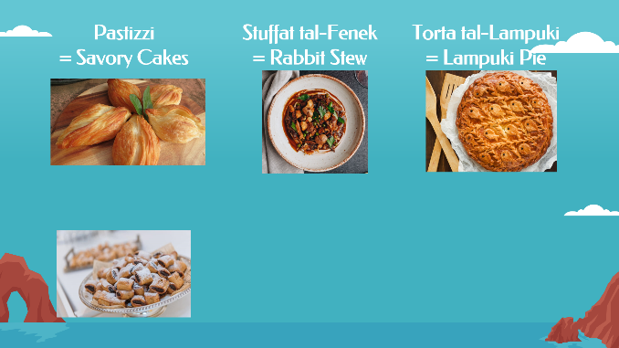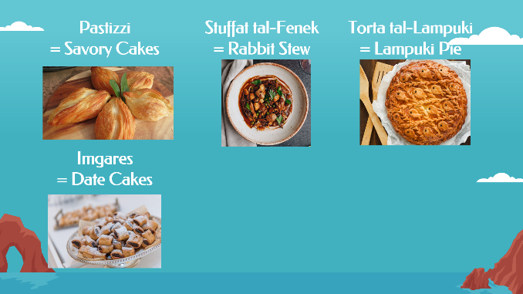
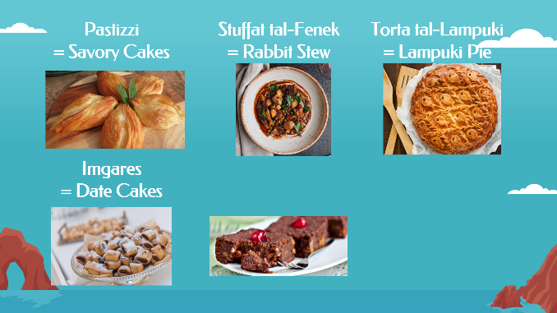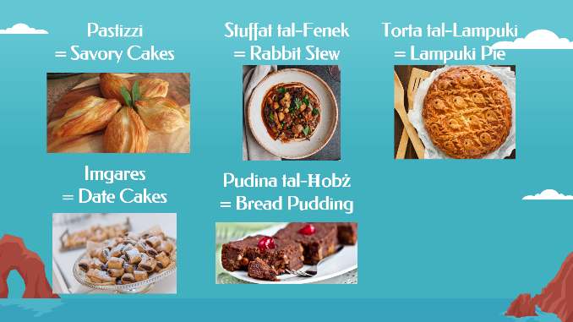
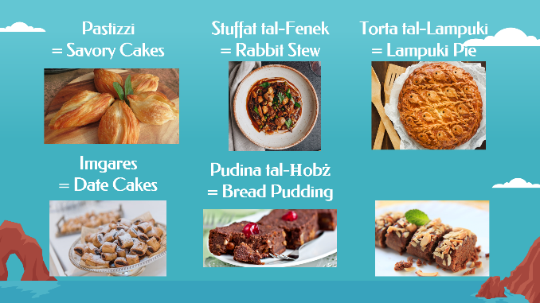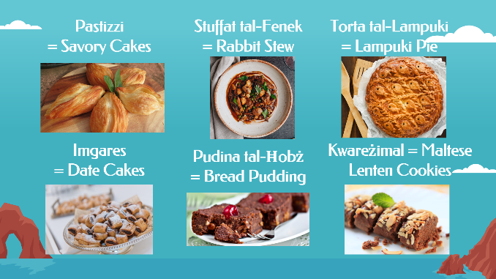

ACTIVITIES

THE FIRST ACTIVITY: True or false
We have a PowerPoint presentation with some facts about Malta. We read them one by one and students have to decide if the statement is true or false. If the fact is true, they raise their hand, and if the fact is false, they stay still. After they make their decision, we tell them the right answer and explain it shortly.
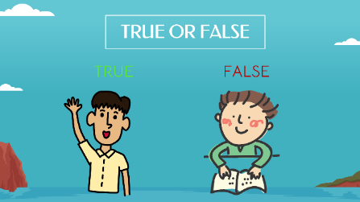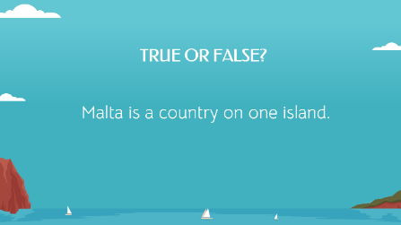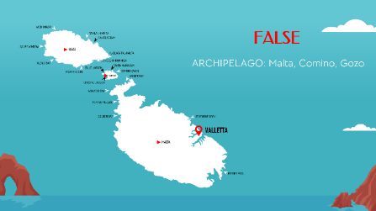
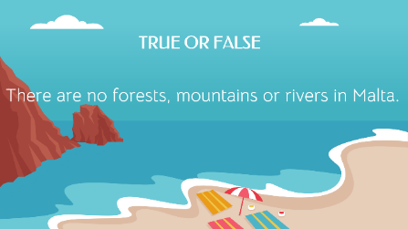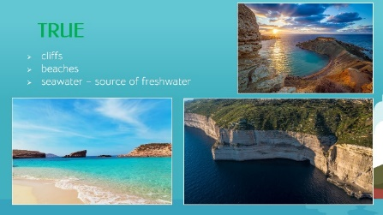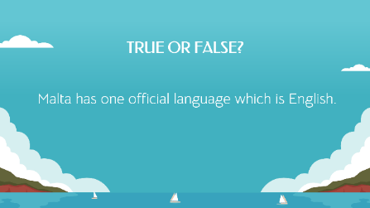
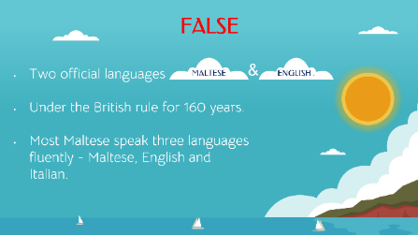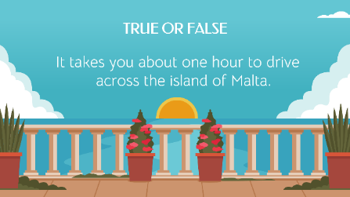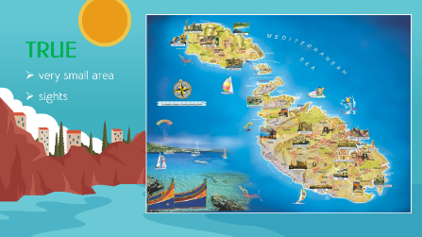
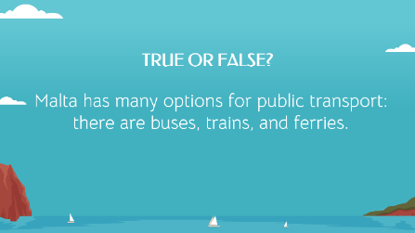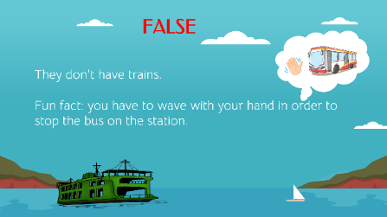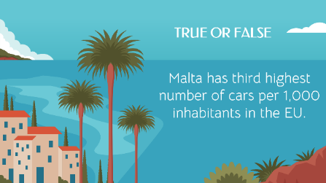
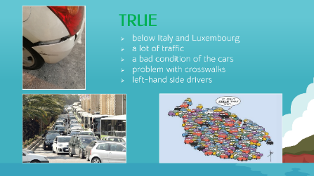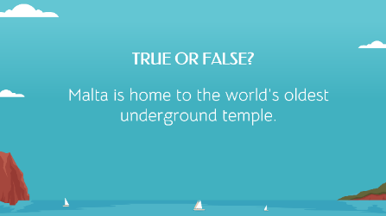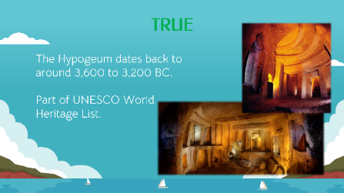

THE SECOND ACTIVITY: The smallest countries in the world
Each pair gets a list of the 11 smallest countries in the world. Their job is to put the countries in the right order from the smallest under the number one to the largest under the number 11. Some of them are already written down. The names of the missing countries are written in the box above the list. Then we discuss the connections between the country sizes and their cultures and languages.
The worksheet:
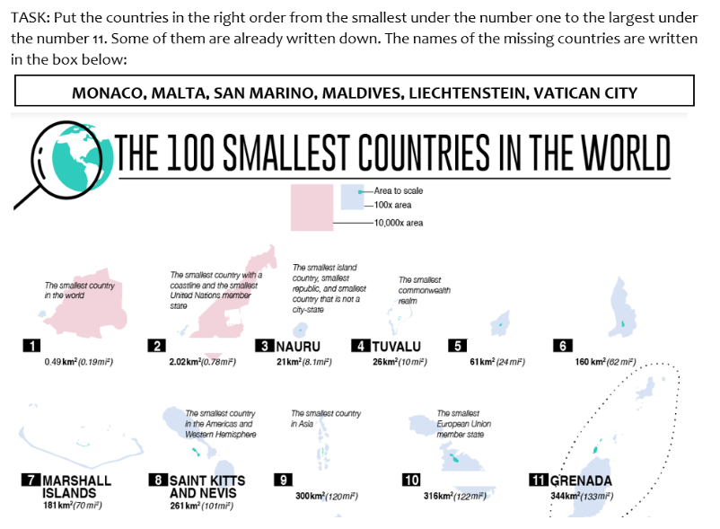

THE THIRD ACTIVITY: The odd one out
We present some interesting spots in Malta but there is a twist. One of the places we will describe briefly is not in Malta. The job of the students is to find the odd one out – the place that is not in Malta. They guess which one is the invader after we present all the spots.
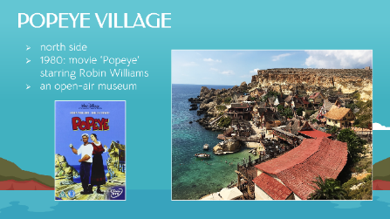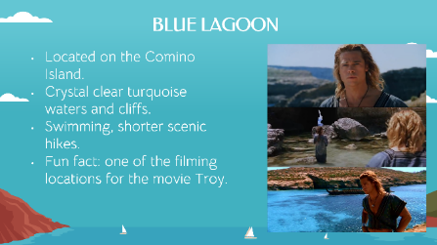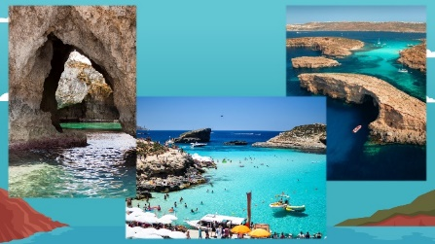
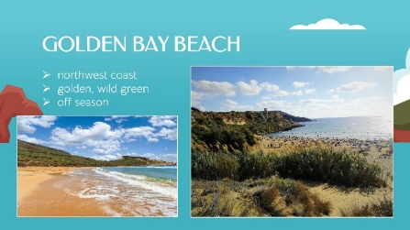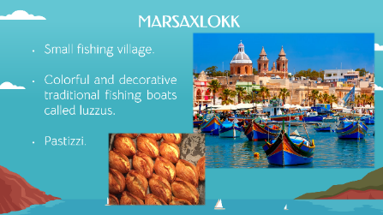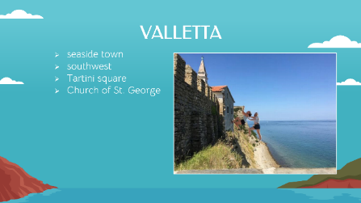
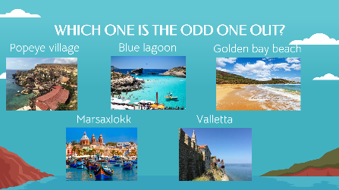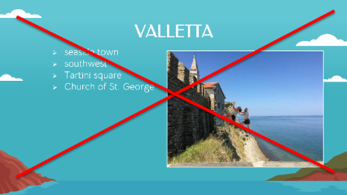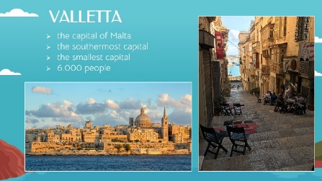

THE FOURTH ACTIVITY: Maltese cuisine
students are divided into groups of three. Each group gets 18 cards with pictures of traditional Maltese food, English names for the food, and Maltese names. Their task is to match each picture with the right Maltese and English word. In the end they should have 6 groups of 3 cards.
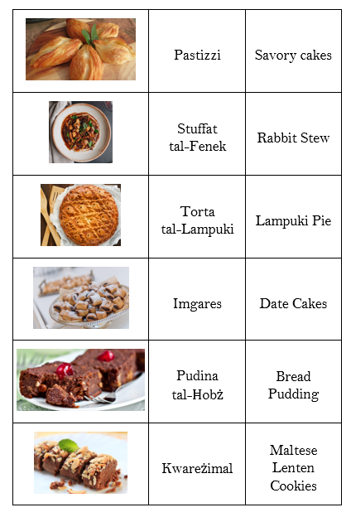

THE FIFTH ACTIVITY: Let's learn some Maltese words
First, we choose a topic and then learn some Maltese words. We also listen to the pronunciation of the words. Then we play the game on the website Digital dialects: Maltese language games. We call student by student and they choose an answer. At the end we make a review of the words the students have memorized.
The website link: https://www.digitaldialects.com/Maltese.htm (Pridobljeno 26. 3. 2023).

ACTIVITIES FOR CHILDREN

THE FIRST ACTIVITY
Name of the activity: The smallest countries in the world.
Aim of the activity: To become familiar with the 11 smallest countries in the world including Malta. To understand how the country size influences the language and culture of the country.
Age of learners: 9–10 years old (4th grade).
Approximate length of the activity: 12 minutes.
Description of the activity: Children are divided into pairs. Each pair gets a list of the 11 smallest countries in the world. They have to put the countries in the right order from the smallest under the number one to the largest under the number 11. Some of the countries are already written down. The names of the missing ones are written in the box above the list. After we check the results we discuss the connections between the country sizes and their cultures and languages – stronger sense of community, stronger social connections, cultural diversity, multilingualism.
The worksheet:
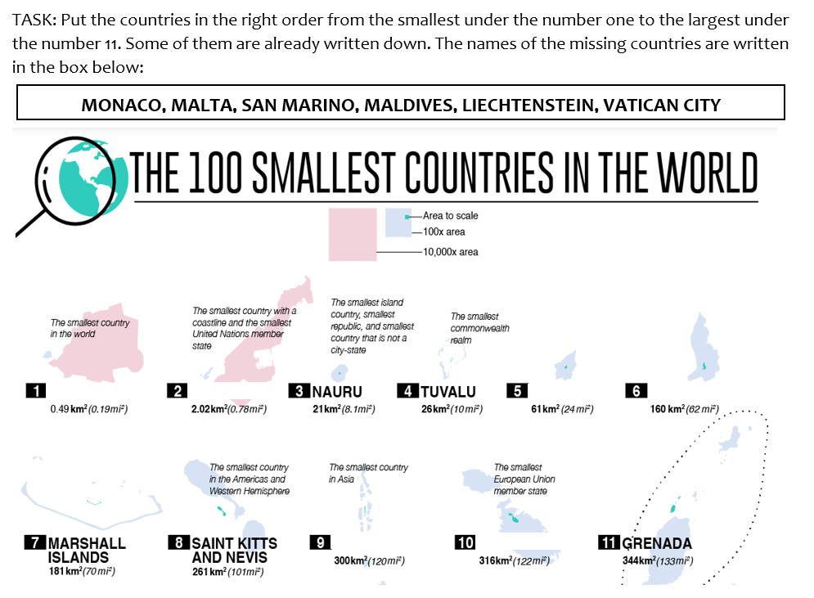

The answers:
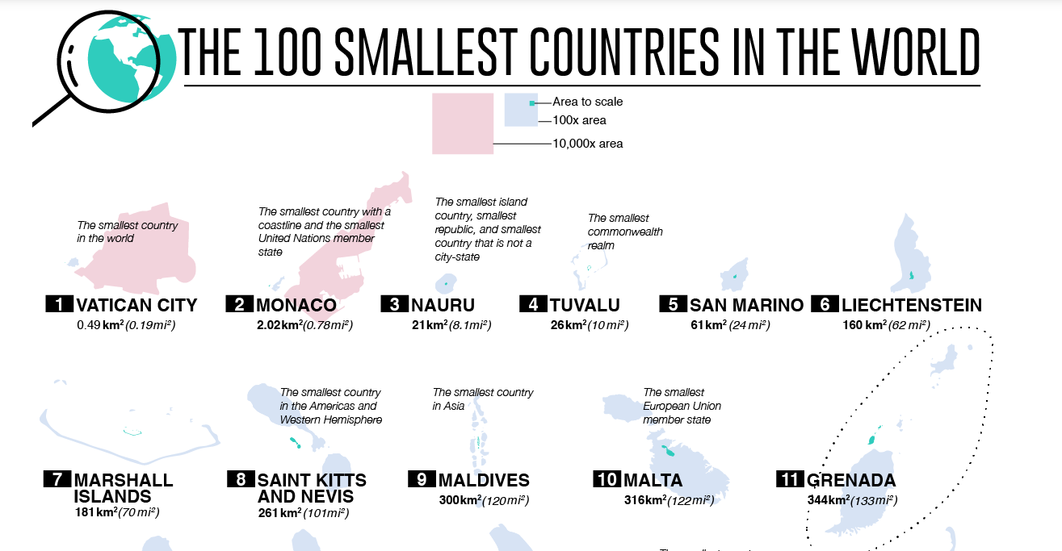
Language level of learners: A1.
Skills practised (listening/speaking/reading/writing): Reading, writing, listening (following the rules), self-correction, pair cooperation, mutual listening.
Vocabulary practised: A country, small/large, the smallest/the largest, the world.
Materials needed: A worksheet, a projection of the answers.
Cross – curricular links: Social sciences.
FREPA/CARAP descriptors:
- Knows that there may be differences between cultures.
- Being sensitive to differences and to similarities between different cultures and countries.
- Motivation to study and compare cultures and countries.
- A will to ask questions relative to cultures.
- The will to construct “informed” knowledge.
- Assuming one’s own cultural identity.
- Can observe cultural phenomena and classify relationships between them.
- Can develop a system of interpretation which enables one to perceive the particular characteristics of a culture (beliefs, cultural practices).
- Can communicate while taking sociocultural differences into account.
How the activity develops intercultural awareness: Students find out that countries are different in size which influences the cultural and linguistic aspect.
Classroom organisation (group work, pair work, whole-class …): Pair work.
Possible pre- and post- activities: A possible pre-activity is a discussion about the elements that have an affect on cultures and languages. Through the activity we lead them to the element: the area of the country. Post-activities could be a conversation about Slovenia and its place on the list, or a research about cultures of the mentioned countries – how many languages they speak, a brief history review, etc.
Variations (if there are any): Students could work individually. Another variation could be turning the activity into a project work discovering about the connection between the size of the country and its culture and language.
Additional notes (if applicable): They can discover more about the smallest countries in the world in social sciences or they make their own map in arts.

THE SECOND ACTIVITY
Name of the activity: Maltese cuisine.
Aim of the activity: To find pairs of traditional Maltese dishes and their names in English and Maltese language.
Age of learners: 9–10 years old (4th grade).
Approximate length of the activity: 8 minutes.
Description of the activity: Children are divided into groups of three. Each group gets 18 cards. They have to match each picture of the traditional food with the right Maltese and English word. In the end there should be 6 groups of 3 cards.
Language level of learners: A1.
Skills practised (listening/speaking/reading/writing): Recognizing and naming pictures of traditional Maltese dishes, reading, group cooperation, mutual listening, following the rules.
Vocabulary practised: Traditional food, dish, savoury cake, rabbit stew, fish pie, date cakes, bread pudding, Maltese Lenten cookies.
Materials needed: Cards with pictures and names of the traditional Maltese food, projection of the correct matches.
Cross – curricular links: Social sciences.
FREPA/CARAP descriptors:
- Knows that a number of cultures, more or less different, exist.
- Accepting the existence of cultural traditions (meals) which may differ from those of one’s own culture.
- Being sensitive to differences and to similarities between different languages/cultures.
- Can compare languages.
- Knows that cultural systems are complex in different domains (language).
- Can apply procedures for making comparisons.
- Being aware of traces of otherness in a language (for example of loan words).
- Can observe linguistic elements in languages and cultures which are more or less familiar.
How the activity develops intercultural awareness: Students get an insight of how the English language differs from Maltese language. They are introduced also into Maltese cuisine which is different from Slovene.
Classroom organisation (group work, pair work, whole-class …): Group work.
Possible pre- and post- activities: A possible pre-activity is a conversation about traditional dishes from Slovenia and the countries where the students are from/other countries. Possible post-activities are comparing Maltese cuisine to Slovene or to take a look at some recipes of Maltese dishes. We could also cook or bake one or two traditional Maltese dishes.
Variations (if there are any): Students are not divided into groups and do not receive the cards. We prepare a PowerPoint presentation and then the students guess which words and pictures go together. Another possible variation is that the students in groups of four play a Memory game.
Additional notes (if applicable): /

LESSON PLAN
Študentki: Manca Oblak in Barbara Železnik | Razred: 4.
Učna tema: Cultures
Učna enota: Malta and Maltese culture
Učni cilji:
Učenci:
- razvijajo strategije poslušanja in slušnega razumevanja (iz opisa prepoznajo državo);
- ob poslušanju trditev spoznajo pogosto rabljene jezikovne strukture (Is it true or is it false?) in besedišče (true, false, culture, language, country, history, cuisine, transport, traffic, Malta, Maltese, island, size);
- znajo prebrati angleške in malteške besede za jedi in številke;
- se ozaveščajo o nekaterih temeljnih medkulturnih podobnostih in razlikah (na podlagi velikosti države, njene zgodovine);
- razvijajo svojo medkulturno občutljivost in ozaveščenost (spoznajo državo Malto);
- spoznajo medkulturne podobnosti in razlike na temo tradicionalne kulture (tradicionalna hrana);
- med pogovorom izražajo svoje misli o malteški kulturi in jeziku;
- v govoru uporabljajo osnovne jezikovne strukture, enostavčne in večstavčne povedi.
Besedišče: culture, language, country, history, island, size, cuisine, transport, traffic, numbers, Malta, Maltese, true, false.
Učne oblike: frontalna, individualna, skupinska.
Učne metode: razlaga, pogovor, demonstracija, delo s konkretnim materialom, metoda ustnih del.
Prevladujoči tip ure: obravnava nove učne snovi
Učna sredstva in pripomočki: fotografije Malte, Amerike in Islandije, trditve, PPT predstavitev s trditvami o Malti, kartice s sličicami tradicionalne malteške hrane in angleškimi ter malteškimi imeni, PPT predstavitev tradicionalnih jedi, kratki opisi jedi.
Prostor: matična učilnica

Viri in literatura:
Digital dialects: Maltese language games. https://www.digitaldialects.com/Maltese.htm (Pridobljeno 26. 3. 2023).
Malta travel vlog 2019. https://www.youtube.com/watch?v=3DlSaNU9frg&t=2s (Pridobljeno 14. 3. 2023).
Program osnovna šola. Angleščina. Učni načrt. (2016). Ljubljana: Ministrstvo za izobraževanje, znanost in šport: Zavod RS za šolstvo. https://www.gov.si/assets/ministrstva/MIZS/Dokumenti/Osnovna-sola/Ucni-nacrti/obvezni/UN_anglescina.pdf

UVODNI DEL (5 minut)
Učence pozdraviva in jih povabiva v krog v sprednjem delu razreda. »Hello students, how are you? Please stand up, come here, and make a big circle. Now sit down.«
Potem na sredino kroga položiva fotografije Malte, Amerike in Islandije (PRILOGA 1). Razporediva jih tako, da je jasno vidno, katere so fotografije Malte, katere Amerike in katere so fotografije Islandije. Podava jim navodila.
»In the middle of our circle are different pictures. They are connected to 3 countries. Take a good look at them.«
Učencem dava nekaj časa za ogled fotografij. Potem nadaljujeva: »Now we are going to read you some statements. Listen carefully and try to guess which country, which pictures are described.«
Prebereva trditev za trditvijo (PRILOGA 2). Na koncu z glasovanjem določimo, za katero državo menijo, da gre. »Which country is described? If you think we were talking about this country (I point to the first group of photos), at my sign show us one finger. If you think we were talking about this country (pointing to another set of photos), show us two fingers. And if you think we talked about this country (I point to the third group of photos), show us three fingers. Ready, steady, show your fingers.«
Poveva jim, na katero državo so se navezovale trditve. Potem jim zastaviva še dve hitri vprašanji. »«
»Do you know Malta? Have you ever heard of this country?« »Yes./No.«
Če odgovorijo da, povejo, kaj že vedo o državi, drugače pa nadaljujemo z osrednjim delom učne ure.
»Tell us what you already know about Malta./Let's go back to your seats.«
OSREDNJI DEL (30 minut)
Dejavnost: A vlog about Malta
Učencem pokaževa lastni video iz potovanja po Malti, Malta travel vlog 2019: https://www.youtube.com/watch?v=3DlSaNU9frg&t=2s. Po ogledu jim zastaviva nekaj vprašanj in se z njimi pogovoriva o posnetku.
»Everyone, now please look at the screen. We will show you a part of our own video that we created during our visit to Malta. «
»What did you see in this video?« Students answer. Ko odgovorijo, jim postaviva nekaj dodatnih vprašanj o temah, ki se jih morda niso dotaknili.
»Which ways of transport and public transport did you notice?« »Planes, ferries, boats, cars, buses, bikes.«
»What kind of natural beauties did you notice?« »Cliffs, beaches, sea, a cave, nature, flowers.«
»What did you think about the cities in Malta and what did you notice about them?« »Old buildings, traffic, people, tourists.«
»Did you notice something about the religion?« »A church (a Catholic church).«
»Do you think that their life and culture is different to ours? Explain.« Učenci izrazijo svoje mnenje.
Dejavnost: True or false
Učencem podava navodila za naslednjo dejavnost, pri kateri učenci ugibajo pravilnost trditev o Malti.
»Now, we would like to check how much you already know about Malta so we will give you some facts and you will have to decide if they are true or false. Look at the presentation (PRILOGA 3). If you think the fact is true raise your hand and if you think it is false stay still.«
Po vsaki podani trditvi se učenci odločijo, ali se jim zdi trditev pravilna ali napačna, in to pokažejo z dvigom roke. Poveva pravilen odgovor, ga na kratko opiševa in nadaljujeva z naslednjo trditvijo.
»Malta is a country on one island.« false
»That is false. Malta is not just one island - it is an archipelago. It consists of 3 islands named Malta, Gozo and Comino. Malta is the biggest one and Comino is the smallest one. Valletta, the capital city, is on the biggest island.«
»There are no forests, mountains or rivers in Malta.« true
»That is true. They don't have forests or mountains, but they do have beautiful cliffs and beaches. They also have lots of sea water. They filter their drinking water straight from the sea, because it is their only source of freshwater.«
»Malta has one official language which is English.« false
»That is false. Malta has two official languages, Maltese and English. English is one of the official languages because they were under the British rule for 160 years. Maltese language is a mix of Arabic, French, Italian and English. Most Maltese speak three languages fluently - Maltese, English and Italian.«
»It takes you about one hour to drive across the island of Malta.« true
»That is true. The area of the island is very small so it is easy to travel and see all of the sights.«
»Malta has many options for public transport: there are buses, trains, and ferries.«
false
»That is false. They have buses and ferries but they don’t have trains.«
»Malta has third highest number of cars per 1,000 inhabitants in the EU.« true
»That is true. That causes a lot of traffic so the combination of this and the fact that they are not the best drivers results in a bad condition of their cars. There is also not a lot of crosswalks, so you have to break the law to get to the other side of the road.«
»Malta is home to the world’s oldest underground temple.« true
»That is true. The underground temple is called the Hypogeum. Today, this unique monument is on the UNESCO World Heritage List. The island has a rich history. Malta has some of the oldest free-standing stone structures in the world. They are even older than Stonehenge and the Egyptian pyramids.«
»Good job everyone! Now you know a lot more about Malta.«
Dejavnost: Discussion about the culture
Sledi pogovor o kulturi in večjezičnosti Malte. Učencem podava nekaj vprašanj in na ta način vodiva pogovor.
Učence spodbudiva: »Let’s talk a bit about the culture and language in Malta.«
Vprašava jih: »What do you think influences the culture of Malta? Why?« »Size of the country (it is small), location of the country (on island), the history (ruled by different civilisations), religion (Catholicism, Christianity), tourism (always in touch with other cultures).«
»Why does the small size of the country have an impact on the culture?« »The people have a stronger sense of community, stronger social connections, it is easy to travel across the country, because the communities are closer together, it is easier to pass down traditions to other generations. Because of its size and location, Malta was often ruled by different countries and cultures. They all made the Maltese culture more diverse and also had a big influence on their language.«
Dejavnost: Maltese cuisine
Učence s pomočjo barv razdeliva v skupine po 3. Še prej jim podava navodila za dejavnost.
»We will divide you into groups of three. Each group will get 18 cards with pictures of traditional Maltese food, their English names and Maltese names. Your job is to match each picture with the right Maltese and English word. In the end, there should be 6 groups of cards.«
Nato učence razdeliva v skupine. Če jih je v razredu 24, bi deljenje izgledalo tako: »We will choose who will work together. When we point at you and say colour, hold up a coloured pencil of the same colour. Than hold it in the air until all the students raise their hands.«
Potem pokaževa na prvega učenca in mu določiva barvo: »You, blue.« Nato določiva barvo 2., 3., 4., 5., 6., 7. in 8. učencu, potem pa začneva barve ponavljati. Tako vsako barvo ponoviva trikrat in s tem izbereva, kateri učenci bodo skupaj v skupini.
Skupinam razdeliva kartice (PRILOGA 4) in jih nekaj časa pustiva, da v miru sestavljajo besede s slikami tradicionalnih jedi. Vmes hodiva po razredu in skupinam po potrebi pomagava.
Ko skupine končajo z delom, preverimo njihove rešitve. »Let's check how well you did. We will show you a picture of traditional Maltese food and you will show cards with English and Maltese name.«
Ob PowerPoint predstavitvi (PRILOGA 5) pregledamo odgovore. Vsako tradicionalno hrano na kratko opiševa (PRILOGA 6).
ZAKLJUČNI DEL (10 minut)
Odpreva spletno stran Digital dialects: Maltese language games. Skupaj izberemo med temama numbers 1–12 in colours.
»We will play a game and learn some Maltese words. You can choose between numbers 1–12 and colours.«
Ko izberemo temo, jim podava nadaljnja navodila. »Let's take a look at Maltese numbers/colours. Try to remember the words.«
Po pregledu vseh besed, začnemo z igro. »Now we are ready to play a game. If you know the answer, raise your hand and wait. You will tell the answer when we call you.«
Ko z igro zaključimo, učencem zastaviva še dve vprašanji, vezani na obravnavano tematiko.
»What is the one thing that surprised you the most about Maltese culture?«
»What else do you remember from the lesson?«
Učenci odgovorijo na vprašanji, potem pa se jim zahvaliva za sodelovanje in se od njih posloviva.

PRILOGE
PRILOGA 1: Fotografije Malte, Amerike in Islandije
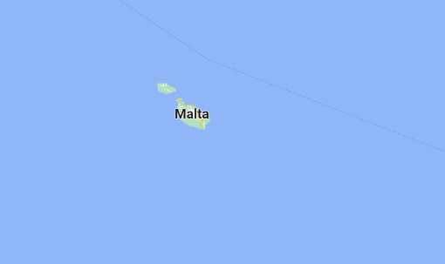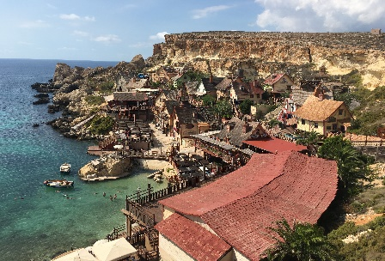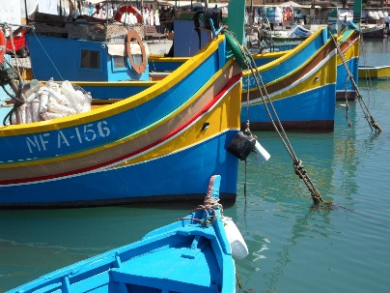
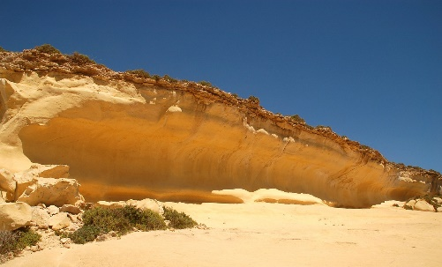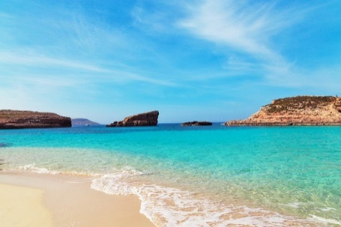
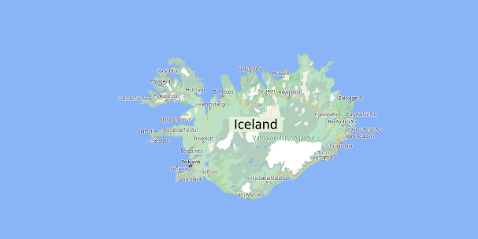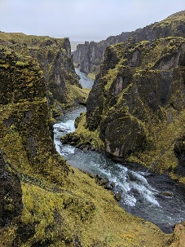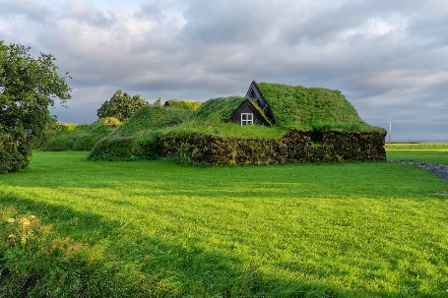
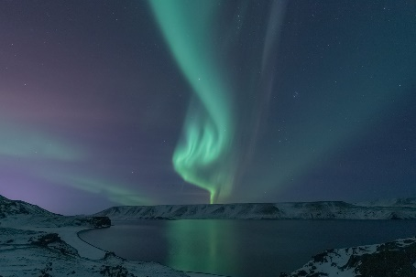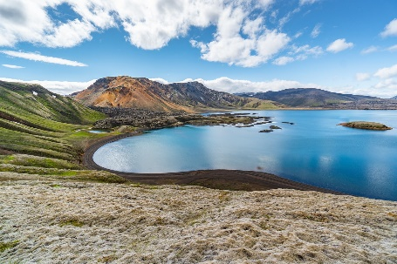
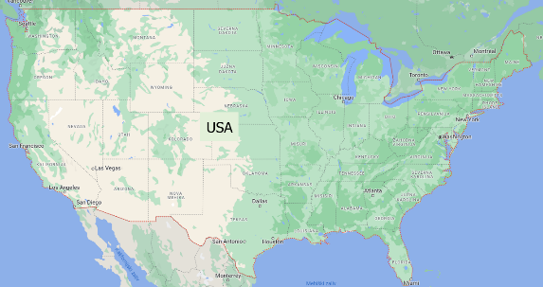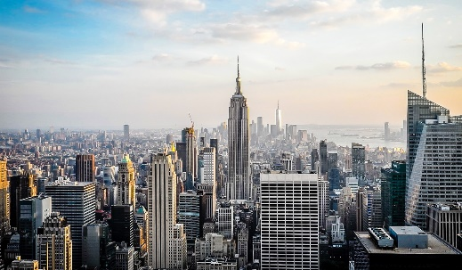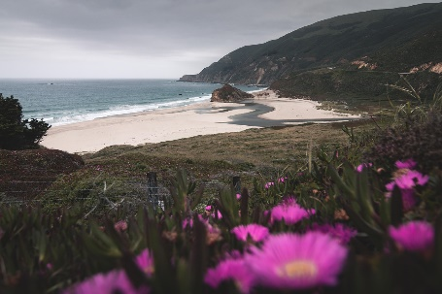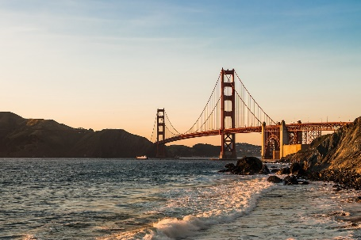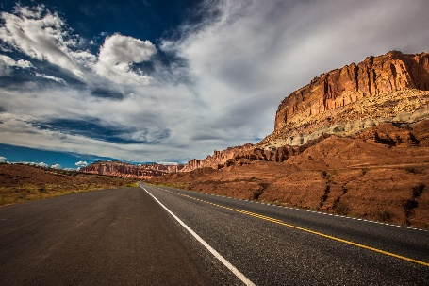
PRILOGA 2: Trditve
- A very common colour is yellow.
- The traditional boat is very colourful.
- There is a lot of sea around the country.
- It is a very small country.
- It can be very hot there in the summer.
- There is a real cartoon village.
PRILOGA 3: PowerPoint predstavitev, trditve o Malti

PRILOGA 4: Kartice za dejavnost Maltese cuisine
PRILOGA 5: PowerPoint predstavitev
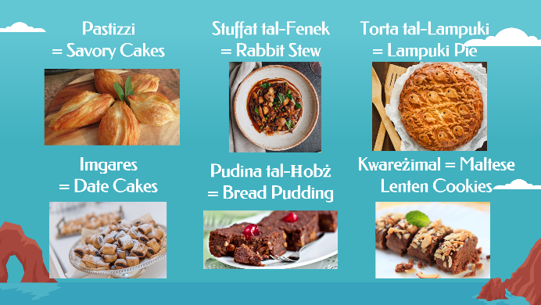
PRILOGA 6: Kratki opisi tradicionalnih malteških jedi
Pastizzi are savoury cakes made with a phyllo-pastry and filled with either ricotta or mushy peas.
Rabbit Stew is a slow cooked stew with a rabbit meat and lots of vegetables.
Lampuki Pie is a fish pie. Lampuki is the Maltese name for dorado fish or mahi-mahi.
Date Cakes are crunchy pastry, packed with a date filling, for example chocolate.
Bread Pudding is a food of Malta's poorest inhabitants. Traditionally, it is made of stale bread soaked in liquid. Sugar, margarine, chocolate powder, and cocoa powder are normally added to the bread pudding mixture.
Maltese Lenten Cookies are vegan cookies made of flour, sugar, cinnamon, honey, and orange zest. Traditionally they are baked during the forty days of Lent.

