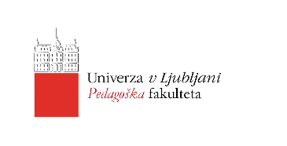

magistrska stopnja razrednega pouka
2022/23

Syria
project work file

Jezikovno in medkulturno ozaveščanje
Manca Jež in Zala Šuštaršič
Ljubljana, 20. 5. 2023
Introduction
For the topic, we decided to choose Syria. We wanted to present a country different from what we are used to in Europe. The way of living in Syria is very different than in Slovenia. They have been dealing with poverty and war for more than 10 years now and consequently is their school system quite different from ours. We wanted to bring awareness to how difficult it is to live and go to school in some parts of the world and make up appreciate what we have and how important it is to feel safe and be able to study freely. On the other hand, we wanted to put in the foreground the importance of certain organisations like UNICEF, which is working every day on saving lives and giving children an opportunity to access quality education through school rehabilitation, teacher training and providing essential learning materials. We also find Syrian history, sights, food and traditions very interesting and worth learning about.

PPT presentation
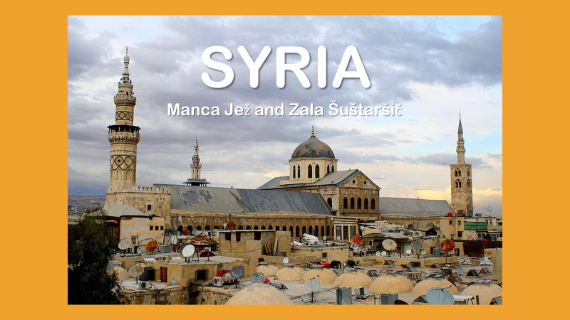
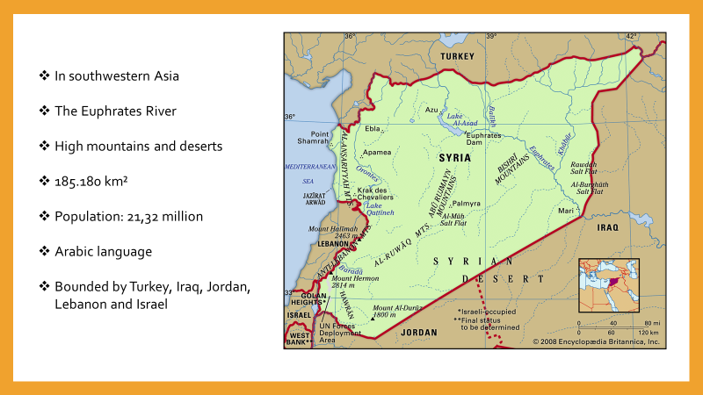
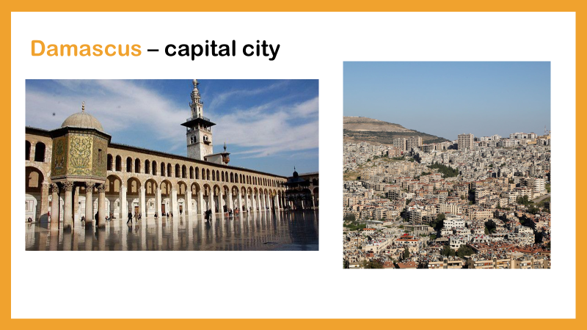
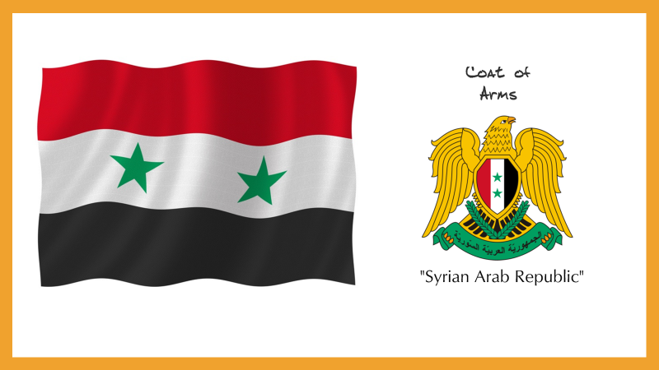
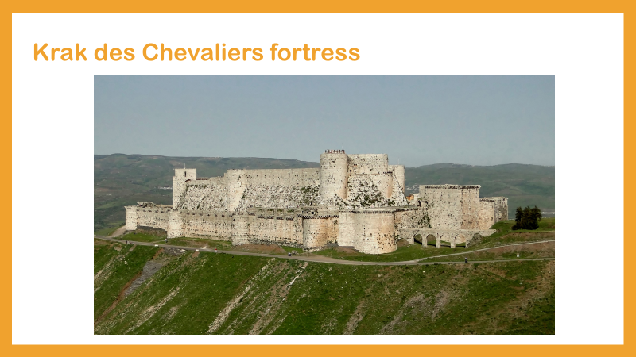
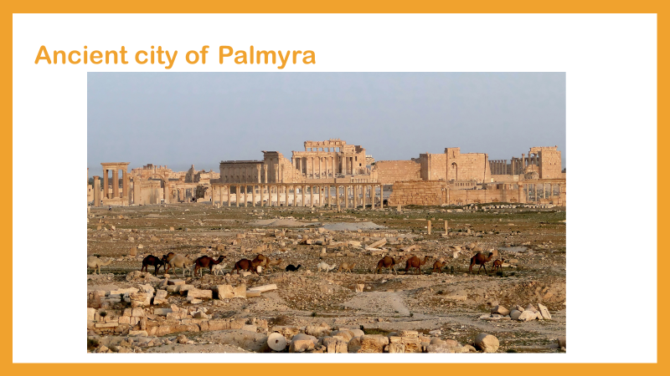
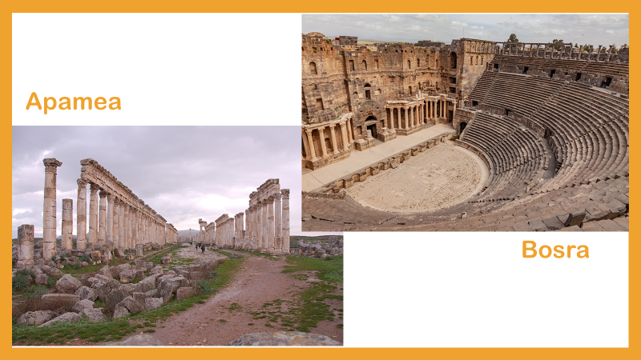
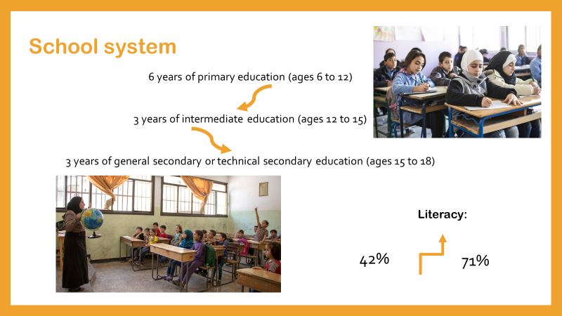
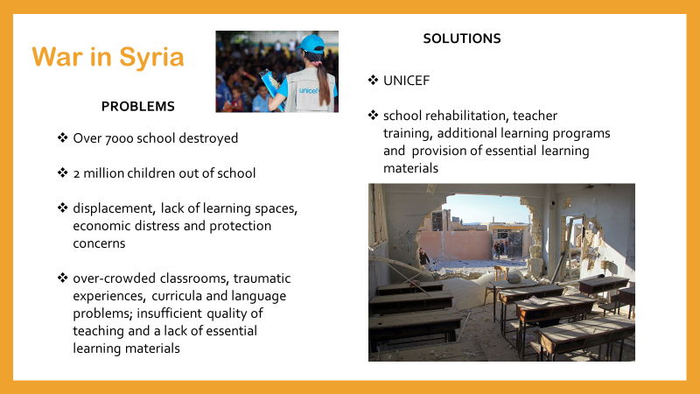
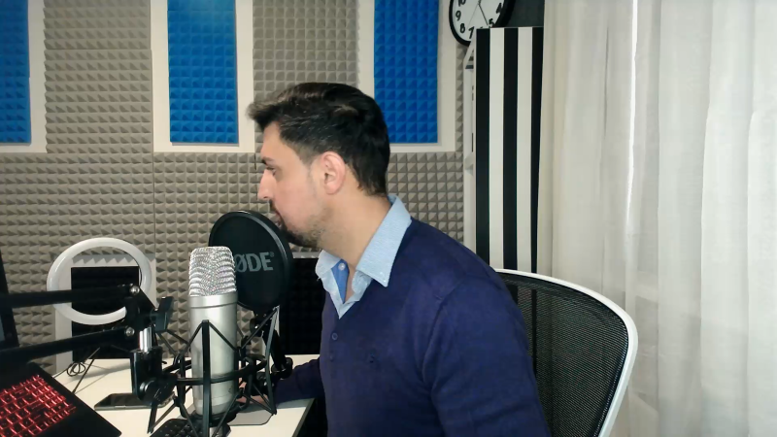
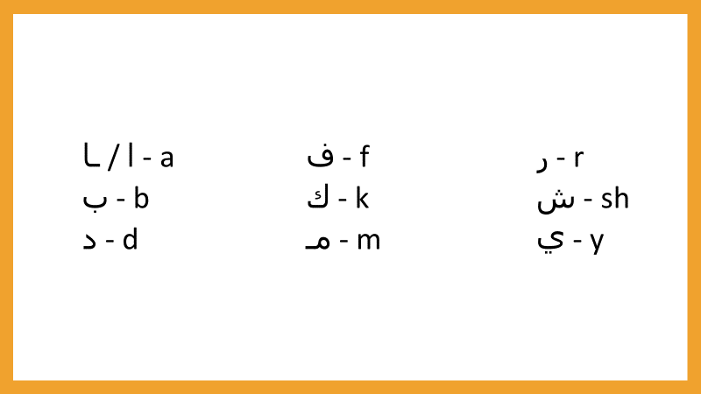
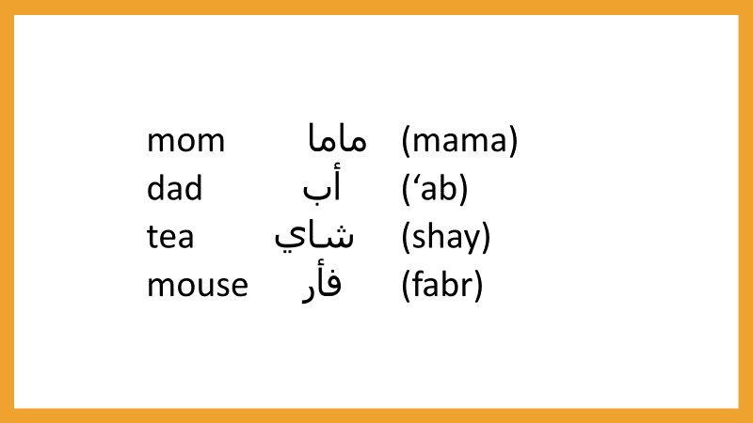
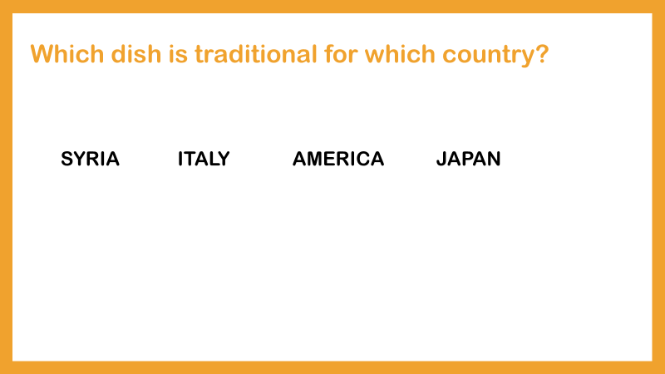
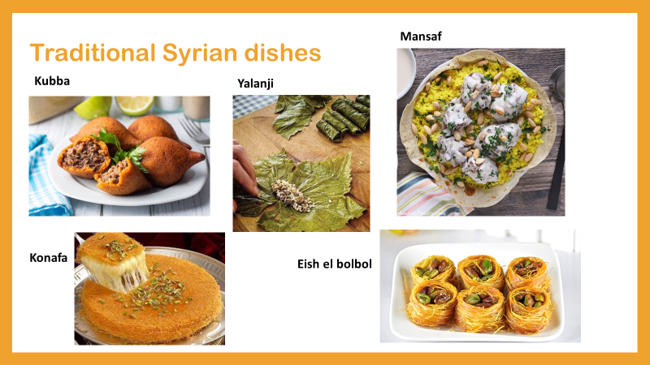
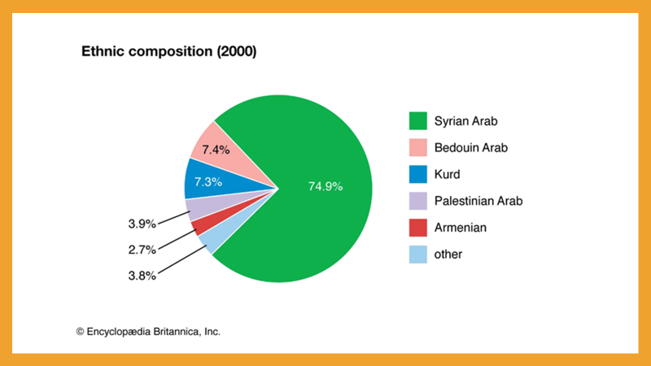
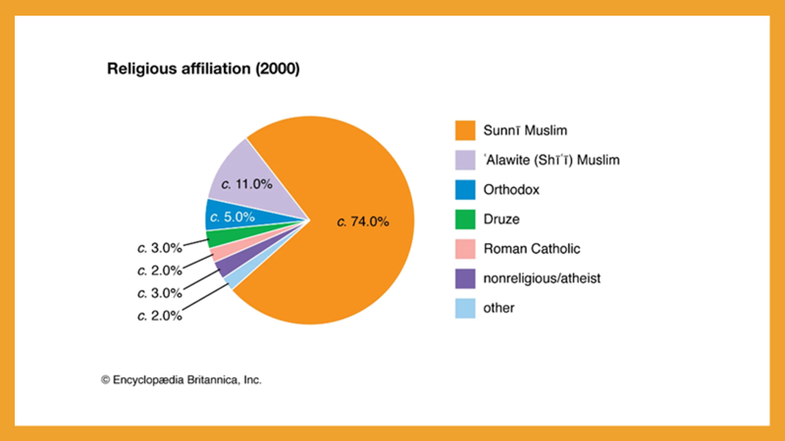
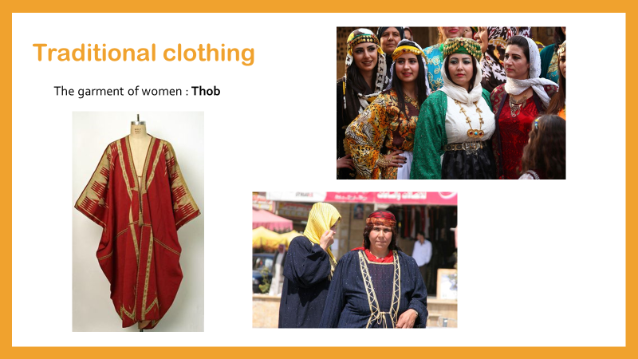
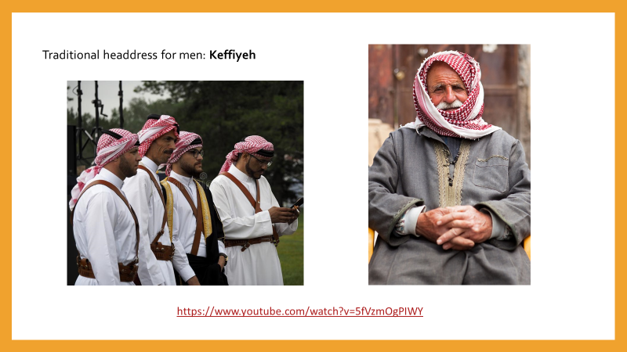

Collection of the activities for pupils:
1st activity
Name of the activity: food all over the world
Aim of the activity: Students connect different dishes to their country’s origins
Age of learners: 10, 11 years old
Approximate length of the activity: 10 minutes
Description of the activity: Students get 12 pictures of different dishes that originate from Italy, America, Japan and Syria.
Language level of learners: beginners
Skills practised (listening/speaking/reading/writing): speaking
Vocabulary practised: dish, food, country, origin, main dish, appetizer, dessert, Syrian traditional dishes: Eish el bolbol, Yalanji, mansaf
Materials needed: cut out pictures of the dishes and names of the countries
Cross – curricular links: geography – learning about Syria
FREPA/CARAP descriptors: K 8.2, K 9.4, K 10. 10.3, K 12.4, K 13, A 6, S 1.1, S 1.7, S 1.10, S 3
How the activity develops intercultural awareness: it helps them differentiate traditional dishes between different cultures / countries and learn about traditional Syrian food.
Classroom organisation (group work, pair work, whole-class …): pair work
Possible pre- and post- activities: before we get to know Syria, we talk about its location, population, religion, history, language, find it on a map, learn about its flag, coat of arms, school system. After we talk about traditional Syrian food, look at some pictures and describe them.
Variations (if there are any): for older students, it can be a competition between pairs, we can also adjust the number of members in the groups in the players are younger
Additional notes (if applicable): /
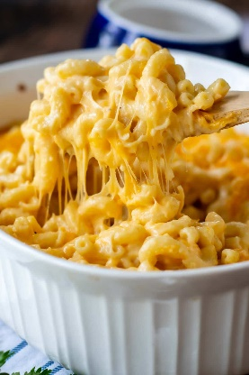
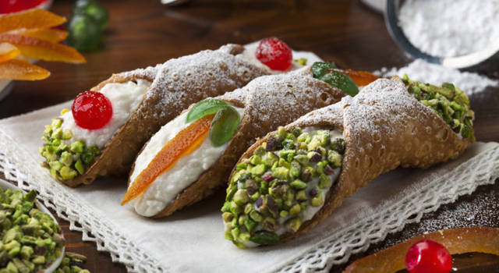
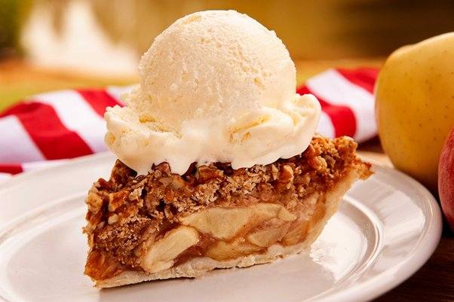
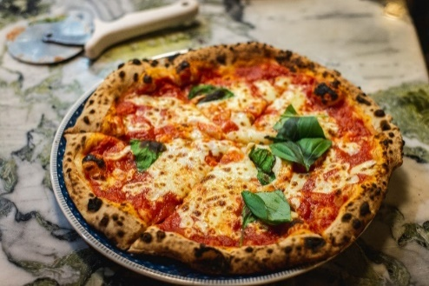
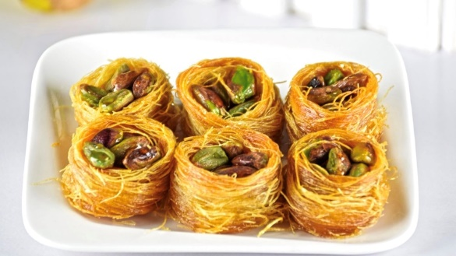
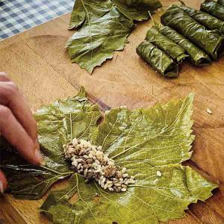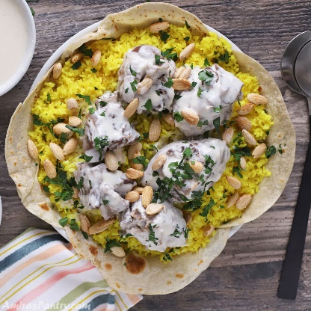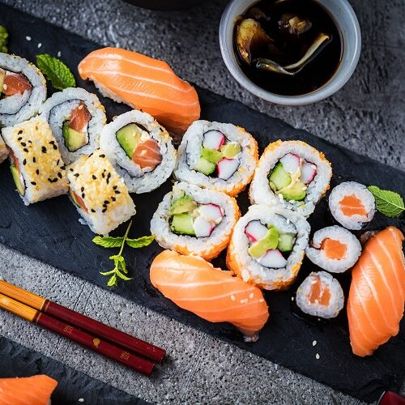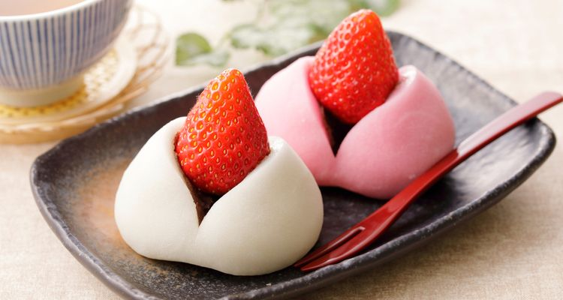

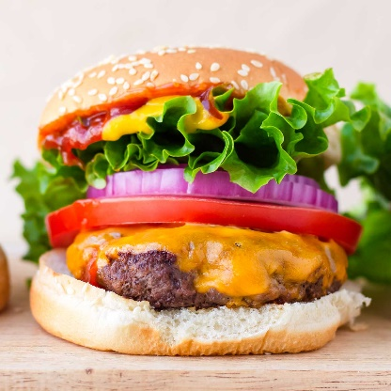
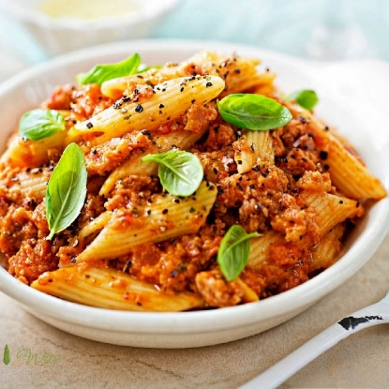
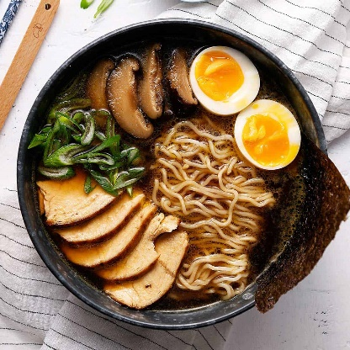

ITALY AMERICA

JAPAN SYRIA

2nd activity
Name of the activity: Arabic alphabet
Aim of the activity: learning about different types of alphabet
Age of learners: 10, 11 years old
Approximate length of the activity: 10 minutes
Description of the activity: Each group gets cards with different words in English and Arabic. Their task is to match English word with the correct Arabic word and the correct spelling. For help, they see Alphabet letters on the projection
Language level of learners: beginners
Skills practised (listening/speaking/reading/writing): speaking, reading
Vocabulary practised: mom, dad, tea, mouse
Materials needed: cards with words
Cross – curricular links: geography – learning about Syria
FREPA/CARAP descriptors: K 11.3.2, A 2.2, A 4.3.2, A 5.3.3, A 7.2.1, A9.2.1, S 1.2, S 1.3, S 1.4.2, S 2.2
How the activity develops intercultural awareness: pupils learn about different alphabets and different types of writing around the world
Classroom organisation (group work, pair work, whole-class …): group work
Possible pre- and post- activities: before that activity we can talk about different types of writing different cultures have and look which other countries use Arabic alphabet
Variations (if there are any): students could also try to write with Arabic letters
Additional notes (if applicable): /
mom ماما (mama)

dad أب (‘ab)

tea شاي (shay)

mouse فأر (fabr)

Projection:

Other activities we do with pupils:
3rd activity: world map
Description of the activity: Each pupil gets a colouring world map and has to find and colour his own country and Syria. We do the activity together frontally.
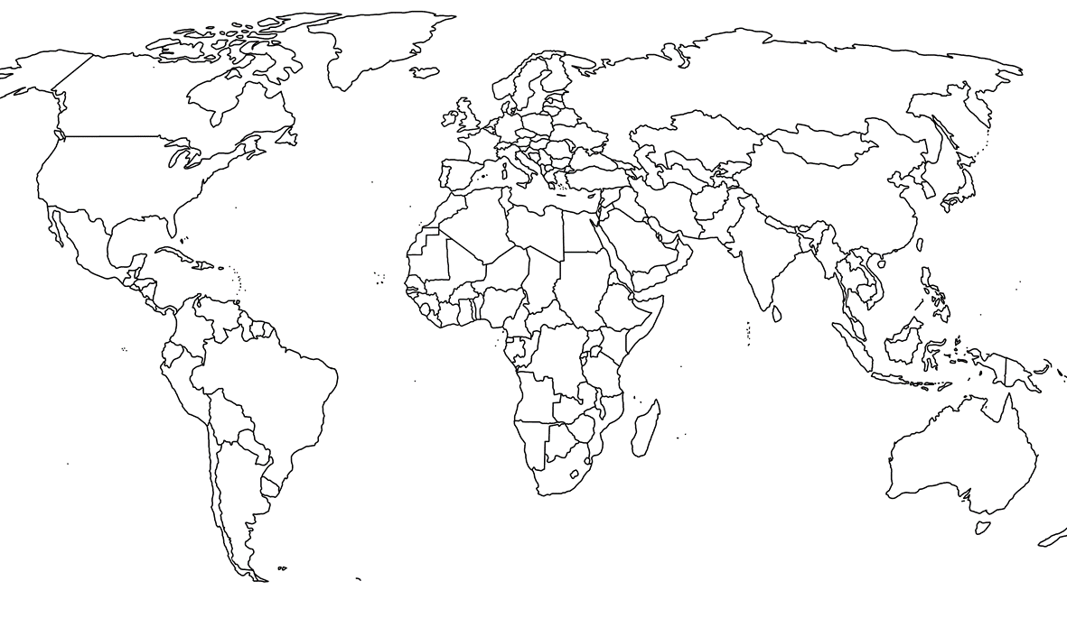
4th activity: short video about history of Syria
https://www.youtube.com/watch?v=JDMuwJYwYs0
5th activity: video about Syrian talking in different dialects

Lesson plan
LESSON PLAN
Teachers: Manca Jež, Zala Šuštaršič
Grade: 4th grade
Lesson topic: Syria
Lesson forms: frontal work, individual work, group, pairs work
Teaching aids/materials: computer, world maps, cards
Teaching methods: explanation, demonstration, games
Lesson aims:
Students:
- learn about new culture
- can show Syria on the world map
- get to know interesting facts about Syria
- get to know different foods and different traditions in Syria
- get to see Arabic writing
- interact with each other using English
Language skills practiced: listening, speaking, reading, writing
References:

STRUCTURE OF THE LESSON
Stage of the lesson and timing | Activity
Introduction  (15 min) | We introduce ourselves and tell that in today’s lesson will learn about Syria. Each pupil gets a world map. They need to locate and colour their own country on the map. We talk about the continents and together we find and colour Syria on the world map.
Main part  (1h10min) | In the main part of the lesson, we introduce Syria and tell a few basic information about the country. We show presentation where pupils can see the flag, symbol and the capitol. We briefly explain the history background and watch the video about history of Syria.  We talk about our education system with pupils (are we well educated, can a lot of people read etc.) and then tell pupils about education system in Syria, that many people are not well educated. We also look at the photos of the school in Syria.  We explain to the pupils that in Syria they speak different language and have different alphabet. We do the activity with Arabic words.  We talk about ethnic and linguistic groups. Then we do the activity “food all over the world”. We show pupils a video about typical clothes people wear in Syria and show them a typical Syrian dance.
End of the lesson  (10 min) | At the end of the lesson pupils can ask us different questions about Syria and we try to answer them. For the last activity, we do a short quiz with them.

References
https://education.stateuniversity.com/pages/1483/Syria-EDUCATIONAL-SYSTEM-OVERVIEW.html Pridobljeno: 3. 3. 2023
https://www.enjoytravel.com/us/travel-news/interesting-facts/facts-about-syria Pridobljeno: 3. 3. 2023
https://www.youtube.com/watch?v=5fVzmOgPIWY Pridobljeno: 3. 3. 2023
https://www.unicef.org/syria/education Pridobljeno: 3. 3. 2023

