SELF REFLECTION
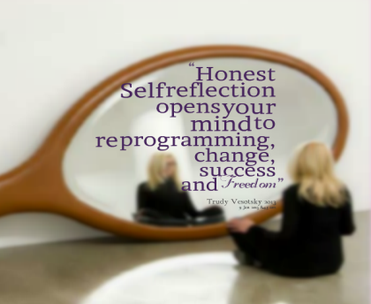
Name:
Date:
Class:
Things that went…
…well. | …not as well as I had hoped.
If I performed this lesson again with a similar class I…
would… / because… | would not… / because…
Interesting or memorable points/things/thoughts from the lesson…
My use of FL...
As a result of this lesson I now realise…

