SELF REFLECTION
Name:
Date:
Class:
Things that went…
…well. | …not as well as I had hoped.
A storybook, singing and moving along with the song. | The game with pairs was not appropriate for the room we were in. There was not enough space.
If I performed this lesson again with a similar class I…
would… / because… | would not… / because…
... write down the text of the story, because it was not easy to talk naturally and by heart when I was nervous.  … choose less words when working with children. | ... do the same repeating activity for the words, because classmates didn't want to move around a lot.
Interesting or memorable points/things/thoughts from the lesson…
I think lesson was successful. Better activities are usually connected with moving around – they are more enjoyable and we gain more from them. It is important to have enough room for activities and to give short and clear instructions.

My use of FL...
… was not as fluent as I would want it. I didn’t always find the right words. But it definitely encourage me to start talking in English more.

As a result of this lesson I now realise…
… it is important and not difficult to have English activities that are appropriate for preschool children. We only need to make them fun and include a lot of repeating.
ALL COLLECTED MATERIAL
Topic: Clothes

VOCABULARY:
- Clothes  - Shirt  - Sweater  - T-shirt  - Dress  - Skirt | - Cap  - Hat  - Gloves  - Coat  - Jacket  - Suit | - Blouse  - Tie  - Scarf  - Belt  - Shorts  - Pants | - Pajamas  - Raincoat  - Socks  - Boots  - Shoes  - Slippers

STORY BOOKS
- Palermo, S. (1992). English junior: igraje do znanja angleščine. Murska Sobota: Pomurska založba.
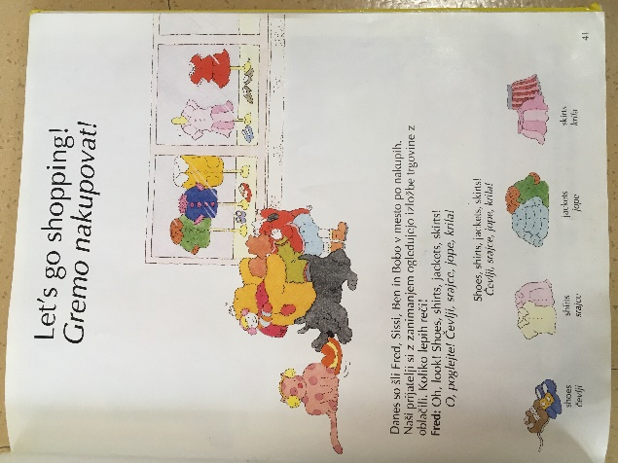
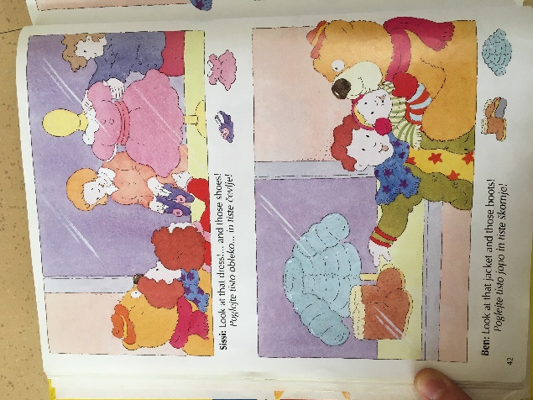
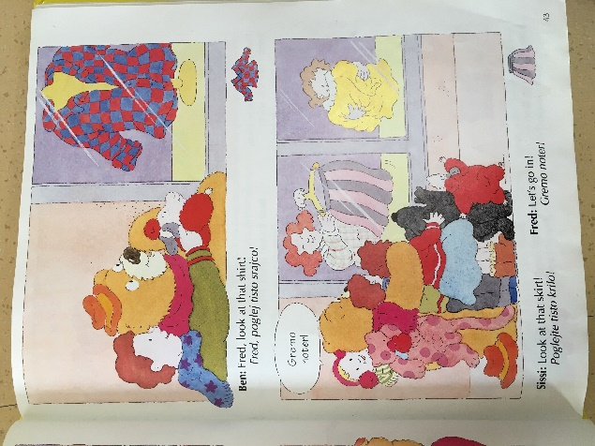
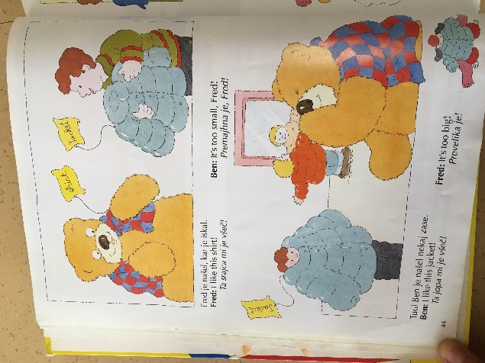
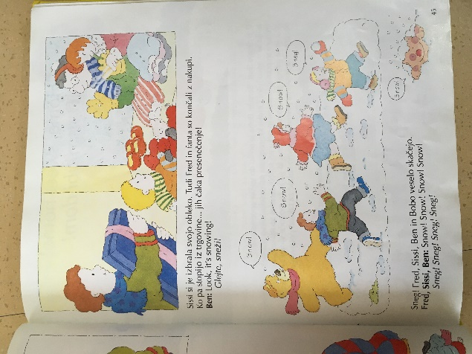

- Child, L. (2010). Charlie and Lola's Clothes. London: Orchard Books.
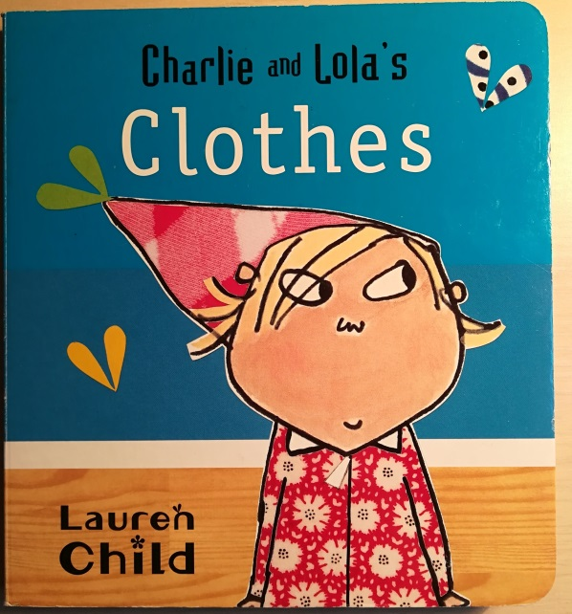
CARD GAMES
Slap it!
A very basic game is to spread the cards face up and the first student to slap the correct card when you call out a word gets to keep it; the student with the most cards at the end of the game wins.
Find your match 1
Kids make a circle. Every kid gets a card and has to find a friend with the same picture on his card (looking for pairs). One kid steps into the circle and says: ‘’I wear a … shirt/trousers etc.’’ Than a kid with the same card steps to him and says: ‘’I also wear a … shirt/trousers etc.’’ We repeat this until everyone has found matching pair.
Find your match 2
Every kid gets a card and has to find a matching card. When both kids with matching cards find each other, they have to tell the right word (word of a piece of clothing that is on the card).
MOVEMENT ACTIVITIES:
Squat if you’re wearing it:
We put clothes in the middle of the circle. After naming a piece of clothing in the middle of the circle, every kid with wearing that piece of clothing has to squat down.
Run to the right picture:
We place cards face up in the row on the floor. We choose a kid to run to a card, on which a picture of a piece of clothing we named is.
Link: https://www.youtube.com/watch?v=JFuO1xeYlSc
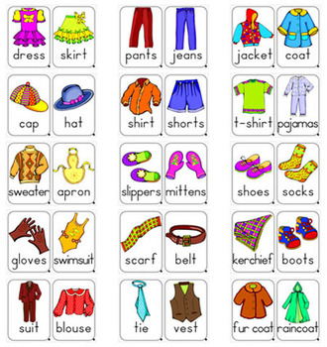
PICTURES:

SONGS:
- What are you wearing? https://www.songsforteaching.com/happalmer/whatareyouwearing.htm
- What are you wearing? … and versions
https://storytimeukulele.wordpress.com/2017/12/19/what-are-you-wearing-and-variations/
- Let’s get dressed song
https://www.youtube.com/watch?v=OAVh6StYLq8
- Put on your shoes
https://www.youtube.com/watch?v=-jBfb33_KHU
- My shirt, jacket, socks, shoes … yeah!
https://www.youtube.com/watch?v=9317y8fExAA

WEBPAGES:
When planning, pay attention:
- https://www.theteflacademy.com/blog/2017/09/how-to-teach-english-as-a-foreign-language-to-young-learners/
- https://busyteacher.org/4087-how-to-teach-preschoolers-preschool-games-and.html
- https://busyteacher.org/2921-teaching-english-vocabulary-10-fabulous-ways-to.html
Activities on topic clothing:
- https://www.englishclub.com/efl/tefl-articles/clothes-vocabulary/
- https://owlcation.com/academia/Teaching-pre-school-English
- https://busyteacher.org/6975-8-great-esl-clothes-activities.html

Card games:
- https://www.fluentu.com/blog/educator-english/esl-kindergarten-games/
More websites for children activities:
- https://esl.yourdictionary.com/lesson-plans/esl-activities-kindergarten.html
_____________________________________________________________________________
OUR PRESENTATION:

Topic: Clothes
Age of children: 5 – 6 years
VOCABULARY:
- Clothes  - Jacket  - Sweater  - T-shirt  - Cap | - Pants  - Scarf  - Shoes  - Pajamas  - Socks | - Boots  - Gloves  - Coat  - Slippers
A STORY BOOK
- Briggs, R. (1998). The Snowman. Italija: Printer Trento S.r.l.
*We took just one part of the silent picture book (without words) that shows a boy getting dressed.
A story:
There is a boy. How should we name him? It is a cold, snowy morning and he is still sleeping in his bed.
Maybe he is dreaming about something nice? Oh no, he is opening his eyes.
He's awake and now he is looking outside.
He sees the snow outside his house. He wants to get out and play on the snow. He wants to make a snowman. But he is still in his pajamas.
He grabs a sweater,
then puts on his trousers
and asks mum to go outside and play.
He puts on his warm socks and boots and runs out.
And now his cap
and gloves.
He is ready. But he ran so fast that he lost his cap. I think he will be cold.
MOVEMENT ACTIVITY
Run to the right picture:
We place cards face up in the row on the floor. We choose a kid to run to a card, on which a picture of a piece of clothing we named is. We help them with gesture showing. (Look at: Appendix 1)
Link: https://www.youtube.com/watch?v=JFuO1xeYlSc

REPEATING ACTIVITY
Kids get clothing magazines and they have to find a piece of clothing that we say.

CARD GAME
Find your match 1
Kids make a circle. Every kid gets a card and has to find a friend with the same picture on his card (looking for pairs). One kid steps into the circle and says: ‘’I wear a … shirt/trousers etc.’’ Than a kid with the same card steps to him and says: ‘’I also wear a … shirt/trousers etc.’’ We repeat this until everyone has found matching pair.
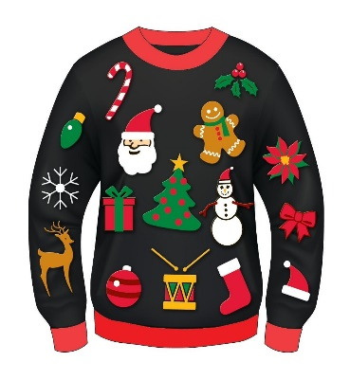 | 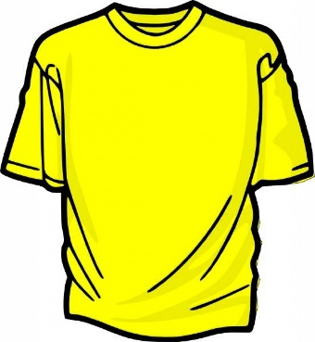 | 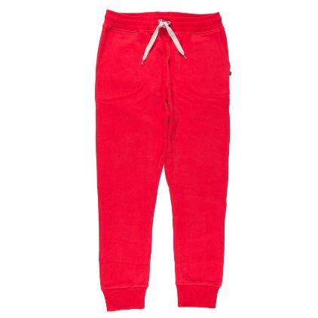
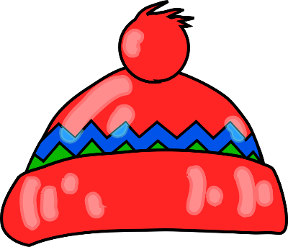 |  | 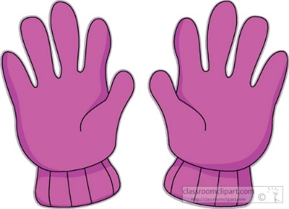

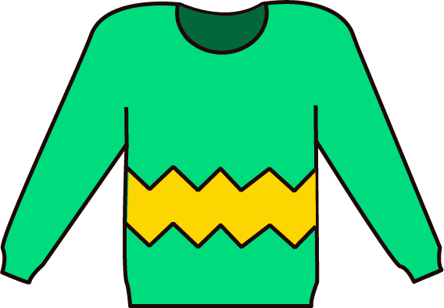 | 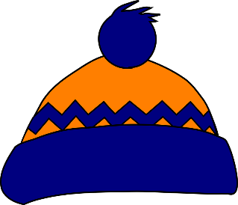 | 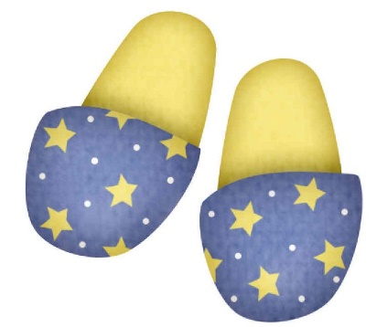
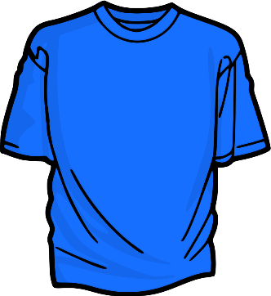 | 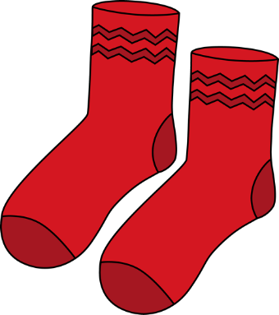 | 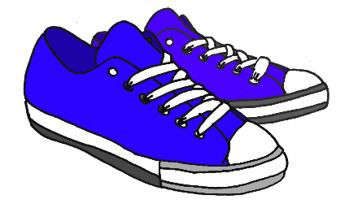
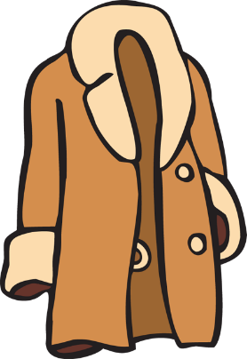 | 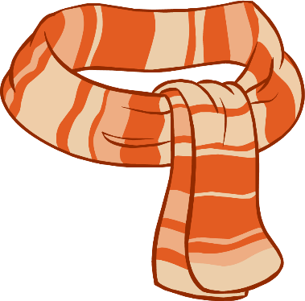 | 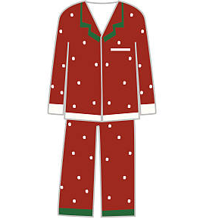
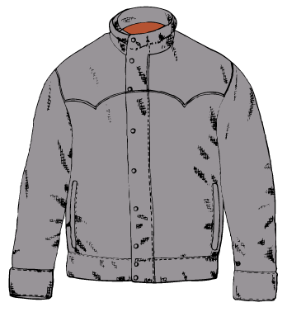 |  | 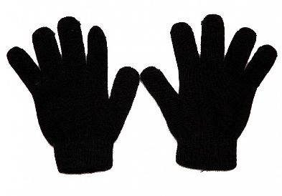

SING A SONG
If we have enough time, we sing a song.
Let’s get dressed song
Link: https://www.youtube.com/watch?v=OAVh6StYLq8

APPENDIX 1:
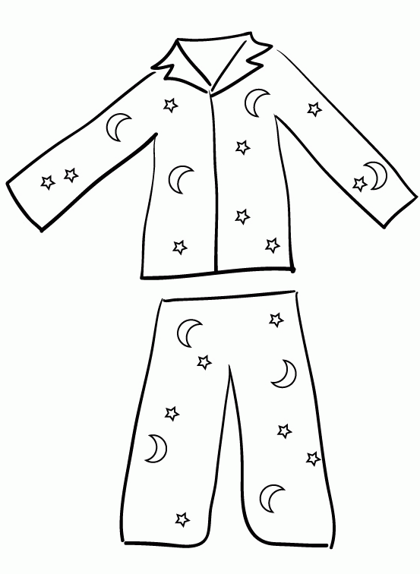 | 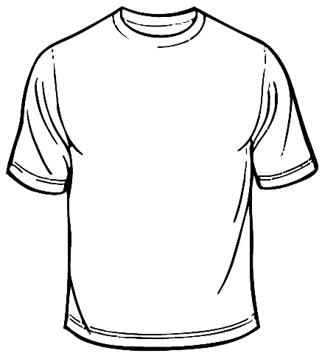 | 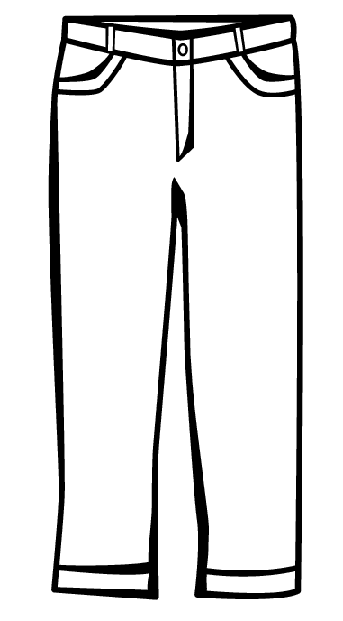
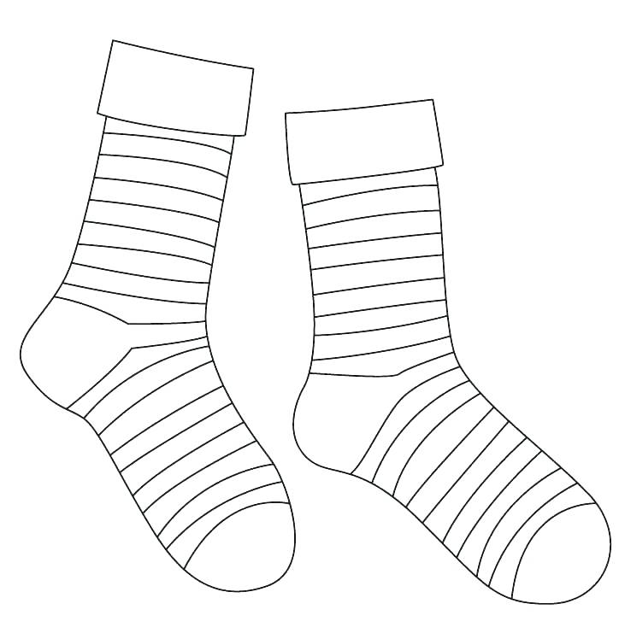 | 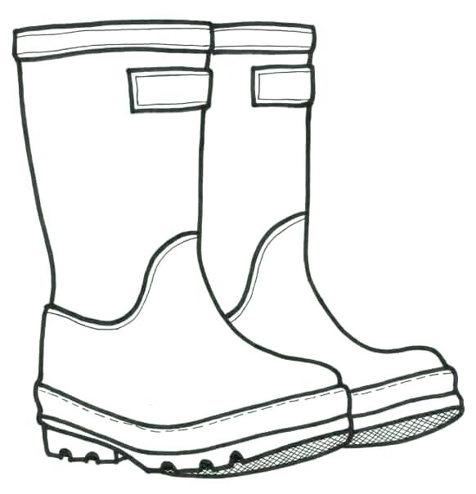 | 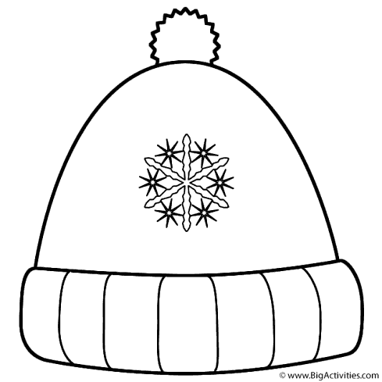
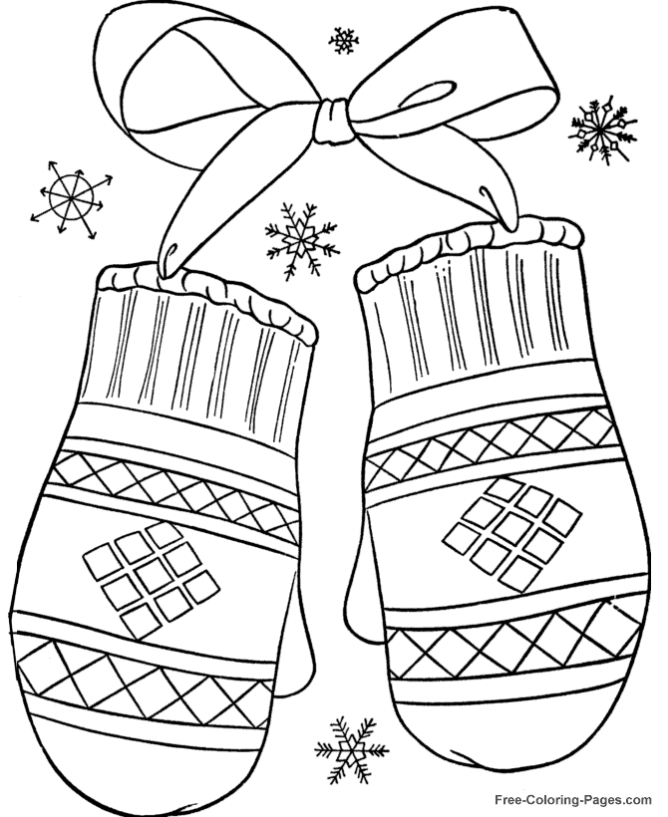 | 