SELF REFLECTION
Name: Matic Suhadolc
Date: 14.3.2023
Class: 3.
Things that went…
…well. | …not as well as I had hoped.
I think everything went quite well. I think singing was the activity that was the best out of all. | I think we should have prepared more pictures of animals for memory games.
If I performed this lesson again with a similar class I…
would… / because… | would not… / because…
I would perform same activities because I think they were all accepted very well. I would do more singing just to memorize lyrics better. | I would not put pictures on the chair because they were sliding off the chair a lot.
Interesting or memorable points/things/thoughts from the lesson…
I think the most interesting thing was how well accepted the song were. I also remember how much fun we were having while playing pantomime. We were moving around a lot and were having a lot of fun.
My use of FL...
I think my use of English was very good. I think I could improve on my speaking a little bit but I think it was not too bed. Communication with others was realy good, I was quite surprised by how smooth our conversation was.
As a result of this lesson I now realise…
I realize that we as kindergarten teachers have a lot of power over what we present to kids. I think we should use a lot more song even if they are “home made”. I will definitely use song that we wrote in my group at work and I will definitely improvise more as it gives off a lot more genuine vibe.

ALL COLLECTED MATERIAL
Topic: Animals
VOCABULARY:
- Animals  - Parrot  - Bird  - Seal  - Monkey  - Penguin  - Butterfly  - Hyenas | - Giraffe  - Polar Bear  - Lion  - Lioness  - Zebra  - Cat  - Eagle  - Leopard | - Dog  - Fish  - Rabbit  - Elephant  - Deer  - Snake  - Bear  - Gorilla | - Mouse  - Dolphin  - Horse  - Pig  - Cow  - Sheep  - Turtle  - Hippo

STORY BOOK
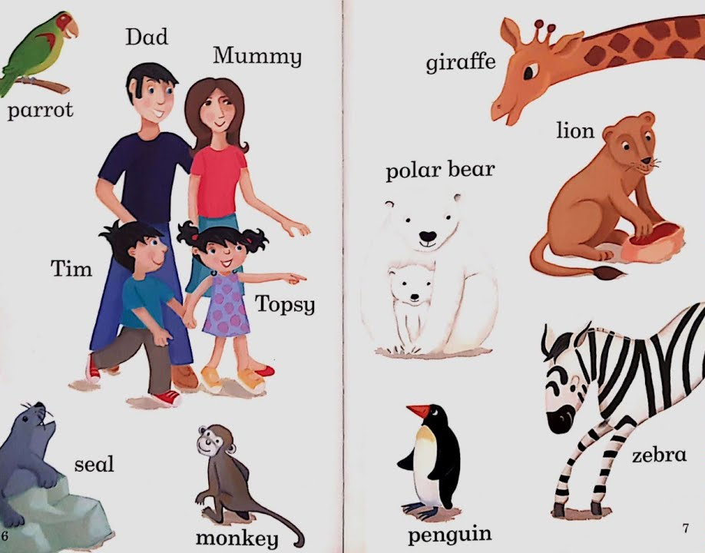
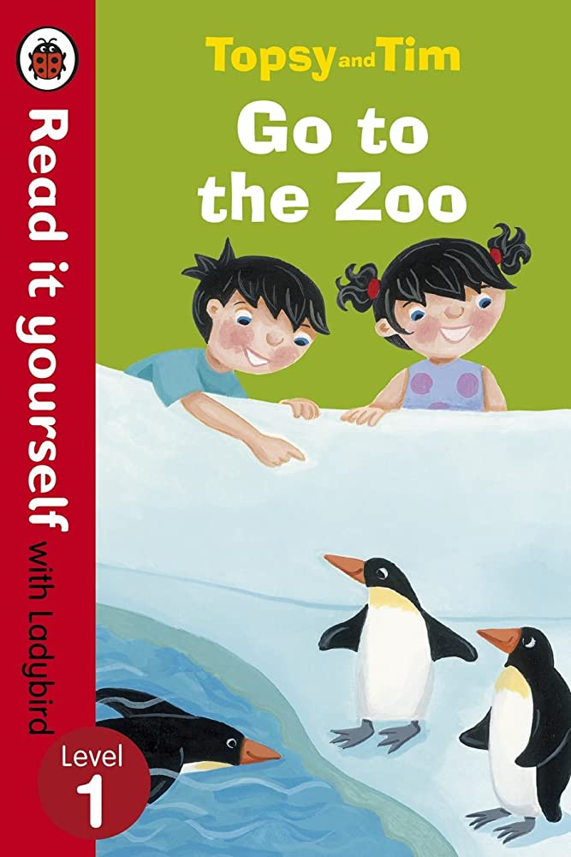
Adamson, J. in G. (2013). Topsy and Tim go to the Zoo. Penguin Books Ltd.

ILUSTRATED ENCYCLOPEDIA
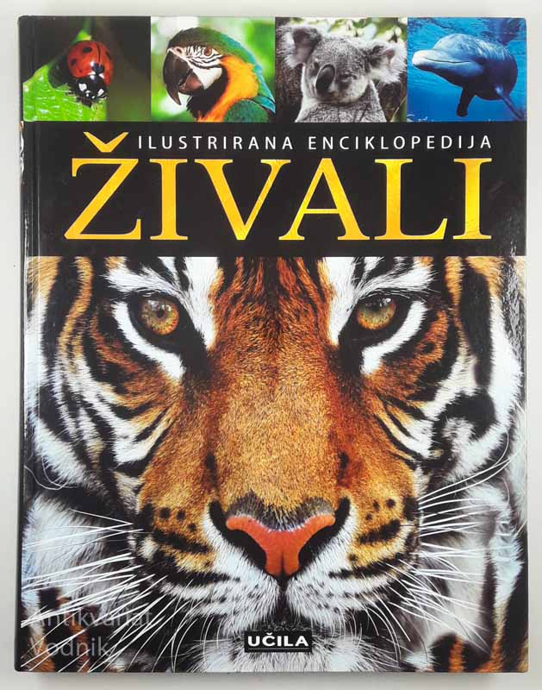

Burnie, D. (2010). Živali. Učila international.

CARD GAMES:
Find your soulmate!
Kids get an animal. They have to find their soulmate. One kid says out loud: “I have a lion”. Then a kid with a lioness says: “I have a lioness, come here”. The first kid says: “I´m coming soulmate”. We repeat this until everyone has found their soulmate. (Appendix)

Memorize Animals!
Kids get a pack of cards, which have pictures of different animals. Every animal has a pair. They put the cards on the table and turn them face down. Then one kid opens a card, names the animal and then tries to find the animal´s pair (he only has one chance, if he doesn´t find the pair he has to put the cards back face down, if he finds the pair, he keeps the cards). A player with the most cards in the end wins. (Appendix)

REPEATING ACTIVITY:
Find it!
Children get a picture of animals. Kindergarten teacher names an animal, which they have to find and point at. (Appendix)
MIND GAME:
Animal Puzzles
Kindergarten teacher chops animal pictures in to different pieces, which children then put together. When they put the pieces together they name the animal.

MOVEMENT ACTIVITIES:
Name and show!
Kids make a circle. Kindergarten teacher puts pictures of animals face down on the floor in the middle of the circle. One kid at a time takes one of the pictures, names the animal and then shows how the animal moves. (Appendix)

Pantomime and name!
Kids make a circle. Kindergarten teacher puts pictures of animals face down on the floor in the middle of the circle. One kid at a time takes one of the pictures, pantomimes the animal, other kids have to guess which animal is pantomimed. After one of the kids correctly guesses the name, everybody repeats it after him. (Appendix)
Animals go home!
Kindergarten teacher makes a number of different animal dens based on the number of kids (15 kids 1 per 5 kids or vice versa). Every kid takes a picture of animal. Kindergarten teacher then plays some music to which kids dance on based on the animal they chose, when the music stops, kindergarten teacher says: ”Lions go home”., and then kids who have pictures of a lion have to go to the correct den, which is marked with a stuffed animal.
SONGS:
The pet´s song (Vintar, Ž. Melodija, besedilo)(Suhadolc M. Kitara)

The cat likes to purr al day
she meows and likes to play.

The dog likes to play with stones
he barks and chews on bones.

These are the animals that we call pets.
these are the animals that we call pets.

The savanamals (Vintar, Ž. Melodija, besedilo)(Suhadolc M. Kitara)

Hippo likes to dive and swim,
hyenas like to scream.

Lion likes to roar and lay,
the elephant is grey.

These are savanamals.
these are savanamals.
these are savanamals.

The jungle fools (Vintar, Ž. Melodija, besedilo)(Suhadolc M. Kitara)
Gorillas are so big and brave,
monkeys are so small and afraid.

Frogs are jumping out of the lake,
sloths are sleeping they re not awake.

Aligator’s watching hippos bath,
leopard’s running cause he is late.

These are jungle animals,
they like to play.
ALL PICTURES ARE IN APPENDIX.
WEBPAGES:
When planning, pay attention:
- https://www.theteflacademy.com/blog/2017/09/how-to-teach-english-as-a-foreign-language-to-young-learners/
- https://busyteacher.org/4087-how-to-teach-preschoolers-preschool-games-and.html
- https://busyteacher.org/2921-teaching-english-vocabulary-10-fabulous-ways-to.html
Activities on topic animals:
- https://www.preschoolplayandlearn.com/preschool-animal-theme/

_____________________________________________________________________________
OUR PRESENTATION:

Topic: Animals
Age of children: 5 – 6 years
VOCABULARY:
- Animals  - Parrot  - Bird  - Seal  - Monkey  - Penguin  - Butterfly  - Hyenas | - Giraffe  - Polar Bear  - Lion  - Lioness  - Zebra  - Cat  - Eagle  - Leopard | - Dog  - Fish  - Rabbit  - Elephant  - Deer  - Snake  - Bear  - Gorilla
A STORY BOOK
Adamson, J. in G. (2013). Topsy and Tim go to the Zoo. Penguin Books Ltd.
We will read the book and ask questions along the way.

REPEATING ACTIVITY
Find it!
Children get a picture of animals. Kindergarten teacher names an animal, which they have to find and point at. (Appendix)

CARD GAMES
Find your soulmate! 1
Kids get an animal. They have to find their soulmate. One kid says out loud: “I have a lion”. Then a kid with a lioness says: “I have a lioness, come here”. The first kid says: “I´m coming soulmate”. We repeat this until everyone has found their soulmate. (Appendix)

Memorize Animals!
Kids get a pack of cards, which have pictures of different animals. Every animal has a pair. They put the cards on the table and turn them face down. Then one kid opens a card, names the animal and then tries to find the animal´s pair (he only has one chance, if he doesn´t find the pair he has to put the cards back face down, if he finds the pair, he keeps the cards). A player with the most cards in the end wins. (Appendix)

MOVEMENT ACTIVITIES:
Pantomime and name!
Kids make a circle. Kindergarten teacher puts pictures of animals face down on the floor in the middle of the circle. One kid at a time takes one of the pictures, pantomimes the animal, other kids have to guess which animal is pantomimed. After one of the kids correctly guesses the name, everybody repeats it after him. (Appendix)

SONGS:
The pet´s song (Vintar, Ž. Melodija, besedilo)(Suhadolc M. Kitara)

The cat likes to purr al day
she meows and likes to play.

The dog likes to play with stones
he barks and chews on bones.

These are the animals that we call pets.
these are the animals that we call pets.

The savanamals (Vintar, Ž. Melodija, besedilo)(Suhadolc M. Kitara)

Hippo likes to dive and swim,
hyenas like to scream.

Lion likes to roar and lay,
the elephant is grey.

These are savanamals.
these are savanamals.
these are savanamals.

The jungle fools (Vintar, Ž. Melodija, besedilo)(Suhadolc M. Kitara)
Gorillas are so big and brave,
monkeys are so small and afraid.

Frogs are jumping out of the lake,
sloths are sleeping they re not awake.

Aligator’s watching hippos bath,
leopard’s running cause he is late.

These are jungle animals,
they like to play.

APPENDIX
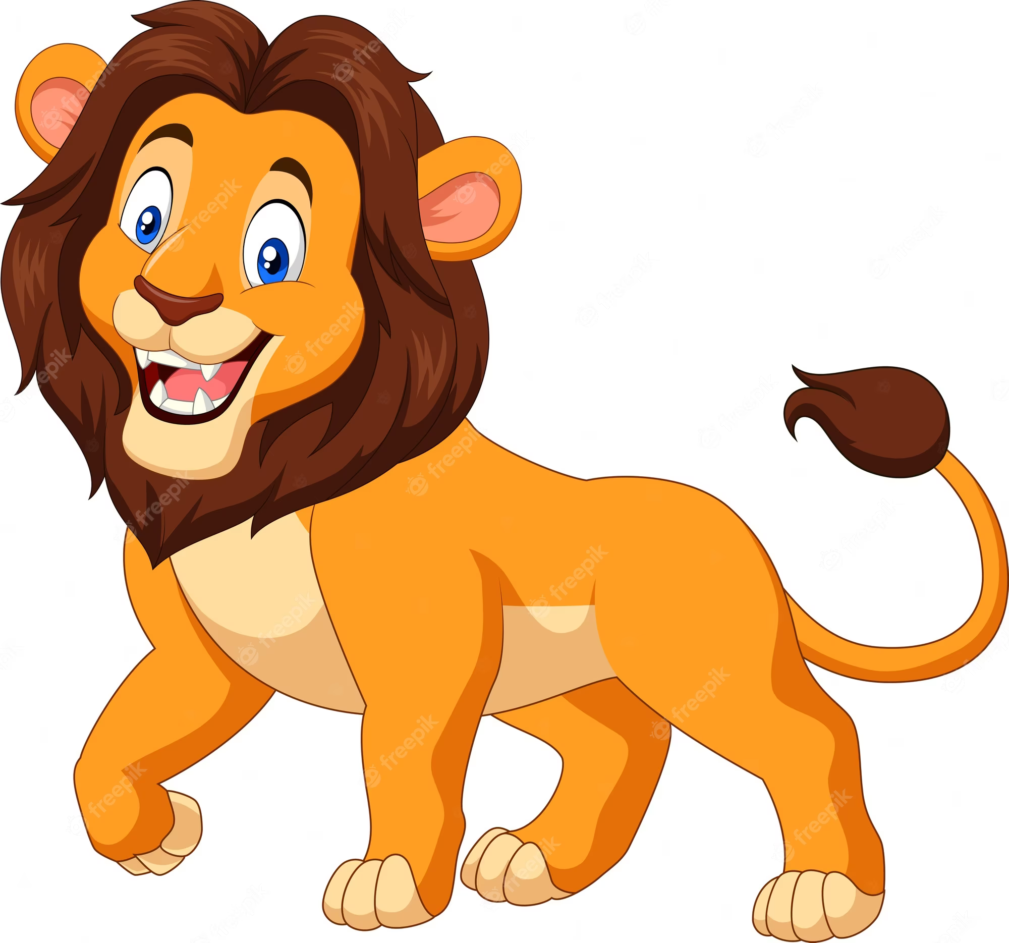 | 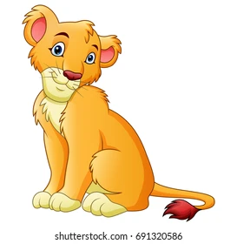 | 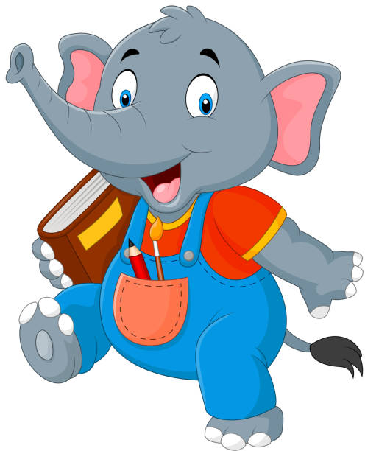
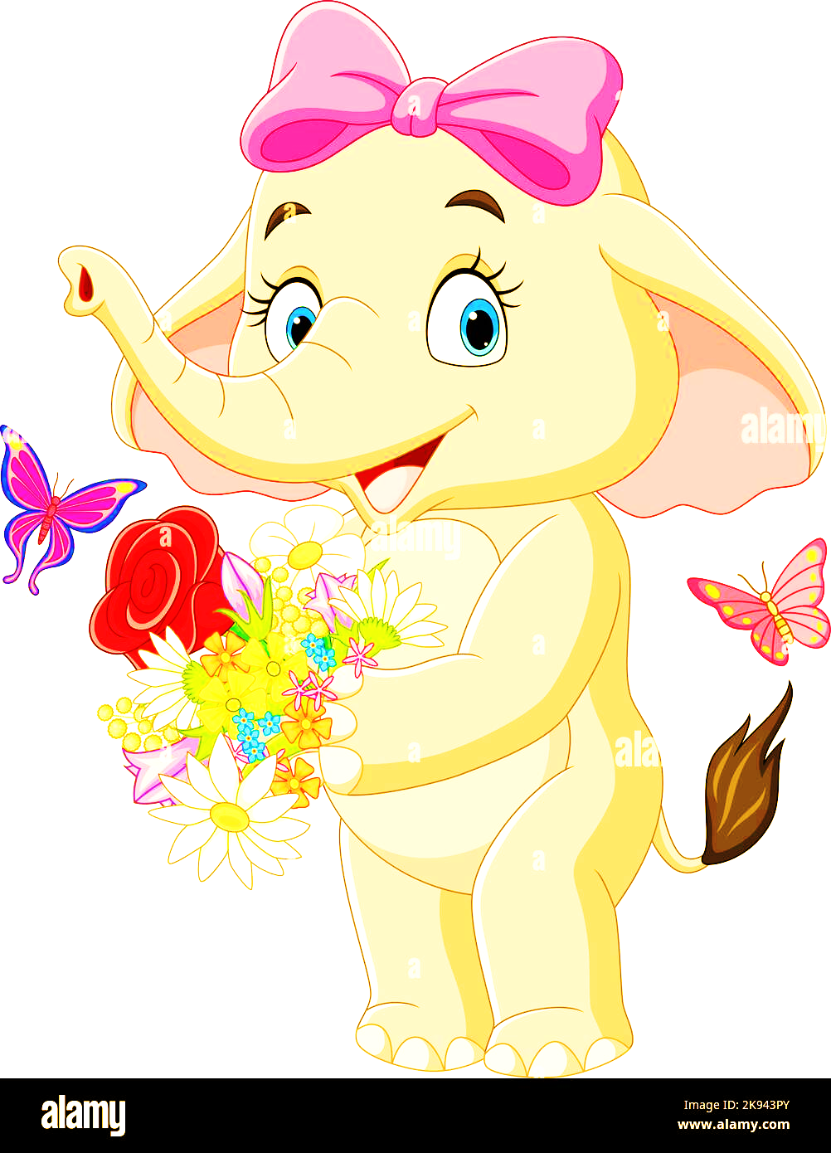 | 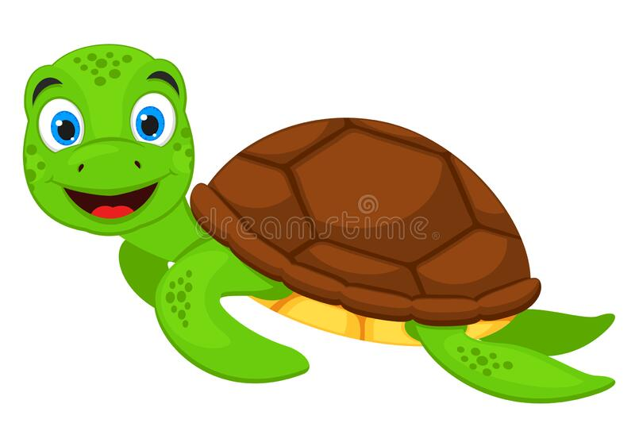 | 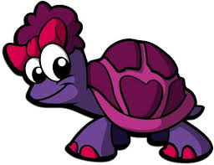
 | 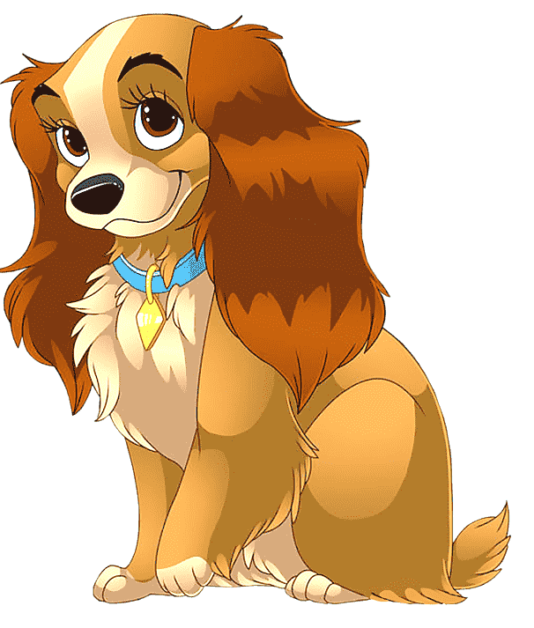 | 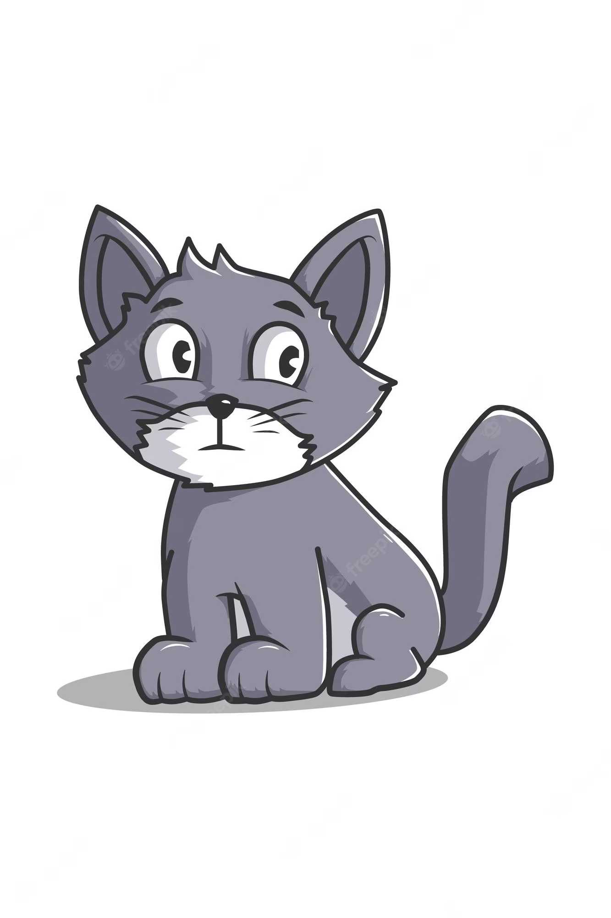
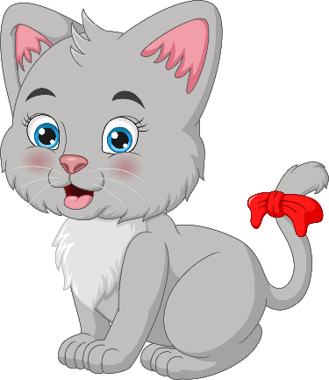 | 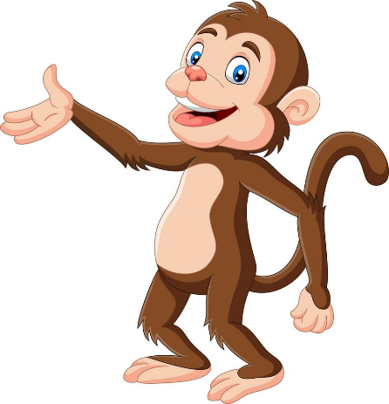 | 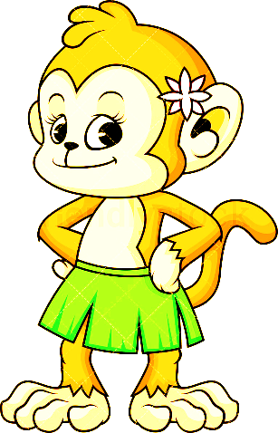
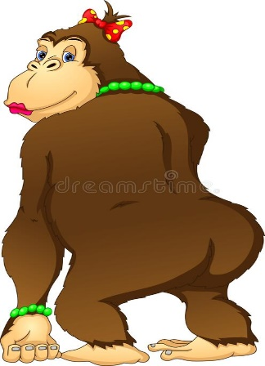 | 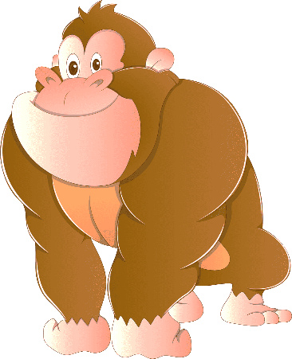 | 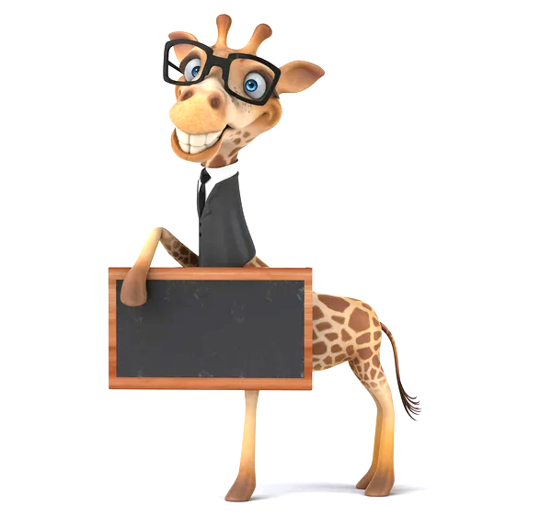
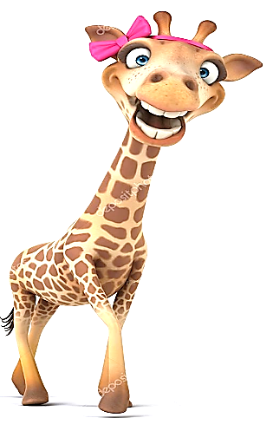 |  | 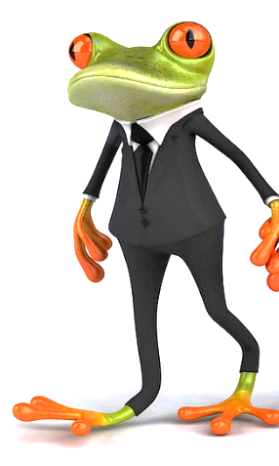
 | 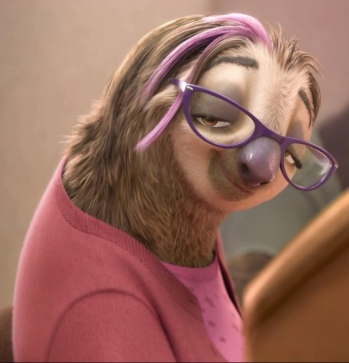 | 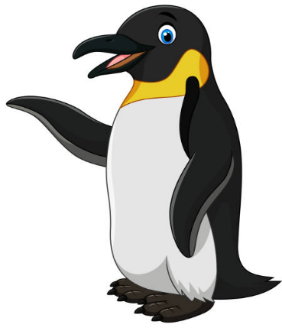
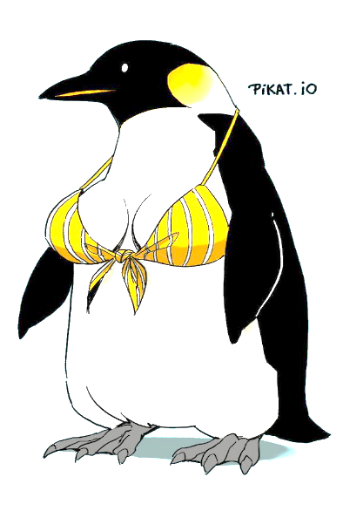 | 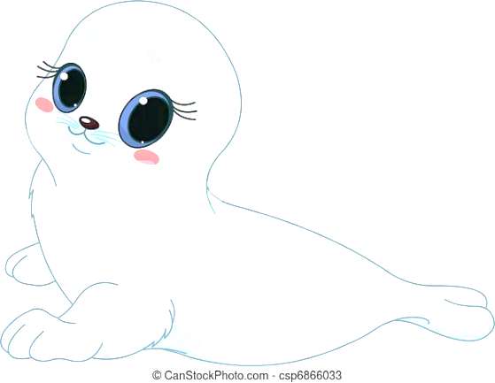 | 