ALL COLLECTED MATERIAL
Topic: Animals

VOCABULARITY:
Animals | A monkey | A parrot | A tiger | A wolf
Zoo | An elephant | A bear | A kangaroo | A hyena
Cage | A zebra | A lion | A snake | A meercat
A spider | A crocodile | A giraffe | Fish | A panda
A camel | A hippo | A deer | A racoon | A fox

CARD GAMES:
Which animal is this?
Kids sit in a circle and each up one card from the deck. They show it to class and name which animal is on the picture. We can play this game as long as we want. After all kids name the animal, they give the card back and pull another one.

Miming game
Each kid pull one card from the deck and keep it to him/her self. They cannot show it to anybody. Every kid then show to everybody which animal is on the picture, without talking. Other kids must guess what animal it is.

PICTURES:
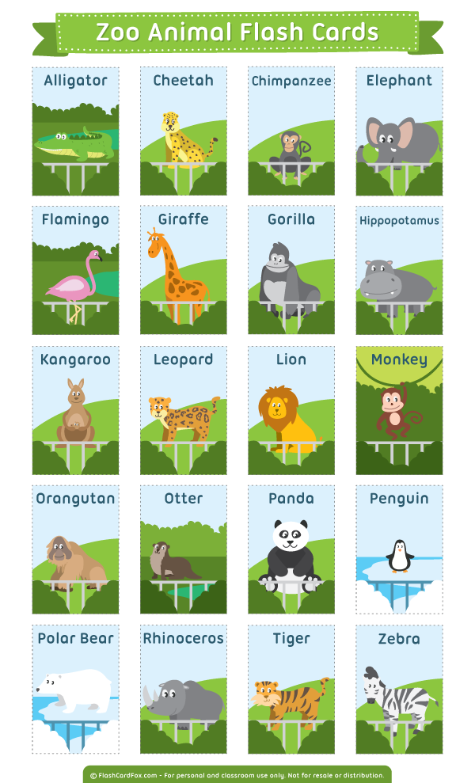

Flashcards:
https://supersimple.com/free-printables/super-simple-songs-animals-complete-flashcards/
https://learnenglishkids.britishcouncil.org/print-make/flashcards/wild-animals-flashcards
https://www.mes-english.com/flashcards/animals.php

SONGS:
I like animals.
https://www.youtube.com/watch?v=yS1zl4g7HLA
Wild animals (for guessing with is it).
https://www.youtube.com/watch?v=v5aVK0APPkU
The animal song
https://www.youtube.com/watch?v=wCfWmlnJl-A

BOOKS:
Ladybird Animal Stories read by Cassie Layton
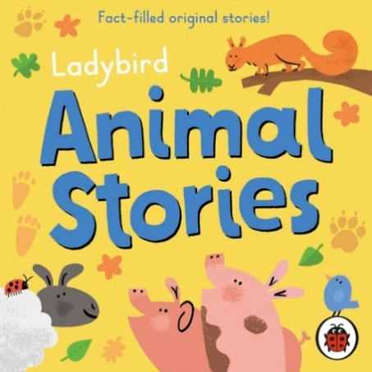
A Ladybird Buggy Book: Animals
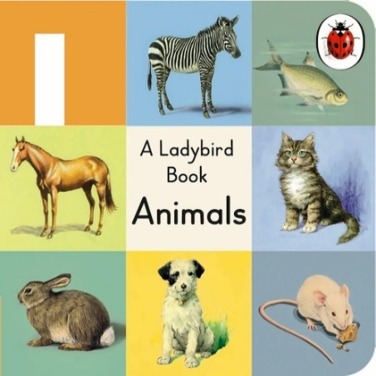
First 100 animals: lift the flap
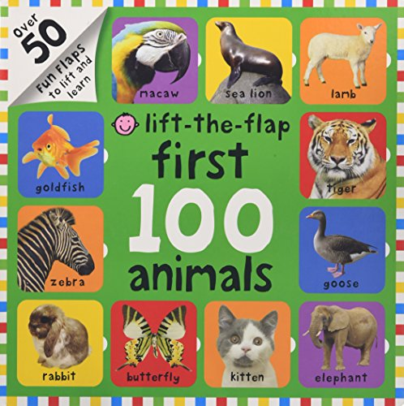
OUR PRESENTATION
Topic: animals
Age: 5-6 years
VOCABULARY:
Animals | A monkey | A parrot
Zoo | An elephant | A bear
Cage | A zebra | A lion
 | A crocodile | A giraffe

CARD GAMES:
Which animal is this?
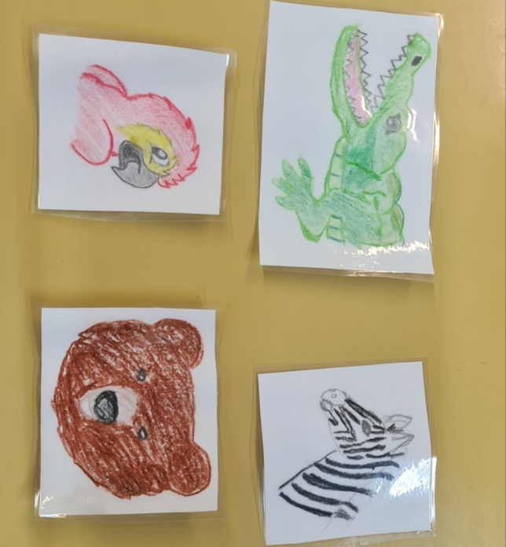
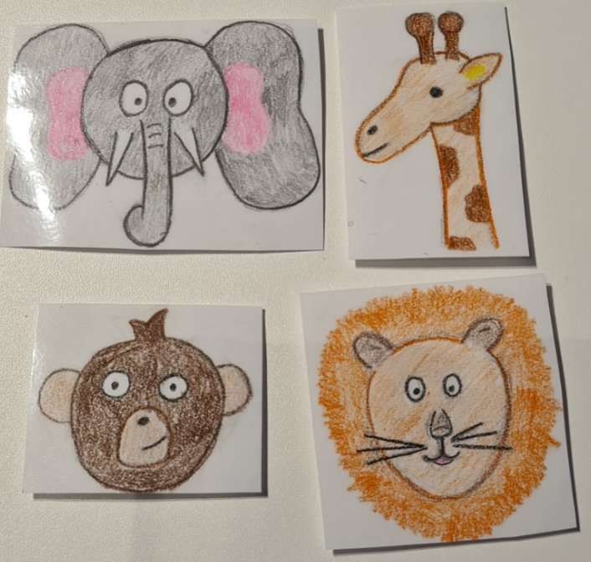
Kids sit in a circle and each up one card from the deck. They show it to class and name which animal is on the picture. After all kids name the animal, they give the card back. If the kids are into it, they can pull another one.

PANTOMIME:
Each kid get one card and they cant show it to the others. One kid at the time show which animals he/she has by miming not talking. After each kids gets the right answer thenext kids shows his animal. (we can double the cards, so all kids would have one animal)

STORY:
We didn’t use a book for our presentation, but we make up our own.
On two A4 white pages we draw 8 cages for 8 animals that live in a zoo (lion, monkey, giraffe, elephant, crocodile, bear, zebra and parrot).

Then we told kids the story, that we are at the zoo. There are a lot of animals. Oh noo... the animals left their cages and don’t know where are they. Would you help them? We start with first cage and ask the kids: Which animal do you think lives in this cage?, and the kids figure out that it is a lion. Then we move one to another cage and so on. Kids help sord all 8 animals in their cages.
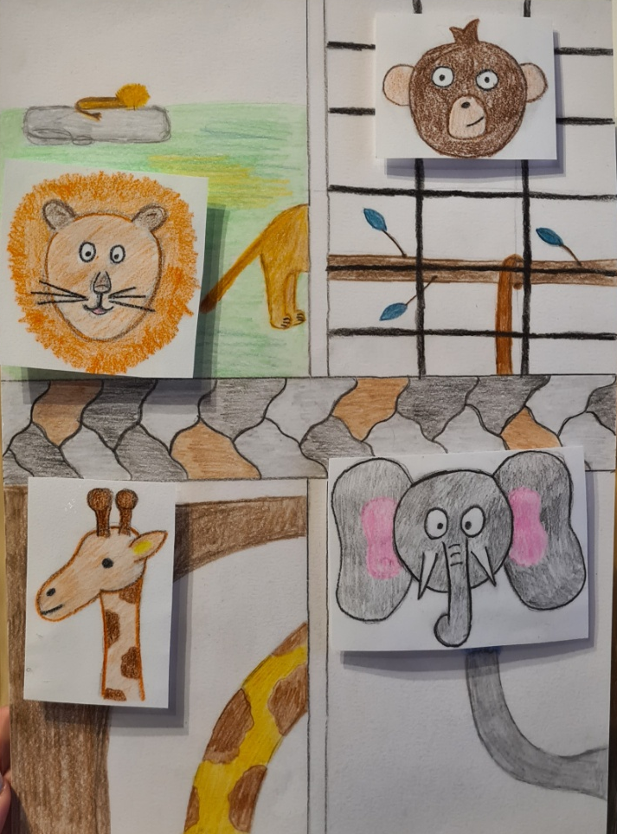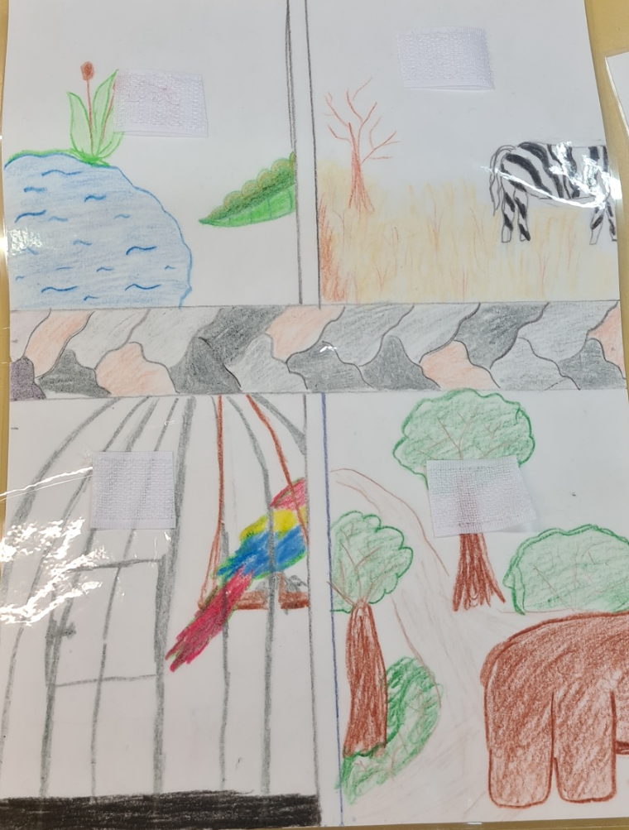

Expend: we can add animals each time, to expend vocabulary for kids. We build big zoo with different animals, than we can move to farm animals, home animals and do something similar.

