  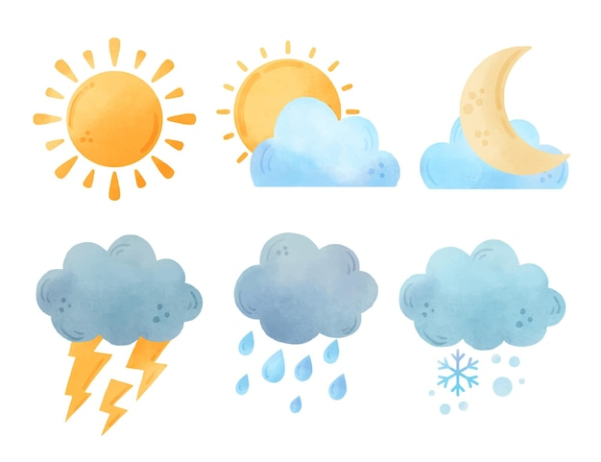
  SNOWING
  RAINING
  SUNNY
  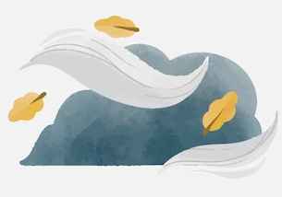
  WINDY
  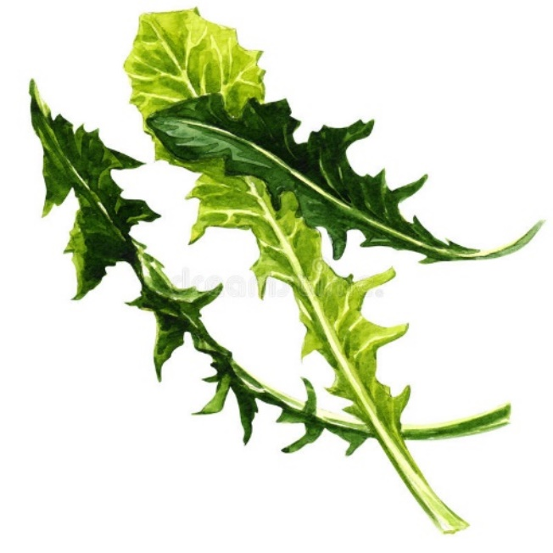
  DANDELION GREENS
  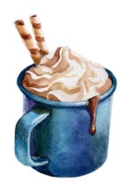
  HOT CHOCOLATE
  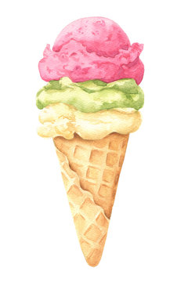
  ICE CREAM
  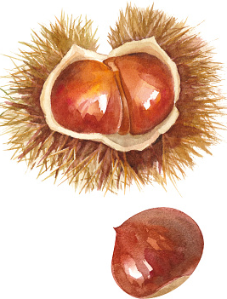
  CHESTNUTS
  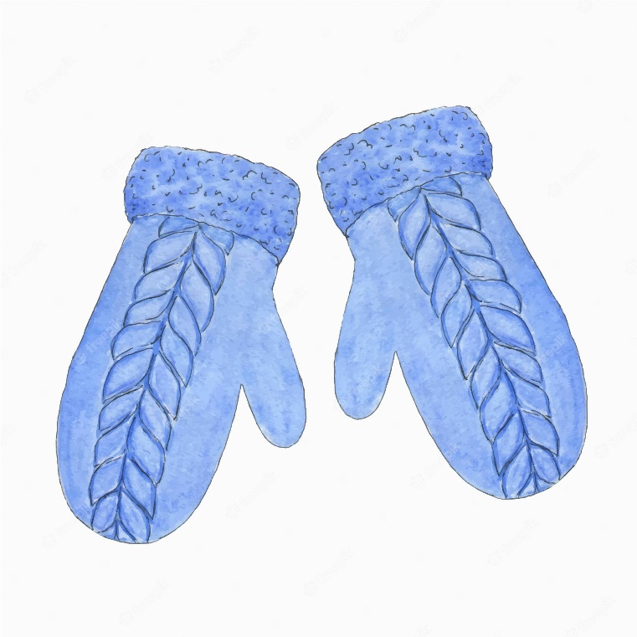
  MITTENS
  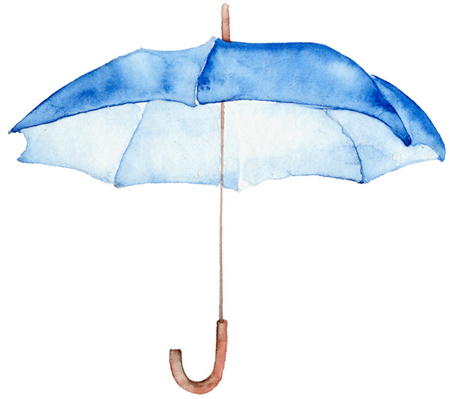
  UMBRELLA
  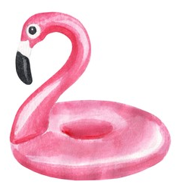
  WATER FLOAT
  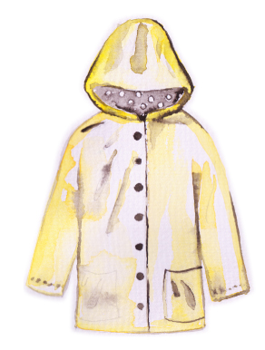
  RAINCOAT
  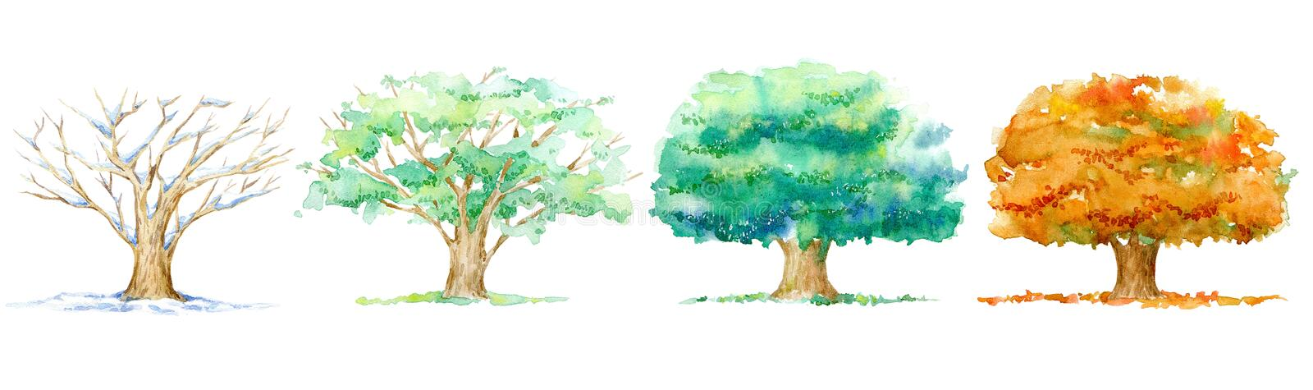
  WINTER
  SPRING
  SUMMER
  AUTUMN

