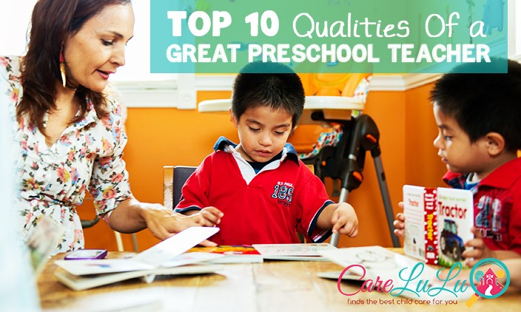
Top 10 Qualities of a Great Preschool Teacher

May 06 2015

Being a preschool teacher is a tough job that doesn’t usually entail the type of social (let alone financial) respect it should. Throw in a demanding and sometimes fussy bunch of parents (and oh yeah, their kids) and you will find classrooms led by the few, the proud, the brave, the preschool teachers.
Finland seems to have bucked the global teacher-undervaluation trend through clever use of what they call “academic sauna.” If you can take the heat and survive the rigorous qualification process, it feels great when you make it through. Finnish teachers’ salaries are not that high but they are as well respected as their peers in medicine and law, for example.
How can you identify a good preschool teacher if you don’t happen to have a Nordic social policy handy? Here are 10 qualities to look for in a great early childhood educator:
1. A great preschool teacher is a true believer. That means she has to be passionate about helping kids and making a difference in their lives. American preschool teachers (or any American teachers, really) are simply not doing what they do for the money. They do it because they believe in it.
2. A true early childhood educator is someone with a heart. Preschoolers need a lot of warmth and understanding. If you have to choose between qualifications and heart, go with heart every time.
3. A great child care provider is patient. Preschoolers are not cherubs. They don’t jive that well with short fuse personalities!
4. A wonderful caregiver is tolerant. Each kid is a little different. Cookie cutters are tools for kitchen activities, not early childhood education.
5. A good preschool teacher is perseverant and inventive. They’ll get the job done even if it means coming up with a new way to do it.
6. A great preschool director is realistic. Not every problem has an immediate solution especially when it comes to children.
7. A good early childhood educator is honest. If there is a problem, being ignorant and avoiding it is the worst course of action. Opening lines of communication with parents is critical.
8. A great child care center director is organized. Kids like predictable routines and for the most part, their parents do too. Especially when it comes to teacher reports and conferences.
9. A good child care provider is tidy. The smaller the children, the more important it is to keep their play area clean.
10. A great preschool teacher is not afraid to laugh! A sense of humor is a huge asset (sometimes the only asset) that can help get through a day with a fussy preschooler.
https://www.carelulu.com/resources/parents/top-10-qualities-great-preschool-teacher/

