How to Include Spanking in Child Discipline
Effective discipline is when a parent or caretaker is able to shape a child’s actions to create desirable behavior. The focus of any disciplinary action should be on creating order and promoting good moral character. Although there are many different ways to implement correction some strategies have been proven to be more effective than others. Therefore, it’s very important to educate yourself on how to most effectively discipline your children.

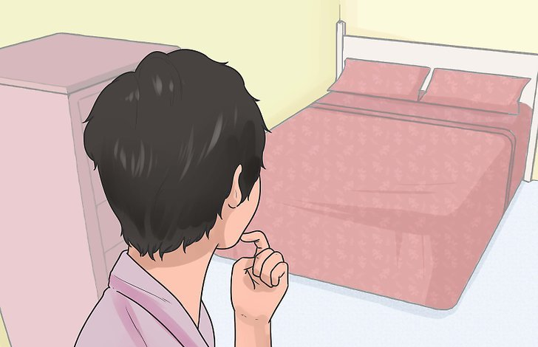
Spanking Only as a Last Resort

1. Find a private area. Conducting this type of discipline in a private area preserves the dignity of your child and prevents unnecessary embarrassment. The focus should be on discipline and additional embarrassment for your child should be minimized.
  - Most experts are adamant that children should never be spanked under any circumstances. Nonetheless, some parents believe that spanking is the best way to get children to adhere to rules. Whatever your position is on spanking, it’s clear that spanking can have some negative consequences. Therefore this method of discipline should be used sparingly and only to prevent your child from engaging in dangerous activities.
  - Be sure that siblings and other children are not present during the spanking.
  - If a spanking occurs in a public place you should take your child to a private area away from onlookers.

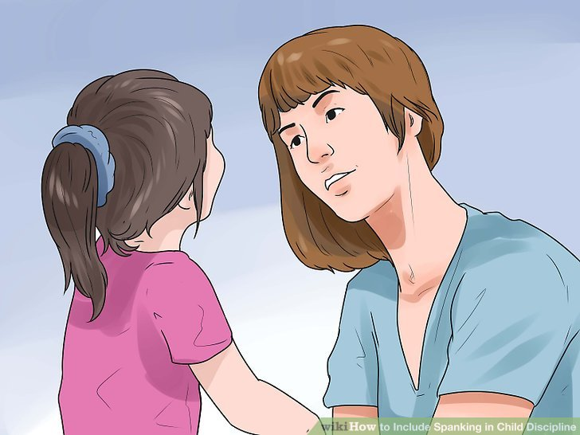
2. Explain to your child why he/she is being spanked. It is important that your child understands why he is being disciplined so that he learns what is acceptable and unacceptable behavior. Try to use all discipline, including spankings, as a teaching opportunity and not just punishment.
  - Be sure to use clear age appropriate language that your child understands when you explain the consequence.
  - For example you could say, "Donnie, you were running through the house with the scissors and almost ran into your brother. I have already given you a warning about this behavior so now it is time for a spanking."
  - Whenever possible, give your a child a warning before proceeding to spanking. This will allow him/her the opportunity to adjust his behavior to avoid the spanking.
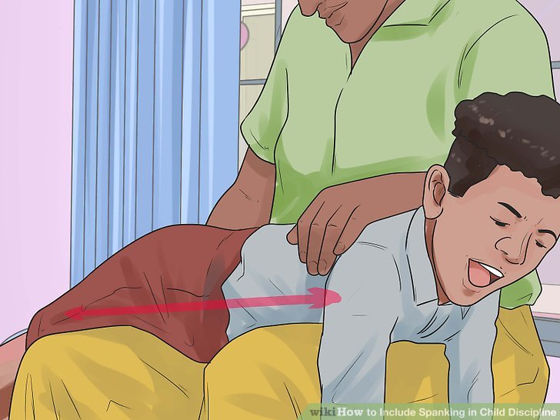
3. Allow younger children to lie across your lap with their bottom facing up. This position allows you to spank the child appropriately without causing injury. However, older children may stand up facing forward.
  - Make sure that your child is fully clothed during spankings. Spankings on bare skin can cause bruising and other avoidable injuries.
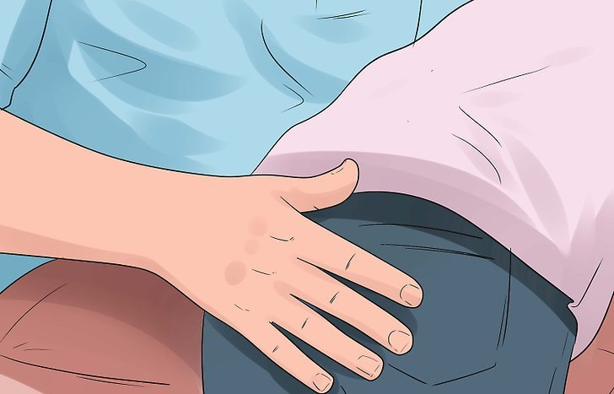
4. Pat your child on the backside. Be sure to use an open hand and use limited force. Pats should never leave any bruising or marks of any kind. The focus should be on teaching your child better behavior, not hurting him/her.
  - Objects should never be used to spank your child and you should limit spankings to approximately three to four pats on the backside.
  - Never spank your child when you are angry. Any spankings should be done when you are calm. This will help you avoid unintentional injury.
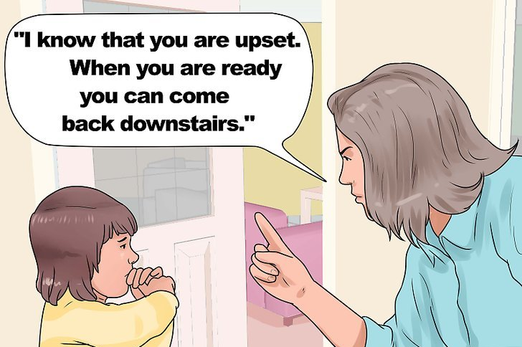
5. Allow your child to return to his normal routine. When the spanking concludes your child will likely be upset. Allow him/her the opportunity to calm down. Let him/her know that when he is ready that he can resume normal activity.
  - For example you could say, "I know that you are upset. When you are ready you can come back downstairs."

