Spanking Can Be an Appropriate Form of Child Discipline

Jared Pingleton
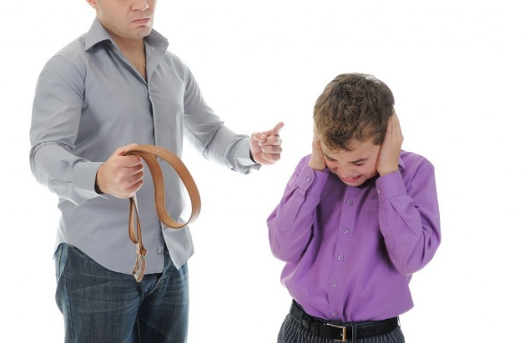
Sep 16, 2014
NFL running back Adrian Peterson’s recent arrest for allegedly abusing his four-year-old son has once again sparked the debate over whether spanking is an appropriate form of discipline. Though some contend any form of physical correction equates to child abuse, there is a giant chasm between a mild spanking properly administered out of love and an out-of-control adult venting their emotions by physically abusing a child.
At Focus on the Family we believe that parents have been entrusted with the incredible privilege and responsibility of shaping their children’s behavior in a positive direction. Unfortunately, each of us enters this world with desires that are selfish, unkind, and harmful to others and ourselves. Spanking, then, can be one effective discipline option among several in a parents’ tool chest as they seek to steer their children away from negative behaviors and guide them toward ultimately becoming responsible, healthy, happy adults.
It is vital, however, that spanking be administered within proper guidelines. The reports about the punishment meted out by Peterson to his son, and the consequent injuries his son suffered, indicate his behavior on that occasion was far outside those boundaries. These kinds of experiences are why this whole issue is fraught with controversy – a child should never be abused.
Properly understood and administered, spanking is most effective as a deterrent to undesirable behavior for younger preschoolers (but never for infants). That’s because reasoning and taking away privileges often simply don’t work with kids in that age range. As children age, spanking should become even less frequent as other types of consequences are utilized. Spanking should be phased out completely before adolescence.
Generally speaking, we advise parents that corporal discipline should only be applied in cases of willful disobedience or defiance of authority—never for mere childish irresponsibility. And it should never be administered harshly, impulsively, or with the potential to cause physical harm. Along those lines, we caution parents who have a hard time controlling their temper to choose alternative forms of discipline. There is never an excuse or an occasion to abuse a child.
For parents who do choose to spank, the proper philosophy and approach is extremely important. Too begin with, as with all forms of correction, the concepts of punishment and discipline are absolute opposites. Punishment is motivated by anger, focuses on the past, and results in either compliance (due to fear) or rebellion and feelings of shame, guilt and/or hostility. On the other hand, discipline is motivated by love for the child, focuses on the future, and results in obedience and feelings of security.
This is because the term discipline derives from the root word “disciple” which means “to teach.” Parents have an ongoing opportunity and responsibility to teach our children how to love well and live life as effectively and healthfully as possible. What we want children to understand is that the gentle sting of a spanking is connected to the greater and often long-term pain of harmful choices. Simply put, prevention is easier than cure.
A child should always receive a clear warning before any offense that might merit a spanking and understand why they are receiving this disciplinary action. If he or she deliberately disobeys, the child should be informed of the upcoming spanking and escorted to a private area. The spanking should be lovingly administered in a clear and consistent manner. Afterward, the lesson should be gently reiterated so that the child understands and learns from this teachable experience.
Many parents today view themselves primarily as their child’s friend and recoil at the idea of administering discipline. Children, though, desperately need their parents’ love and affirmation as well as their authoritative guidance and correction. Disciplining our sons and daughters is part of the tough work of parenting, but it will pay big dividends in the long run.
The author of the Bible’s book of Hebrews writes, “No discipline seems enjoyable at the time, but painful. Later on however, it yields the fruit of peace and righteousness to those who have been trained by it” (Hebrews 12:11, HCSB). So spanking, when used judiciously, appropriately, and in combination with other disciplinary techniques, can be a helpful part of training our children.
Let me offer a final word on the national tragedy of child abuse. I oversee Focus on the Family’s counseling department, and my colleagues and I deal with the fallout from those who were abused as children on a daily basis. The pain from these horrific memories lingers with many of these individuals for a lifetime. Abusing a vulnerable child is always, and extremely, damaging and wrong.
That’s why my heart goes out to Adrian Peterson’s young son. Peterson has apologized for his behavior and expressed his desire to be a good father to his son, to, in his words, “teach my son right from wrong.” I earnestly hope he has learned from this serious mistake, and I wish him well in his desire to be a good father.
Parenting is a hard job. None of us do it perfectly. And to make it even more challenging, none of our kids come with an instruction manual attached. But our children need us to do it to the best of our ability, with all the wisdom, love, gentleness and strength we can muster. We won’t go wrong if we exercise a firm and consistent hand with a soft and loving heart.

