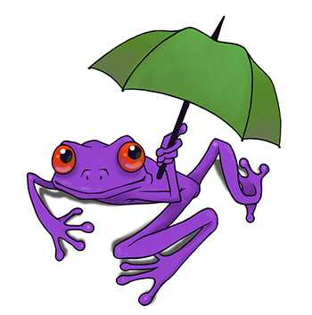
Teacher Jokes

1. A first grade teacher handed out a coloring page to her students - on it was a picture of a frog holding an umbrella.

When the class handed them in, one little boy had colored the frog bright purple. The teacher scolded him, asking, “How often have you seen a purple frog?”

The little boy answered, “The same number of times I've seen a frog holding an umbrella.”

2. Teacher: If I had ten apples in my right hand and nine in my left, what would I have?
Student: Huge hands!

3. Teacher: Annie, what's the chemical formula for water?
Annie: H I J K L M N O.
Teacher: What are you talking about?
Annie: Didn't you say it's H to O?

4. Mrs. Johnson wrote on the chalk board, “I ain’t had no fun all summer.”
“So, George,” she said. “What should I do to correct this?”
“Get a boyfriend,” George answered.

5. Teacher: Billy, your essay on "My Dog" is exactly the same as your brother's. Did you copy it?
Billy: No, Mrs. White. It's the same dog!

6. Teacher: Megan, why are you doing your multiplication on the floor?
Megan: You said we had to do it without tables!

7. Teacher: I wish you’d pay a little attention, David.
David: I'm paying as little as I can, teacher.

8. Teacher: You missed school yesterday, didn't you?
Student: Not very much.

9. Teacher: I hope I didn't see you looking at Maria's exam.
Student: I sure hope you didn't, either!

10. Teacher: What do you call a fish with no eyes?
Student: Fsh.

11. Teacher: Where's your text book?
Student: At home.
Teacher: What's it doing there?
Student: Having a better day than I am.

