
CLASSROOM LANGUAGE - RHYMES AND SONGS

Children usually like singing and performing. It helps them feel at ease with English.

You could use chants, rhymes and songs:
- for enjoyment
- as part of your teaching plan
- as a change in activity
- to revise vocabulary
- to connect with new or familiar topics
- for drama

A song or rhyme should:
- suit your pupils’ age group and their interests
- match their level of English
- have a catchy, easy to remember melody

Children often sing a song or say chant or rhyme all together. When they are familiar with the rhymes, songs and chants they can perform them by singing or saying different parts in groups. Group performance develops teamwork but it still allows everyone to take part.

- A CHANT
Question group: Who’s having fun?
Spider group: Spiders in the sun.
Question group: Who’s having lunch?
Beetle group: Beetles in a bunch.
Question group: Who’s chewing socks?
Puppies group: Puppies in a box.
Question group: Who’s fast asleep?
Sheep group: Three black sheep.

- teacher reads the whole chant
- teacher reads a line after a line, children repeat after him
- they say the chant all together
- teacher divides children into 5 groups:
  - a question group
  - a spider group
  - a beetle group
  - a puppies group
  - a sheep group
- each group says its own line; a question group questions, the other groups answer
- they add clapping and stamping for holding the rhythm

- TWO LITTLE DICKY-BIRDS

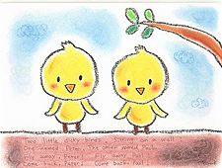
Two little dicky-birds sitting on the wall,
One named Peter, one named Paul.

Fly away Peter, fly away Paul.
Come back Peter, come back Paul.

Two little dicky-birds sitting on the wall,
One named Peter, one named Paul.

- HELLO
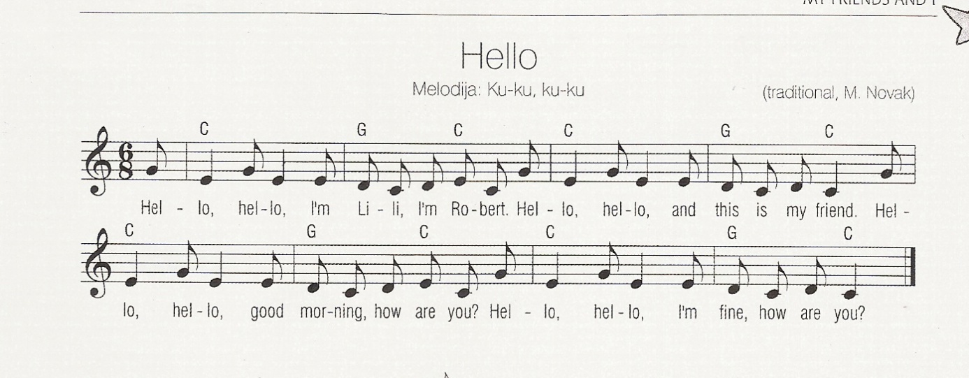

- SHARK
Baby shark, tu tu tu tu tudu (x3)
Mamma shark, tu tu tu tu tudu (x3)
Daddy shark, tu tu tu tu tudu (x3)

Grandma shark, tu tu tu tu tudu (x3)
Going swimming, tu tu tu tu tudu (x3)
Saw a shark, tu tu tu tu tudu (x3)
I swim fast, tu tu tu tu tudu (x3)
Shark attack, tu tu tu tu tudu (x3)
Lost an arm, tu tu tu tu tudu (x3)
Lost a leg, tu tu tu tu tudu (x3)
Swam in circles, tu tu tu tu tudu (x3)
CPR, tu tu tu tu tudu (x3)
It´s too late, tu tu tu tu tudu (x3)
Went to heaven, tu tu tu tu tudu (x3)
Happy shark, tu tu tu tu tudu (x3)
...

USEFUL EXPRESSIONS
- a rhyme
- a chant
- a song
- listen
- repeat
- rhythm
- clap your hands
- stamp your feet
- sing

