Descrivi il tempo: al nord, centro, sud, sulle isole, le temperature massime/minime, i venti e i mari.
Uporabi različne strukture.
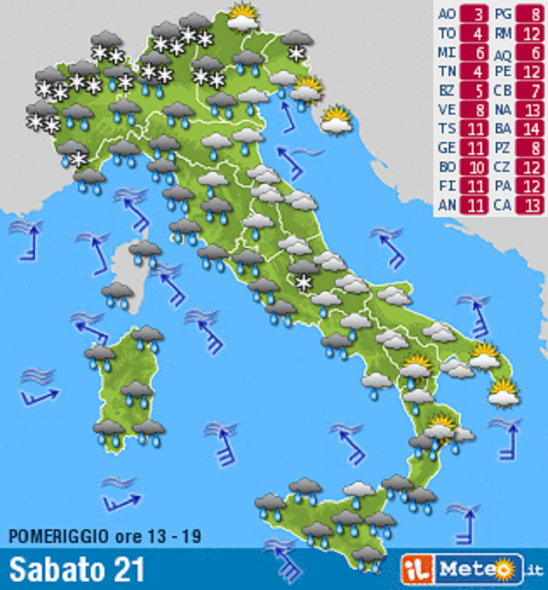
__________________________________________________________________________________________________________________________________________________________________________________________________________________________________________________________________________________________________________________________________________________________________________________________________________________________________________________________________________________________________________

Descrivi il tempo: al nord, centro, sud, sulle isole, le temperature massime/minime, i venti e i mari.
Uporabi različne strukture.




