Comparing food tastes (fruit, vegetables, meat, sweet, salty, bitter, and sour)
Questioning (Why should we eat a lot of vegetables and fruit? is fast food good for our health? Do you eat fast food often? What about sweets?)
Answering (it is healthy to eat vegetables and fruit. Fast food is bad for our health. We should not eat sweets too often.
Giving instructions (describe the food pyramid, look at the pictures, point to …

Types of fruit (cherry, strawberry, blueberry, apple, banana, orange, watermelon)
Types of vegetables (potato, cabbage, carrot, beans, lettuce, eggplant, cucumber)
Meat (steak, bacon, pork beef, sausage, salami)
Fast food (hamburger, pizza, hot dog, sandwich, ketchup)
Sweets (pie, cake, pancake, doughnut, cookies, muffin)
Field, tree, garden, water

New language that emerges through learning (vocabulary, phrases, language needed to carry out activities

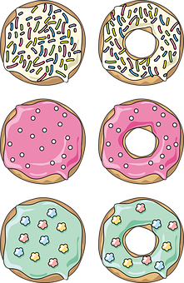
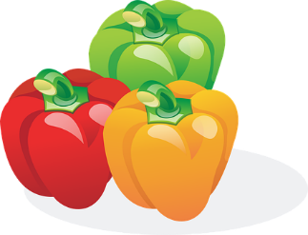
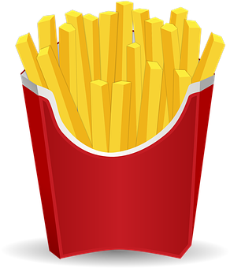
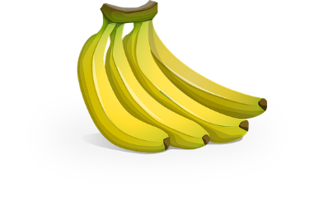
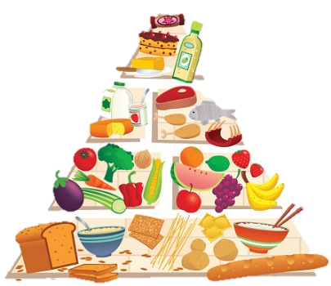
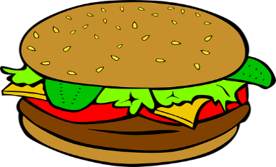
PLAYING
Quiz, classroom games …
ASSESSING
Self-assessment, assessing other students’ project (food pyramid)

Vocabulary building, learning and using
SCIENCE 3rd grade
Language for learning
Language through learning
DOING
Making a food pyramid
Cooking
Drawing food

Food

Food for people
Food for animals
Eating disorders
Language of learning
Where do we grow food?
Types of food
Food for plants
Food and healthy lifestyle
Food in different countries
Timeline of food
Food etiquette around the world
Traditions from around the world
Communication
Cognition
LEARNING, UNDERSTANDING, IDENTIFYING
Where do we get the food from? Distinguish between healthy and unhealthy food. Distinguish between food for animals, plants and people.

Culture
Content

