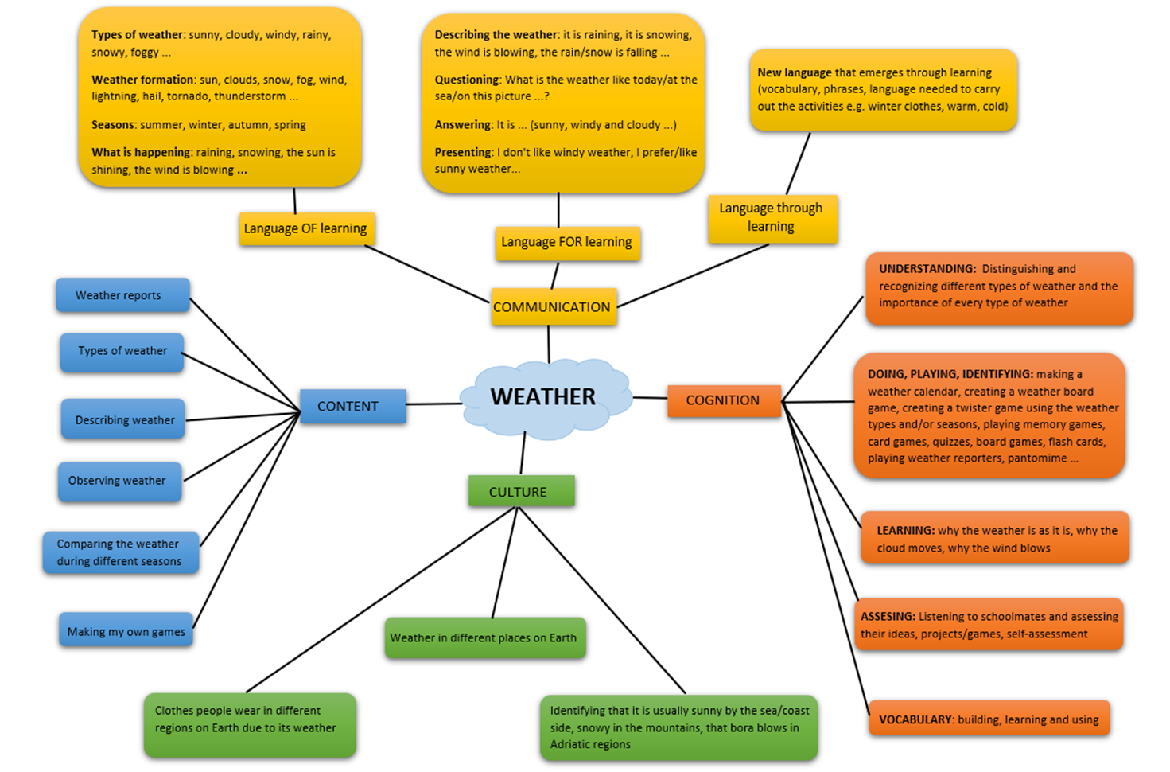
The topic Weather is a part of the science curriculum, 1st – 3rd grade, best for 2nd grade

