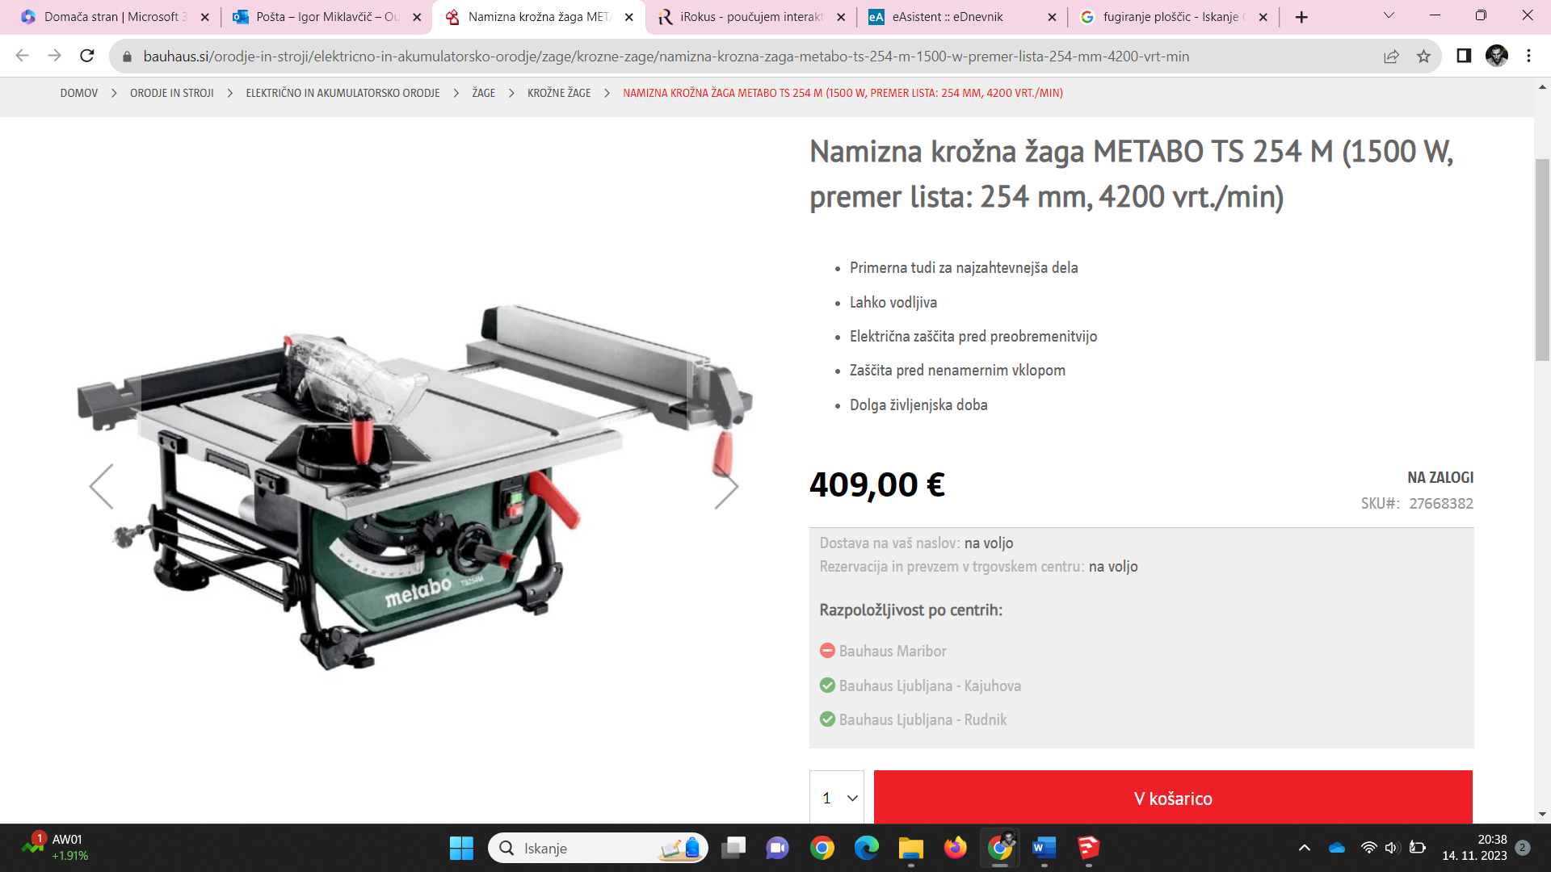

https://www.bauhaus.si/orodje-in-stroji/elektricno-in-akumulatorsko-orodje/zage/krozne-zage/namizna-krozna-zaga-metabo-ts-254-m-1500-w-premer-lista-254-mm-4200-vrt-min

