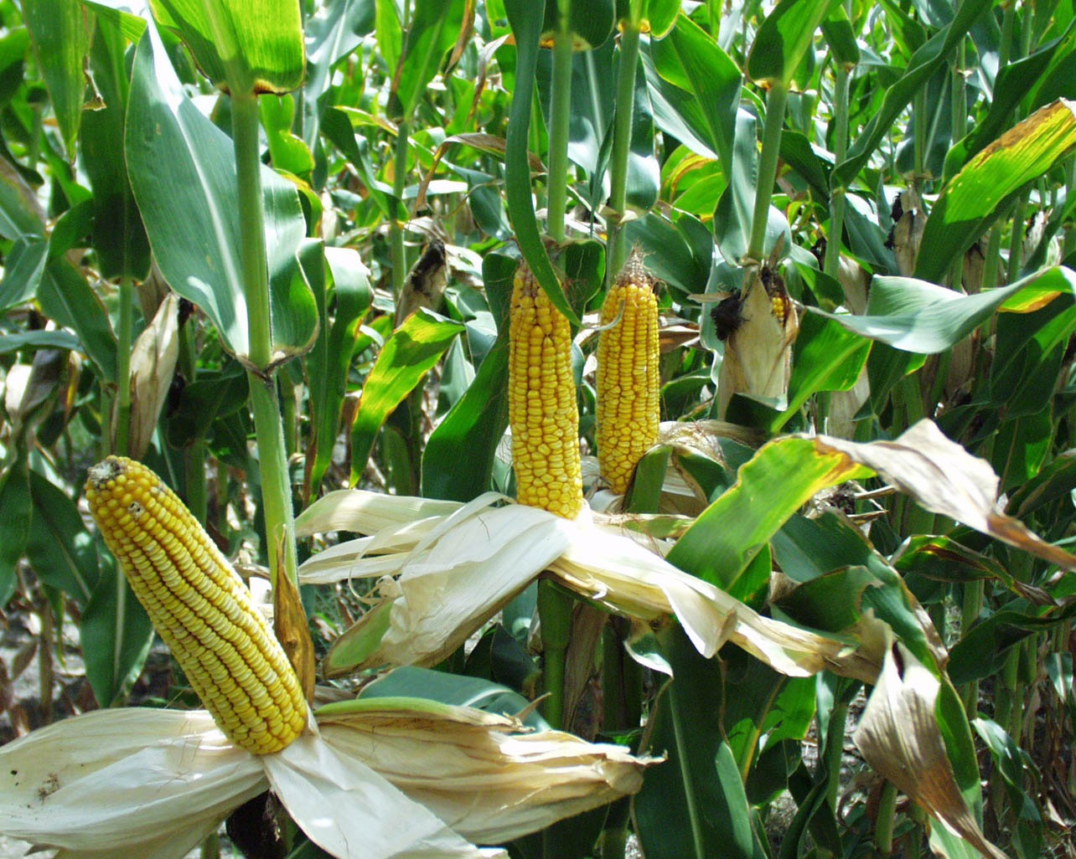
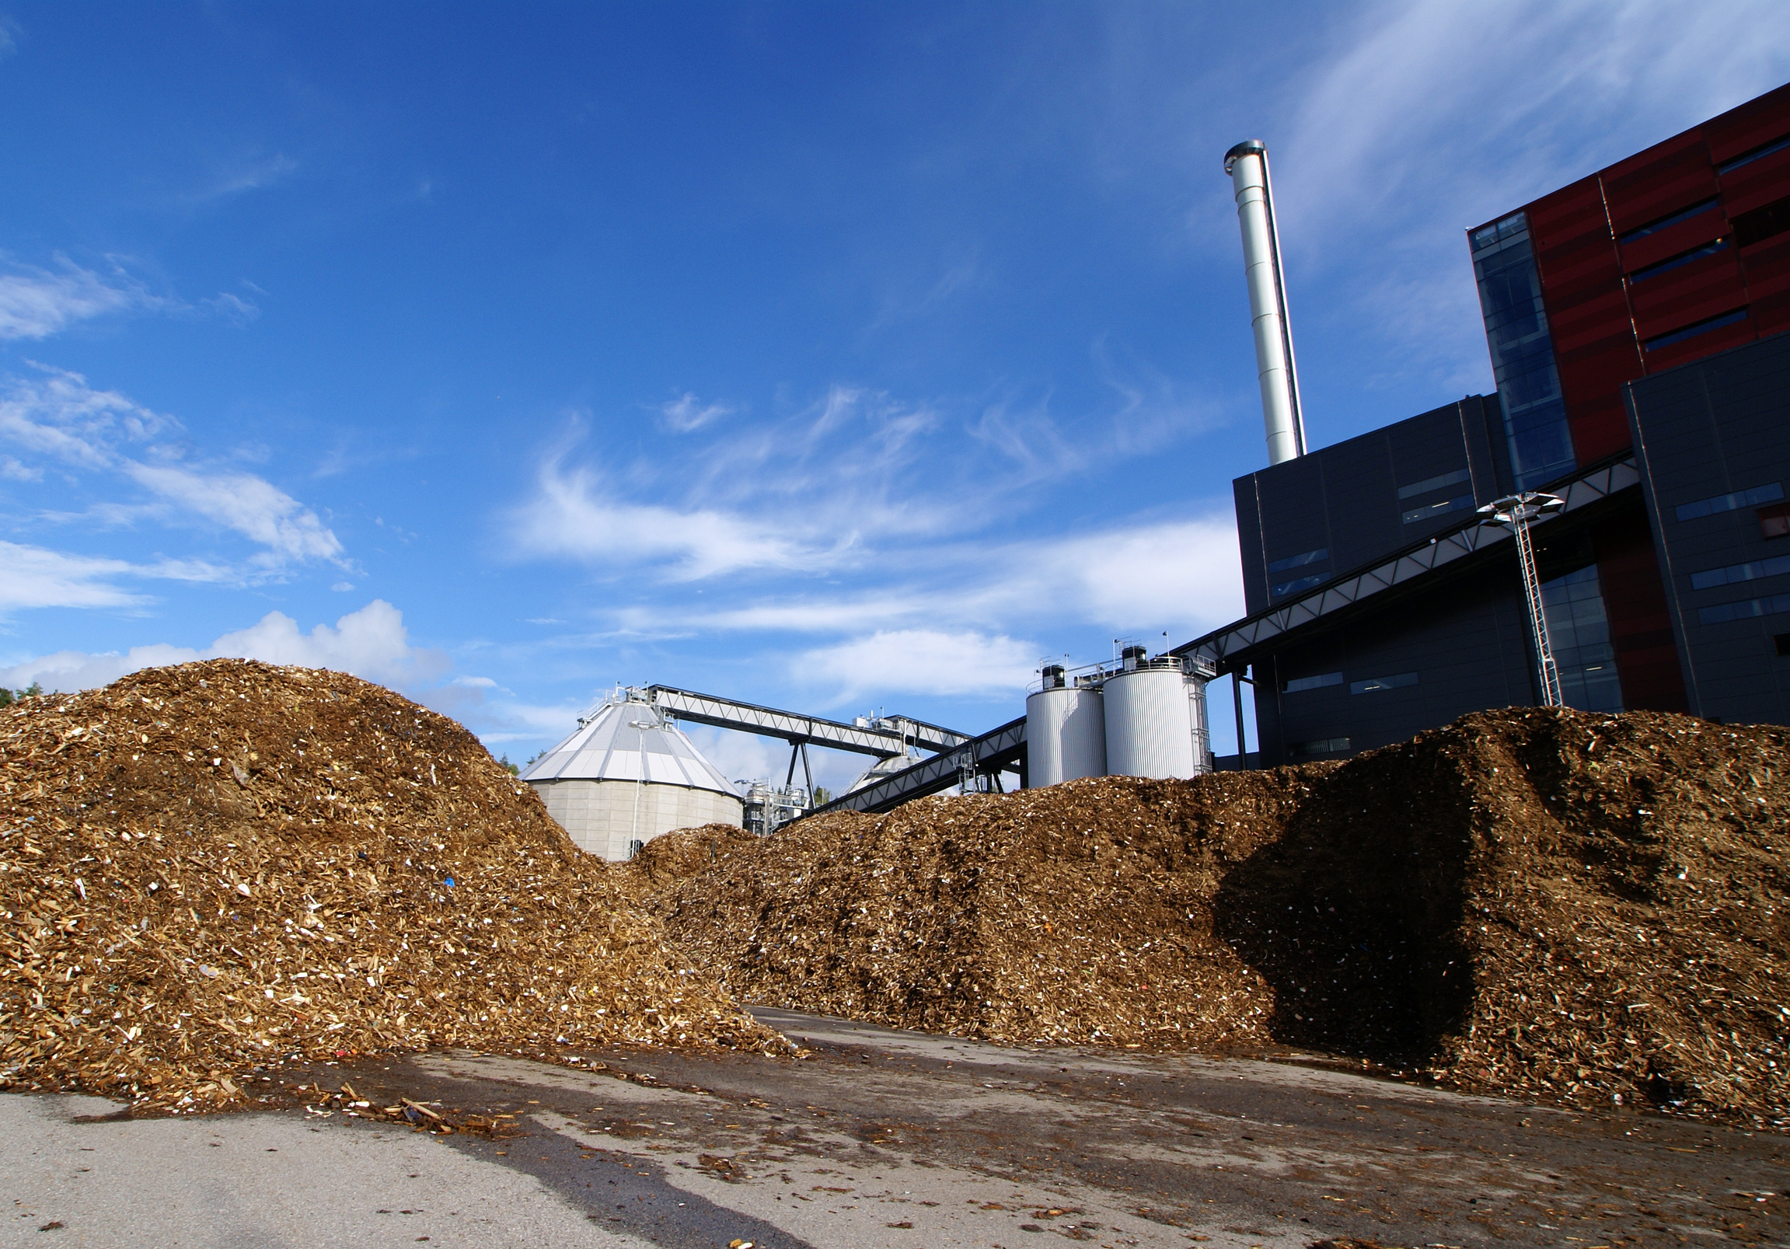
October 7, 2015
7–10pm

The Location
1234 Main Street, Anytown, State ZIP
www.example.com
October 7, 2015
7–10pm

The Location
1234 Main Street, Anytown, State ZIP
www.example.com
Agricultural Production with Compost
Renewable Feedstocks from Agricultural Waste

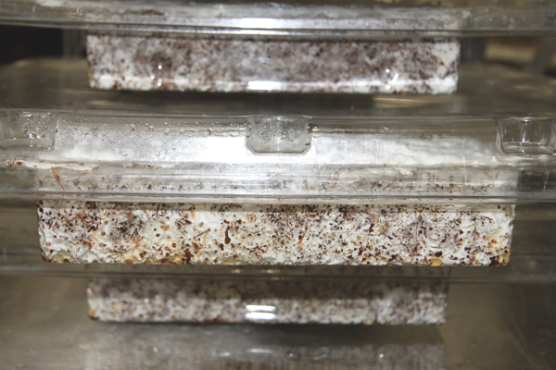
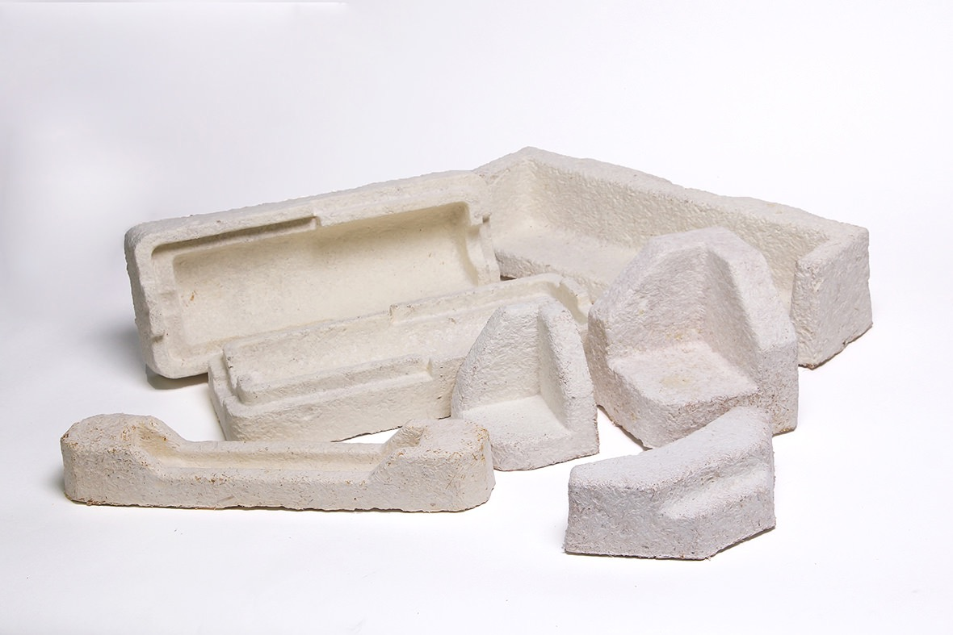
Natural Growth Cycle
Consumer Product

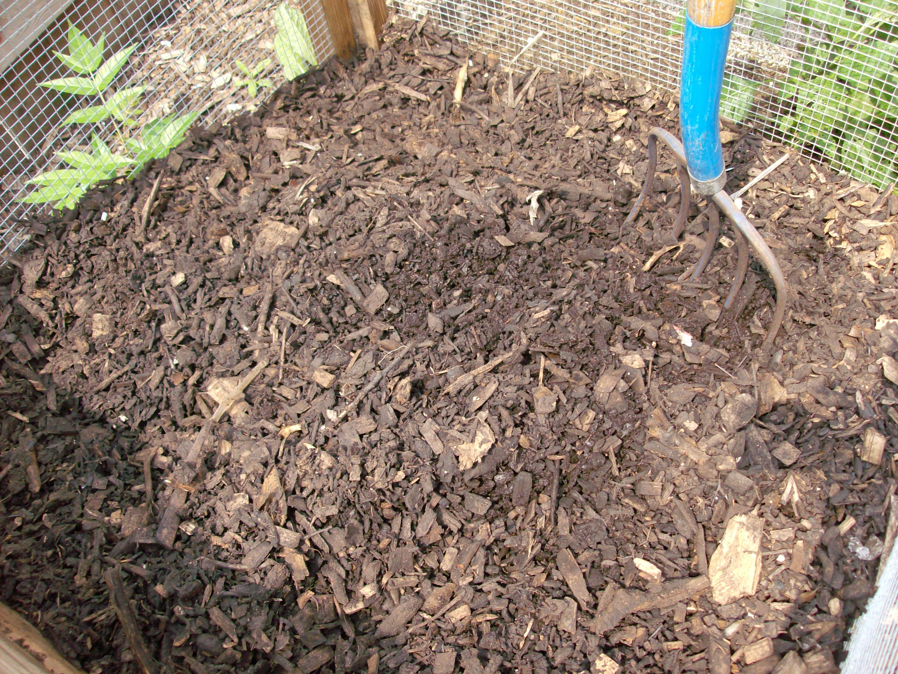

October 7, 2015
7–10pm

The Location
1234 Main Street, Anytown, State ZIP
www.example.com
October 7, 2015
7–10pm

The Location
1234 Main Street, Anytown, State ZIP
www.example.com
Biodegrades by Composting
Non-renewable Petroleum Sources

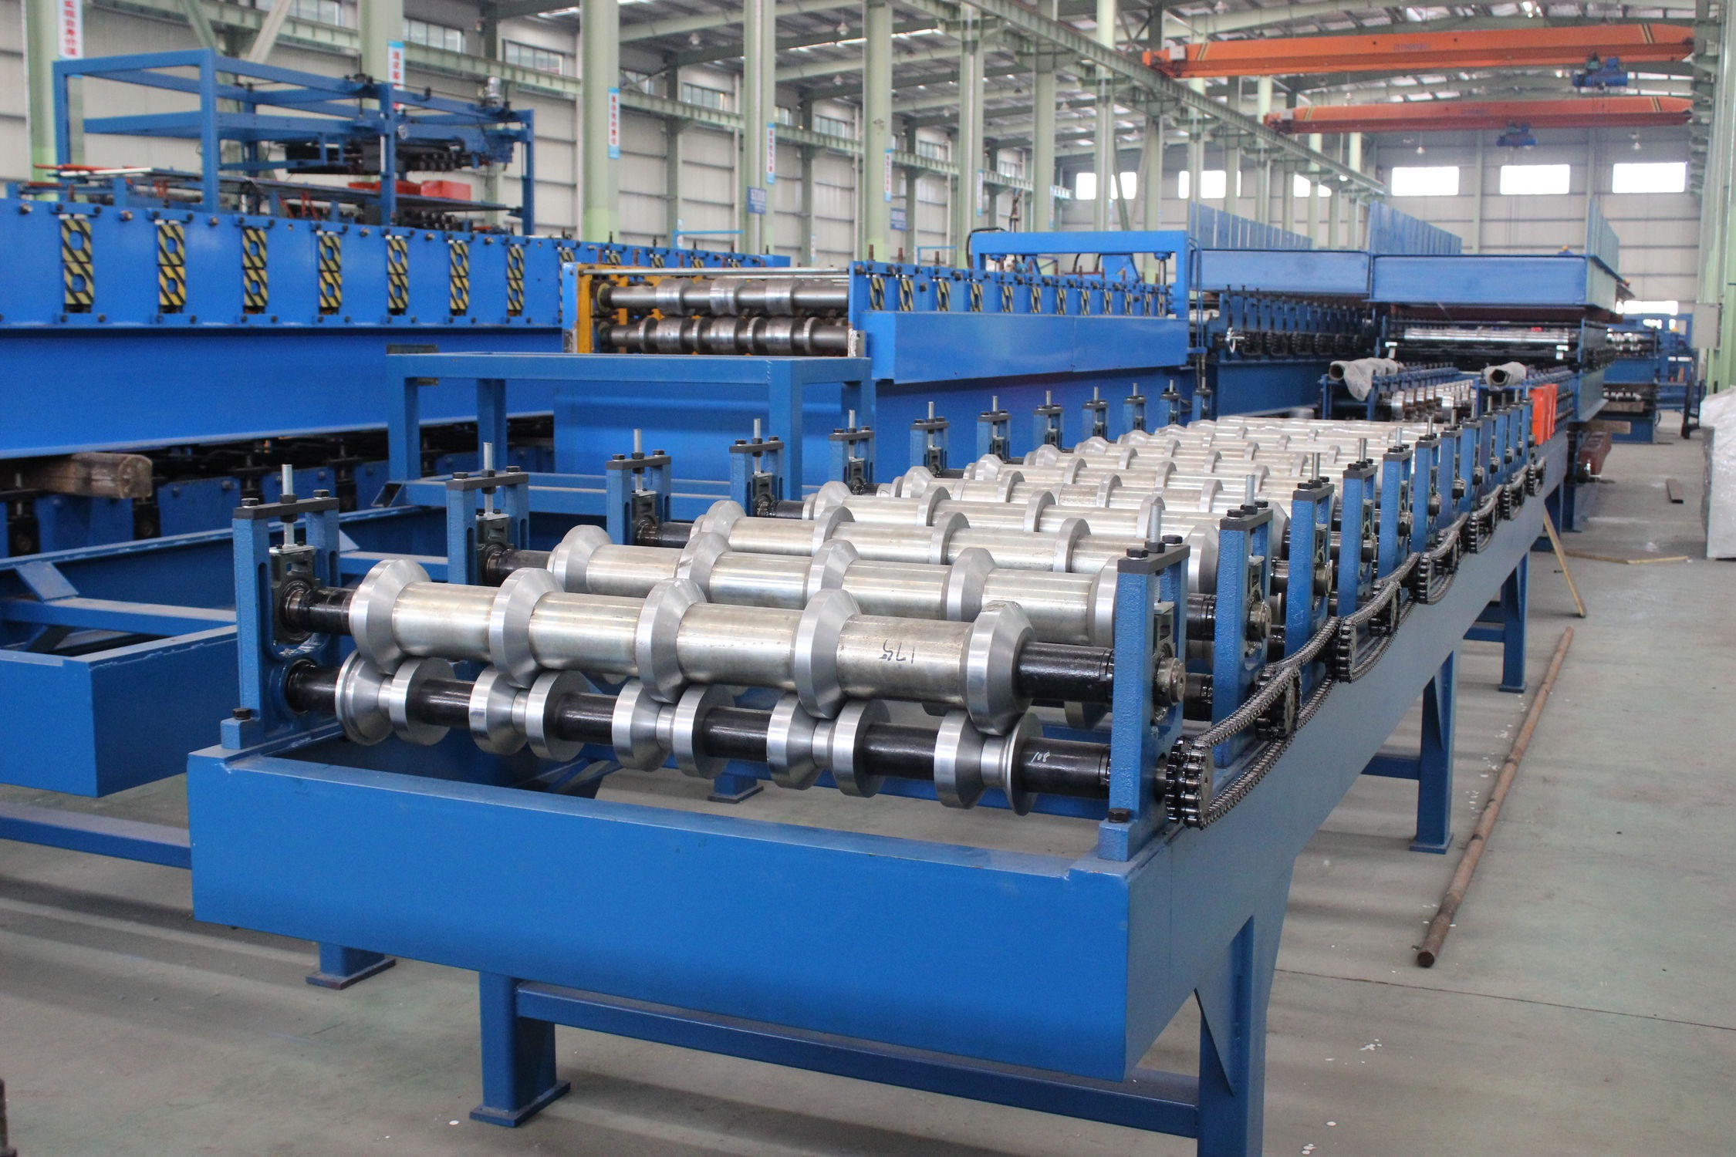
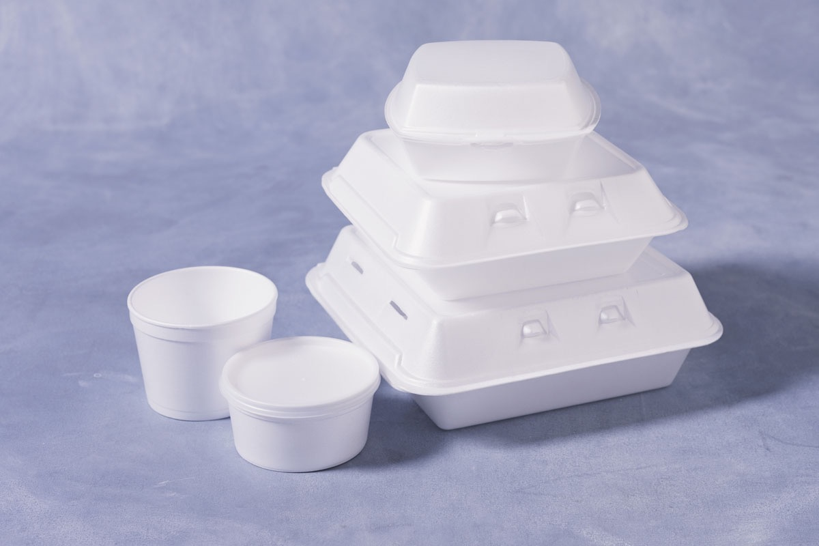
Multi-step Manufacturing Process
Consumer Product

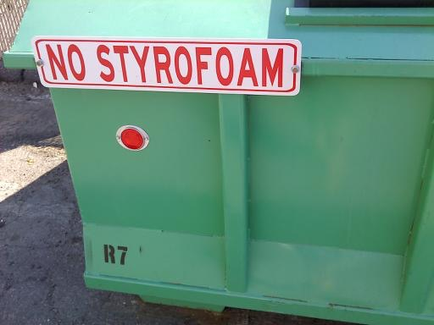

October 7, 2015
7–10pm

The Location
1234 Main Street, Anytown, State ZIP
www.example.com
October 7, 2015
7–10pm

The Location
1234 Main Street, Anytown, State ZIP
www.example.com
Minimal Recyclability
Landfill

