ANIMAL FARM
Character Map
CHARACTER/ANIMAL | CHARACTERISTICS
Old Major

Snow Ball

Napoleon

Mollie

Boxer

Moses

Muriel

Benjamin

Which canimal do you identify with, why?

All animals are equal but some are more equal than others.

Explain the relevance of the proverbs/sayings: 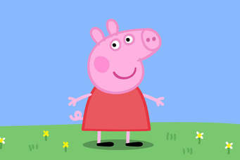
- "I am fond of pigs. Dogs look up to us. Cats look down on us. Pigs treat us as equals." - Sir Winston Churchill
- One cannot have bacon and keep the pig too
- Where the pigsty is open, the pigs run out.
- Throw pearls before the swine
- High on the hog
- When pigs fly.
- Happy as a pig in mud.

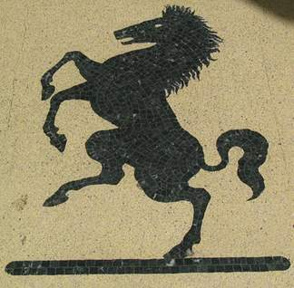 - Beat a dead horse.
- You can only lead the horse to the water, but you cannot make it drink.
- From the horse’s mouth…..
- Talk the hind leg of a donkey
- As stubborn as a mule.
Other:
- A dog is the man´ s best friend.
- Like a lamb to the slaughter.
- A wolf in sheep´s clothing.
- Count ones chicken before they hedge.
- As fit as a butcher´s dog.

Answer!
- Summarise Old Major´s dream.
- What are the 3 reasons why Old Major doesn´t like man?
- Old Major creates rules to govern the animals when they revolt. Write down 5
- Which animals work the hardest and which exploit the system?
- Why is the harvest so successful? In what ways do the animals contribute?
- Contrast the horses and the pigs.
- Describe Benjamin´s attitude towards the rebellion.
- Compare and contrast Snowball and Napoleon.
- Why do the pigs say they deserve more than the other animals? Do you agree? Why (not)?
- With what 2 expressions does Boxer answer all of his problems?
- In what way does Boxer work harder than the other animals?
- What is Napoleon´s solution to the shortage of materials?
- Why are the animals uneasy about Napoleon´s plan?
- What are the 2 ways the humans have come to accept Animal Farm?
- How do the pigs violate the original 7 commandments and what is Clover´s reaction?

