ANIMAL FARM
Character Map
CHARACTER/ANIMAL | CHARACTERISTICS
Old Major | - Humans oppress and control the animals  - Utopian place for animals  - “Beasts of England”  - 2 legs bad/4 legs good
Snowball | - Intelligent, good public speaker  - Great ideas  - How to build a windmill
Napoleon | - Chases “snowball” away  - Leadership/dictatorship  - 7 commandments/alters them
Mollie | - Vain and doubts that the animal utopia will provide all the “small luxuries” she loves so dear (ribbons, sugar cubes)  - Afraid of change
Boxer | - “I will work harder”  - “Napoleon is always right”
Moses | - Spreads false hope  - Independent, but when it suits him he decides to return
Muriel | - Helpless, dependable, unsure
Benjamin | - The oldest animal  - Cynical  - Less straightforward
Cat | - Not for and not against  - But gaining the profit  - Disappears when she decides

Which animal do you identify with, why?

All animals are equal but some are more equal than others.

Explain the relevance of the proverbs/sayings: 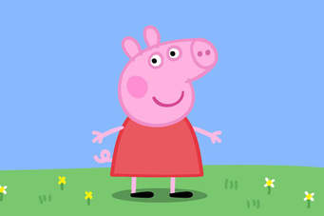
- "I am fond of pigs. Dogs look up to us. Cats look down on us. Pigs treat us as equals." - Sir Winston Churchill
- One cannot have bacon and keep the pig too
- Where the pigsty is open, the pigs run out.
- Throw pearls before the swine
- High on the hog
- When pigs fly.
- Happy as a pig in mud.

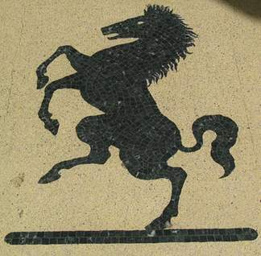 - Beat a dead horse.
- You can only lead the horse to the water, but you cannot make it drink.
- From the horse’s mouth…..
- Talk the hind leg of a donkey
- As stubborn as a mule.
Other:
- A dog is the man´ s best friend.
- Like a lamb to the slaughter.
- A wolf in sheep´s clothing.
- Count ones chicken before they hedge.
- As fit as a butcher´s dog.

Answer!
- Summarise Old Major´s dream.

- What are the 3 reasons why Old Major doesn´t like man?
Humans exploit animals, they do not care about them, they take away their “offspring”/” products “ without asking: humans treat animals as an expendable resource. Humans treat and abuse the animals as slaves. The animals are only being raised and fed in order to be slaughtered at the end.

- Old Major creates rules to govern the animals when they revolt. Write down 5
Whatever goes upon 2 legs is an enemy, whatever goes upon 4 legs or has wings is a friend. Animals must not emulate man. They must not wear clothing, live in houses or copy and of man’s other ‘evil’ habits.

- Which animals work the hardest and which exploit the system?

- Why is the harvest so successful? In what ways do the animals contribute?
The harvest is so successful because each animal is motivated to work hard and does not complain because they know they are doing all the work for themselves; the animals rely on their talents and that results in successful harvest. Also, no animal feels the need to steal.

Horses use their knowledge of the land to work very hard, Boxer and Clover drag the cutter across the field, the hens and ducks gather every stalk. The pigs do not do any actual work, they only supervise.

- Contrast the horses and the pigs.
Horses are born followers, they tend to turn by the wind, because they feel the most comfortable when following the orders and working hard for the “society”, in expectation of being appreciated by the others. Foolishly blind of the bigger picture and with that very contrary to the pigs, which/who are independent and tend to be leaders, using others in their own benefit of being greedy.

- Describe Benjamin´s attitude towards the rebellion.
He is the oldest and the worst tempered character. He seldom talks and when he does he is cynical. He does not represent an active character, he rather sits back and and laughs at everyone. He is known for his saying: ‘’Donkeys live a long time. None of you has ever seen a dead donkey.’’

- Compare and contrast Snowball and Napoleon.

- Why do the pigs say they deserve more than the other animals? Do you agree? Why (not)?

- With what 2 expressions does Boxer answer all of his problems?
- In what way does Boxer work harder than the other animals?
- What is Napoleon´s solution to the shortage of materials?
- Why are the animals uneasy about Napoleon´s plan?
- What are the 2 ways the humans have come to accept Animal Farm?
- How do the pigs violate the original 7 commandments and what is Clover´s reaction?

